**ccus**

McGrath ORACLE APPLICATIONS 12.2.10 CLONING PROCEDURE

ISG

**Document Owner : Umar Basha I**

**Version : v34.0**

**Last Updated : 9th February 2024**

**Creation Date : 3rd Mar 2022**

**Note to Holders:**

If you receive an electronic copy of this document and print it out, please write your name on the equivalent of the cover page, for document control purposes.

If you receive a hard copy of this document, please write your name on the front cover for document Control purposes.

**Document Control**

Change Record

| **#** | **Date** | **Author** | **Version** | **Change Reference** |
| --- | --- | --- | --- | --- |
|  |  |  |  |  |
| 1 | 3-Feb-2022 | Umar Basha I | V17.0 | Initial Document |
| 2 | 2-Aug-2022 | Umar Basha I | V18.0 | Updated document |
| 3 | 8-Sept-2022 | Umar Basha I | V19.0 | Updates from customer. |
| 4 | 19-Dec-2022 | Umar Basha I | V24.0 | Apex url LB issue fix mentioned, |
| 5 | 17-Apr-2023 | Umar Basha I | V26.0 | Script “RefreshTokensv1-CustomTable.sql” included. |
| 6 | 19-May-23 | Umar Basha I | V27.0 | LOGO preview issue update and parallel tasks during adcfgclone running. |
| 7 | 6-June-2023 | Umar Basha I | V28.0 | REST API issue and fix steps got updated. |
| 8 | 12-June-2023 | Umar Basha I | V29.0 | Updated database clone steps and removed unwanted steps/pages from document. |
| 9 | 13-Dec-2023 | Umar Basha I | v33.0 | updated ASADMIN steps |

Approver(s)

| **#** | **Name** | **Role** | **Signature** |
| --- | --- | --- | --- |
|  |  |  |  |
| 1 |  |  |  |
| 2 |  |  |  |

Reviewer(s)

| **#** | **Date** | **Name** | **Role** |
| --- | --- | --- | --- |
|  |  |  |  |
| 1 |  | IT Convergence Apps DBA Group |  |

Distribution

| **#** | **Date** | **Name** | **Role** |
| --- | --- | --- | --- |
|  |  |  |  |
| 1 |  | McGrath Rent Corp |  |

**Note To Holders:**

If you receive an electronic copy of this document and print it out, please write your name on the equivalent of the cover page, for document control purposes.

If you receive a hard copy of this document, please write your name on the front cover, for document control purposes.

**Document Preface:**

This document outlines the Cloning procedures for McGrath 12.2.10 environment.

## 

**Contents**

**McGrath RentCorp ORACLE APPLICATIONS 12.2.10 CLONING PROCEDURE 1**

**Environment Details 4**

# Environment Details

**PRODUCTION Environment - PMGRCI**

**NON-PRODUCTION Environments: TMGRCI/DMGRCI/SMGR2I/SMGR3I/SMGR5I**

**PMGRCI** [ **PROD** ]:

| **Application Tier Node Names** | | **DB Node** | **Web Node** | **CP Node** | **DMZ Node** | **SSO** |
| --- | --- | --- | --- | --- | --- | --- |
|  |  | | |  |  |  |
| **vlmgrcebsdb01p.oci.mgrc.com** | | **Yes** | **No** | **No** | **No** | **No** |
| **vlmgrcebsap01p.oci.mgrc.com**  **vlmgrcebsap02p.oci.mgrc.com** | | **No** | **Yes** | **Yes** | **Yes** | **Yes** |

**Application URL :** <https://ebs-prod-oci.mgrc.com/OA_HTML/AppsLocalLogin.jsp>

**Apex URL:**

**TMGRCI (TEST):**

| **Application Tier Node Names** | | **DB Node** | **Web Node** | **CP Node** | **DMZ Node** | **SSO** |
| --- | --- | --- | --- | --- | --- | --- |
|  |  | | |  |  |  |
| **vlmgrcebsdb02n.oci.mgrc.com** | | **Yes** | **No** | **No** | **No** | **No** |
| **vlmgrcebsap02n.oci.mgrc.com**  **vlmgrcebsap03n.oci.mgrc.com** | | **No** | **Yes** | **Yes** | **Yes** | **Yes** |

**Application URL :** https://ebs-test-oci.mgrc.com/OA_HTML/AppsLocalLogin.jsp

**Apex url** :

**DMGRCI (Dev):**

| **Application Tier Node Names** | | **DB Node** | **Web Node** | **CP Node** | **DMZ Node** | **SSO** |
| --- | --- | --- | --- | --- | --- | --- |
|  |  | | |  |  |  |
| **vlmgrcebsdb01n.oci.mgrc.com** | | **Yes** | **No** | **No** | **No** | **No** |
| **vlmgrcebsap01n.oci.mgrc.com** | | **No** | **Yes** | **Yes** | **Yes** | **Yes** |

**Application URL :** [**https://ebs-dev-oci.mgrc.com/OA_HTML/AppsLogin**](https://phobos.rosettastone.local/OA_HTML/AppsLogin)

**Apex URL :**

**SMGR2I:**

| **Application Tier Node Names** | | **DB Node** | **Web Node** | **CP Node** | **DMZ Node** | **SSO** |
| --- | --- | --- | --- | --- | --- | --- |
|  |  | | |  |  |  |
| **vlmgrcebsdb04n.oci.mgrc.com** | | **Yes** | **No** | **No** | **No** | **No** |
| **vlmgrcebsap04n.oci.mgrc.com** | | **No** | **Yes** | **Yes** | **Yes** | **Yes** |

**Application URL :** [**https://ebs-S2-oci.mgrc.com/OA_HTML/AppsLogin**](https://puck.rosettastone.local/OA_HTML/AppsLogin)

**Apex URL :**

**SMGR3I:**

| **Application Tier Node Names** | | **DB Node** | **Web Node** | **CP Node** | **DMZ Node** | **SSO** |
| --- | --- | --- | --- | --- | --- | --- |
|  |  | | |  |  |  |
| **vlmgrcebsdb05n.oci.mgrc.com** | | **Yes** | **No** | **No** | **No** | **No** |
| **vlmgrcebsap05n.oci.mgrc.com** | | **No** | **Yes** | **Yes** | **Yes** | **Yes** |

# Clone Procedure:

**The below instructions are applicable for all non-prod environments. Wherever applicable, please use the corresponding application nodes. All the commands are given with respect to DMGRCI.**

Database clone

DB steps has been included in this Document so only need to below doc if any clarification is needed

* Check the excel sheet Mcgrath _ OCI TMGRCI Clone from OCI PMGRCI.xls for detailed steps.

**Database cloning steps, check document “Mcgrath _OCI_database_refresh_v4.xlsx”**

**Location :** [**https://drive.google.com/drive/folders/1h_sSq3YsBW881HKpXK8qInUPPGZ5GueV**](https://drive.google.com/drive/folders/1h_sSq3YsBW881HKpXK8qInUPPGZ5GueV)

# Send out email notification to customer

Please send email to below email from Client side 30 minutes prior to taking down instance for cloning

[jonathan.hacker@mgrc.com](mailto:jonathan.hacker@mgrc.com), [ITBSATEAM@mgrc.com](mailto:ITBSATEAM@mgrc.com), [sandeep.pawale@jadeglobal.com](mailto:sandeep.pawale@jadeglobal.com),

# Preparation steps on Source Node

Login to vlmgrcebsap01p.oci.mgrc.com as applmgr

## Run preclone

[applmgr@vlmgrcebsap01p scripts]$ cd $ADMIN_SCRIPTS_HOME

[applmgr@vlmgrcebsap01p scripts]$ perl adpreclone.pl appsTier

## Take tar backup of the below directories

**EBSapps and CUSTOM from run file system**

[applmgr@vlmgrcebsap01p JUN2020]$ pwd

/pmgrci/applmgr/fs1

nohup tar -zvcf /stage/PMGRCI_OCI_APPS_BKP/3aug20/PMGRCI_OCI_EBSapps.tar.gz EBSapps > /stage/PMGRCI_OCI_APPS_BKP/3aug20/PMGRCI_OCI_APPL_TOP.log &

[applmgr@vlmgrcebsap01p applmgr]$ pwd

/pmgrci/applmgr

nohup tar -zvcf /stage/PMGRCI_OCI_APPS_BKP/3aug20/PMGRCI_OCI_CUSTOM_TOP.tar.gz CUSTOM > /stage/PMGRCI_OCI_APPS_BKP/3aug20/PMGRCI_OCI_CUSTOM_TOP.log &

NOTE: folder 3aug20 is just an example.

Login to DB node and take oracle home backup

**Untar Application files**

# Preparation on target node (TMGRCI,DMGRCI,SMGR2I,SMGR3I)

## Backup in Application side for EBS

**In Target environment:**

Run /home/applmgr/ backup_files_R12.2.sh to create pre backups

Sh backup_files_R12.2.sh

**In Sourec environment:**

Run adpreclone in source application

perl adpreclone.pl appsTier

Run tar backup commands to take EBS file system tar backup.

Example:

Go to /pmgrci/applmgr/fs1 or fs2 and run

nohup tar -zvcf /stage/PMGRCI_OCI_APPS_BKP/<date>/CUSTOM.tar.gz CUSTOM > /stage/PMGRCI_OCI_APPS_BKP/<date>/CUSTOM.log &

go to the source RUN file system location and run

nohup tar -zvcf /stage/PMGRCI_OCI_APPS_BKP/<date>/EBSapps.tar.gz EBSapps > /stage/PMGRCI_OCI_APPS_BKP/<date>/EBSapps.log &

## Backup in Database side for EBS

**In Sourec environment:**

Run adpreclon in source application

perl adpreclone.pl dbTier

**In Target environment:**

Run pre backusp script to take db side backups. Like env files, db context file and other important files in oracle home

/home/oracle/db_preclone.sh

Sh db_preclone.sh

SQL> create pfile='/home/oracle/<latest clone directory>/pfile_jun2020.txt' from spfile;

File created. SQL> !ls -l /home/oracle/clone/BKP_JUN2020/pfile_jun2020.txt

-rw-r--r-- 1 oracle asmadmin 3294 Jun 25 07:50 /home/oracle/clone/BKP_JUN2020/pfile_jun2020.txt

## DBA Directories backup in target before refresh (do this on both pdb and cdb)

SQL>set line 200;

SQL>set pages 200;

SQL>col DIRECTORY_NAME format a50;

SQL>col DIRECTORY_PATH format a100;

SQL>col OWNER format a20;

SQL>spool db_link_directories_cdb.log

SQL>select OWNER,DIRECTORY_NAME,DIRECTORY_PATH from dba_directories;

SQL>spool off

SQL> alter session set container=TMGRCI;

SQL> spool db_link_directories_pdb.log

SQL> select OWNER,DIRECTORY_NAME,DIRECTORY_PATH from dba_directories;

/home/oracle/<latest clone directory>/db_link_directories_cdb.log

/home/oracle/< latest clone directory >/db_link_directories_pdb.log

## DB Link backup in target before refresh

SQL> col DB_LINK format a50;

SQL> col USERNAME format a30;

SQL> col host format a50;

SQL> select OWNER,DB_LINK,USERNAME,HOST from dba_db_links;

NOTE : we have crontab scheduled to take the export dump of Apex Schemas. Location “/stage/RCU_SCHEMA_BACKUP/<instance name>”

## Backup in Database side for APEX (optional step)

[oracle@vlmgrcebsdb02n:cmgebst] /home/oracle/clone/BKP_JUN2020 $ cat apxtest_ts_scripts.sql

SQL>spool apxtest_ts_creation.sql

SQL> SET LONG 20000 LONGCHUNKSIZE 20000 PAGESIZE 0 LINESIZE 1000 FEEDBACK OFF VERIFY OFF TRIMSPOOL ON

SELECT DBMS_METADATA.GET_DDL('TABLESPACE','APXTEST_IAU') FROM dual;

SELECT DBMS_METADATA.GET_DDL('TABLESPACE','APXTEST_WLS') FROM dual;

SELECT DBMS_METADATA.GET_DDL('TABLESPACE','APXTEST_STB') FROM dual;

SELECT DBMS_METADATA.GET_DDL('TABLESPACE','APXTEST_IAS_OPSS') FROM dual;

SELECT DBMS_METADATA.GET_DDL('TABLESPACE','APXTEST_MDS') FROM dual;

SELECT DBMS_METADATA.GET_DDL('TABLESPACE','APXTEST_IAS_UMS') FROM dual;

SELECT DBMS_METADATA.GET_DDL('TABLESPACE','APXTEST_IAS_TEMP') FROM dual;

## Backup in Database side for APEX (optional step)

mkdir /stage/OCI_BACKUP/APXTEST_Schema_bkp/JUN2020

ls -ld /stage/OCI_BACKUP/APXTEST_Schema_bkp/JUN2020

drwxr-xr-x 2 oracle oinstall 0 Jun 25 08:06 /stage/OCI_BACKUP/APXTEST_Schema_bkp/JUN2020

[oracle@vlmgrcebsdb02n:cmgebst] /stage/OCI_BACKUP/APXTEST_Schema_bkp/JUN2020 $ cat APXTEST_Schema.par

full=y INCLUDE=SCHEMA:"IN(select username from dba_users where username like 'APXTEST%')"

directory=APXTEST_DIR

dumpfile=expdp_APXTEST_Schema.dmp

logfile=expdp_APXTEST_Schema.log

[oracle@vlmgrcebsdb02n:cmgebst] Dump file set for SYSTEM.SYS_EXPORT_FULL_01 is: /stage/OCI_BACKUP/APXTEST_Schema_bkp/JUN2020/expdp_APXTEST_Schema.dmp Job "SYSTEM"."SYS_EXPORT_FULL_01" successfully completed at Thu Jun 25 08:39:34 2020 elapsed 0 00:22:03 $ nohup expdp system/xxxxxxx@TMGRCI parfile=APXTEST_Schema.par & [1] 20903 [oracle@vlmgrcebsdb02n:cmgebst]

Create dba directory

SQL> alter session set container=TMGRCI;

SQL> select DIRECTORY_NAME,DIRECTORY_PATH from dba_directories where DIRECTORY_NAME='APXTEST_DIR';

DIRECTORY_NAME DIRECTORY_PATH

-------------------------------------------------- --------------------------------------------------

APXTEST_DIR /stage/OCI_BACKUP/APXTEST_Schema_bkp

SQL> create or replace directory APXTEST_DIR as '/stage/OCI_BACKUP/APXTEST_Schema_bkp/JUN2020';

Directory created.

SQL> select DIRECTORY_NAME,DIRECTORY_PATH from dba_directories where DIRECTORY_NAME='APXTEST_DIR';

DIRECTORY_NAME DIRECTORY_PATH

-------------------------------------------------- --------------------------------------------------

APXTEST_DIR /stage/OCI_BACKUP/APXTEST_Schema_bkp/JUN2020

## Disable database backup entries from crontab

#10 10 * * 0 /stage/ProcedureLibrary/rman/rmancloud_backupol cmgebst 0 > /dev/null 2>&1 #10 20 * * 1-6 /stage/ProcedureLibrary/rman/rmancloud_backupol cmgebst 1 c > /dev/null 2>&1 #22 * * * * /stage/ProcedureLibrary/rman/rmancloud_backuparch cmgebst > /dev/null 2>&1

# Silence Nagios and Shutdown EBS application

Please make sure email is sent to McGrath team 30 minutes before shutdown

cd $ADMIN_SCRIPTS_HOME

./adstpall.sh apps/passwd

## Clean up EBS application files/rename them ( in target system)

Cd /tmgrci/applmgr/fs1

Mv EBSapps EBSapps_bkp

Mv FMW_Home FMW_Home

Untar the source EBS file system in target.

nohup tar -xvf /stage/PMGRCI_OCI_APPS_BKP/3aug20/PMGRCI_OCI_EBSapps.tar.gz &

cd /tmgrci/applmgr/

nohup tar -xvf /stage/PMGRCI_OCI_APPS_BKP/3aug20/PMGRCI_OCI_CUSTOM_TOP.tar.gz &

## Create pfile before the drop database. Note :- Drop database will delete spfile & alert logs

SQL> show parameter db_name

NAME TYPE VALUE

------------------------------------ ----------- ------------------------------

db_name string CMGEBST

SQL> show pdbs

CON_ID CON_NAME OPEN MODE RESTRICTED

---------- ------------------------------ ---------- ----------

2 PDB$SEED READ ONLY NO 3 TMGRCI READ WRITE NO

SQL> show parameter pfile

NAME TYPE VALUE

------------------------------------ ----------- ------------------------------

spfile string +DATA/CMGEBST_PHX1FN/PARAMETER FILE/spfilecmgebst.ora

SQL> show parameter db_name

NAME TYPE VALUE

------------------------------------ ----------- ------------------------------

db_name string CMGEBST

SQL> create pfile from spfile;

File created.

SQL> !ls -l $ORACLE_HOME/dbs/initcmgebst.ora -rw-r--r-- 1 oracle asmadmin 3294 Jun 25 15:34 /u01/app/oracle/product/12.1.0.2/dbhome_1/dbs/initcmgebst.ora

## Drop target database Note :- Mount database using newly created pfile

SQL> shutdown immediate

Database closed.

Database dismounted.

ORACLE instance shut down.

SQL> startup mount exclusive restrict;

ORA-32004: obsolete or deprecated parameter(s) specified for RDBMS instance

ORACLE instance started.

Total System Global Area 3.2212E+10 bytes

Fixed Size 3729840 bytes

Variable Size 8657045072 bytes

Database Buffers 2.3488E+10 bytes

Redo Buffers 63377408 bytes

Database mounted.

SQL>

SQL> drop database;

Database dropped.

Disconnected from Oracle Database 12c Enterprise Edition Release 12.1.0.2.0 - 64bit Production

With the Real Application Clusters, Automatic Storage Management, OLAP and Real Application Testing options SQL>

# Database Restoration

## Startup nonmount for controlfile restoration

SQL> startup nomount

ORA-32004: obsolete or deprecated parameter(s) specified for RDBMS instance

ORACLE instance started.

Total System Global Area 3.2212E+10 bytes

Fixed Size 3729840 bytes

Variable Size 8657045072 bytes

Database Buffers 2.3488E+10 bytes

Redo Buffers 63377408 bytes

SQL> show parameter pfile

NAME TYPE VALUE

------------------------------------ ----------- ------------------------------

spfile string

SQL>

## Make sure source wallet copied into target server. Copy latest wallet folder from "/stage/ProcedureLibrary/rman/cmgebsp/recover"

Note :- This is applicable for initial clone (New Setup)

$ cat /u01/app/oracle/product/12.1.0.2/dbhome_1/network/admin/sqlnet.ora | grep ENCRYPTION_WALLET_LOCATION ENCRYPTION_WALLET_LOCATION=(SOURCE=(METHOD=FILE)(METHOD_DATA=(DIRECTORY=/opt/oracle/dcs/commonstore/wallets/tde/$ORACLE_UNQNAME)))

[oracle@vlmgrcebsdb02n:cmgebst] $ cd /opt/oracle/dcs/commonstore/wallets/tde/

[oracle@vlmgrcebsdb02n:cmgebst] /opt/oracle/dcs/commonstore/wallets/tde

$ mv cmgebst_phx1fn cmgebst_phx1fn_b4_refresh_jun2020

$ cp -r /stage/ProcedureLibrary/rman/cmgebsp/recover/cmgebsp_phx1n7-24 cmgebst_phx1fn

[oracle@vlmgrcebsdb02n:cmgebst] /opt/oracle/dcs/commonstore/wallets/tde

$ ls -l

total 104

drwx------ 3 oracle oinstall 20480 J un 25 16:13 cmgebst_phx1fn

drwx------ 4 oracle oinstall 20480 Feb 8 16:21 cmgebst_phx1fn_b4_refresh_jun2020

[oracle@vlmgrcebsdb02n:cmgebst]

**Will get below error if source wallet not copied into target**

------------------------------------------------------------------------------

released channel: ASH3

RMAN-00571: ===========================================================

RMAN-00569: =============== ERROR MESSAGE STACK FOLLOWS ===============

RMAN-00571: ===========================================================

RMAN-03002: failure of Duplicate Db command at 08/06/2019 11:53:09

RMAN-05501: aborting duplication of target database

RMAN-03015: error occurred in stored script Memory Script

ORA-19870: error while restoring backup piece 2pu8h8v8_1_1

ORA-19913: unable to decrypt backup Recovery Manager complete.

## Copy source opc file into target Note :- Source & target are using different object storage buckets. hence need to restore database using source bucket

$ cp /stage/ProcedureLibrary/rman/cmgebsp/recover/opccmgebsp.ora . [oracle@vlmgrcebsdb02n:cmgebst] /u01/app/oracle/product/12.1.0.2/dbhome_1/dbs

$ ls -l *opc*

-rw-r--r-- 1 oracle oinstall 343 Jun 25 16:20 opccmgebsp.ora

-rw-r--r-- 1 oracle oinstall 343 Jun 4 15:31 opccmgebst.ora

[oracle@vlmgrcebsdb02n:cmgebst]

## Make sure database name should be source

$ cat $ORACLE_HOME/dbs/initcmgebst.ora | grep control_files *.control_files='+RECO/CMGEBST_PHX1FN/CONTROLFILE/controlfile01.ctl'

$ cat $ORACLE_HOME/dbs/initcmgebst.ora | grep db_name

*.db_name='CMGEBSP'

## Control file restoration scripts using until time Note :- Allocated channel pointed to source opc file

$ cat restore_controlfile.rcv

set dbid = 3514287677;

run

{

ALLOCATE CHANNEL PHX DEVICE TYPE SBT PARMS='SBT_LIBRARY=/u01/app/oracle/product/12.1.0.2/dbhome_1/lib/libopc.so,ENV=(OPC_PFILE=/u01/app/oracle/product/12.1.0.2/dbhome_1/dbs/opccmgebsp.ora)';

set until time = '2020-06-21:19:00:00';

restore primary controlfile;

}

## Trigger control file restoration after set nls parameter

export NLS_LANG=AMERICAN_AMERICA.AL32UTF8

export NLS_DATE_FORMAT='YYYY-MM-DD:HH24:MI:SS'

[oracle@vlmgrcebsdb02n:cmgebst] /home/oracle/clone/BKP_JUN2020

$ rman target / catalog=rman_catalog/rman_catalog@RMAN

Recovery Manager: Release 12.1.0.2.0 - Production on Thu Jun 25 16:34:26 2020

Copyright (c) 1982, 2014, Oracle and/or its affiliates. All rights reserved.

connected to target database: CMGEBSP (not mounted)

connected to recovery catalog database

recovery catalog schema release 19.03.00.00. is newer than RMAN release

RMAN> @restore_controlfile.rcv

RMAN>

**end-of-file**

RMAN> alter database mount;

Statement processed

RMAN>

**Note: Please check Database status before proceeding with db restore.DB should be in mount state.**

**Example run**

RMAN> @restore_controlfile.rcv

RMAN> set dbid = 3514287677;

executing command: SET DBID

database name is "CMGEBSP" and DBID is 3514287677

RMAN> run

2> {

3> ALLOCATE CHANNEL PHX DEVICE TYPE SBT PARMS='SBT_LIBRARY=/u01/app/oracle/product/12.1.0.2/dbhome_1/lib/libopc.so,ENV=

(OPC_PFILE=/u01/app/oracle/product/12.1.0.2/dbhome_1/dbs/opccmgebsp.ora)';

4> set until time = '2020-06-21:19:00:00';

5> restore controlfile;

6> } a

llocated channel: PHX

channel PHX: SID=4 device type=SBT_TAPE

channel PHX: Oracle Database Backup Service Library VER=19.0.0.1

executing command: SET until clause

Starting restore at 2020-06-25:16:34:34

channel PHX: starting datafile backup set restore

channel PHX: restoring control file

channel PHX: reading from backup piece bev3att6_1_1

channel PHX: piece handle=bev3att6_1_1 tag=TAG20200621T181710

channel PHX: restored backup piece 1

channel PHX: restore complete, elapsed time: 00:00:03

output file name=+RECO/CMGEBST_PHX1FN/CONTROLFILE/controlfile01.ctl

Finished restore at 2020-06-25:16:34:39

released channel: PHX

RMAN>

## Restore & recover database scripts using until time.

**Note :- Recover will be done until all available archived log in object stroage if you not mentoined until time**

$ cat restore_database.rcv

run

{

ALLOCATE CHANNEL PHX1 DEVICE TYPE SBT PARMS='SBT_LIBRARY=/u01/app/oracle/product/12.1.0.2/dbhome_1/lib/libopc.so,ENV=(OPC_PFILE=/u01/app/oracle/product/12.1.0.2/dbhome_1/dbs/opccmgebsp.ora)';

ALLOCATE CHANNEL PHX2 DEVICE TYPE SBT PARMS='SBT_LIBRARY=/u01/app/oracle/product/12.1.0.2/dbhome_1/lib/libopc.so,ENV=(OPC_PFILE=/u01/app/oracle/product/12.1.0.2/dbhome_1/dbs/opccmgebsp.ora)';

ALLOCATE CHANNEL PHX3 DEVICE TYPE SBT PARMS='SBT_LIBRARY=/u01/app/oracle/product/12.1.0.2/dbhome_1/lib/libopc.so,ENV=(OPC_PFILE=/u01/app/oracle/product/12.1.0.2/dbhome_1/dbs/opccmgebsp.ora)';

ALLOCATE CHANNEL PHX4 DEVICE TYPE SBT PARMS='SBT_LIBRARY=/u01/app/oracle/product/12.1.0.2/dbhome_1/lib/libopc.so,ENV=(OPC_PFILE=/u01/app/oracle/product/12.1.0.2/dbhome_1/dbs/opccmgebsp.ora)';

ALLOCATE CHANNEL PHX5 DEVICE TYPE SBT PARMS='SBT_LIBRARY=/u01/app/oracle/product/12.1.0.2/dbhome_1/lib/libopc.so,ENV=(OPC_PFILE=/u01/app/oracle/product/12.1.0.2/dbhome_1/dbs/opccmgebsp.ora)';

ALLOCATE CHANNEL PHX6 DEVICE TYPE SBT PARMS='SBT_LIBRARY=/u01/app/oracle/product/12.1.0.2/dbhome_1/lib/libopc.so,ENV=(OPC_PFILE=/u01/app/oracle/product/12.1.0.2/dbhome_1/dbs/opccmgebsp.ora)';

ALLOCATE CHANNEL PHX7 DEVICE TYPE SBT PARMS='SBT_LIBRARY=/u01/app/oracle/product/12.1.0.2/dbhome_1/lib/libopc.so,ENV=(OPC_PFILE=/u01/app/oracle/product/12.1.0.2/dbhome_1/dbs/opccmgebsp.ora)';

ALLOCATE CHANNEL PHX8 DEVICE TYPE SBT PARMS='SBT_LIBRARY=/u01/app/oracle/product/12.1.0.2/dbhome_1/lib/libopc.so,ENV=(OPC_PFILE=/u01/app/oracle/product/12.1.0.2/dbhome_1/dbs/opccmgebsp.ora)';

SET NEWNAME FOR DATABASE TO '+DATA';

set until time= "to_date('21/06/2020 19:00:00','dd/mm/yyyy hh24:mi:ss')";

restore database;

switch datafile all;

recover database;

}

**Another Option for restoration :- Rman Duplication - PFB Sample scripts**

**We currently don’t use rman duplication (this will be used incase if backup if is not working)**

$ rman auxiliary /

RMAN> startup clone nomount;

$ cat rman_duplicate.rcv

run

{

allocate auxiliary channel PHX1 DEVICE TYPE SBT PARMS='SBT_LIBRARY=/u01/app/oracle/product/12.1.0.2/dbhome_1/lib/libopc.so,ENV=(OPC_PFILE=/u01/app/oracle/product/12.1.0.2/dbhome_1/dbs/opccmgebsp.ora)';

allocate auxiliary channel PHX2 DEVICE TYPE SBT PARMS='SBT_LIBRARY=/u01/app/oracle/product/12.1.0.2/dbhome_1/lib/libopc.so,ENV=(OPC_PFILE=/u01/app/oracle/product/12.1.0.2/dbhome_1/dbs/opccmgebsp.ora)';

allocate auxiliary channel PHX3 DEVICE TYPE SBT PARMS='SBT_LIBRARY=/u01/app/oracle/product/12.1.0.2/dbhome_1/lib/libopc.so,ENV=(OPC_PFILE=/u01/app/oracle/product/12.1.0.2/dbhome_1/dbs/opccmgebsp.ora)';

allocate auxiliary channel PHX4 DEVICE TYPE SBT PARMS='SBT_LIBRARY=/u01/app/oracle/product/12.1.0.2/dbhome_1/lib/libopc.so,ENV=(OPC_PFILE=/u01/app/oracle/product/12.1.0.2/dbhome_1/dbs/opccmgebsp.ora)';

duplicate database cmgebsp dbid 3514287677 to cmgebsd until time "TO_DATE('2020-07-20:22:00:00','yyyy-mm-dd hh24:mi:ss')";

} $

nohup rman auxiliary / catalog=rman_catalog/rman_catalog@RMAN cmdfile=rman_duplicate.rcv log=rman_duplicate.log & [1] 8639

## Trigger restoration connect with recovery catalog in background

$ nohup rman target / catalog=rman_catalog/rman_catalog@RMAN cmdfile=restore_database.rcv log=restore_database.log & [1] 71605 [oracle@vlmgrcebsdb02n:cmgebst]

**Restoration tail log file information.**

archived log file name=+RECO/CMGEBST_PHX1FN/ARCHIVELOG/2020_06_26/thread_1_seq_5948.1109.1044086289 thread=1 sequence=5948 channel default: deleting archived log(s) archived log file name=+RECO/CMGEBST_PHX1FN/ARCHIVELOG/2020_06_26/thread_1_seq_5948.1109.1044086289 RECID=255 STAMP=1044061151 channel PHX3: piece handle=c3v3b1aj_1_1 tag=TAG20200621T191531 channel PHX3: restored backup piece 1 channel PHX3: restore complete, elapsed time: 00:01:21 archived log file name=+RECO/CMGEBST_PHX1FN/ARCHIVELOG/2020_06_26/thread_1_seq_5949.1129.1044086333 thread=1 sequence=5949 channel default: deleting archived log(s) archived log file name=+RECO/CMGEBST_PHX1FN/ARCHIVELOG/2020_06_26/thread_1_seq_5949.1129.1044086333 RECID=258 STAMP=1044061191 media recovery complete, elapsed time: 00:00:10 Finished recover at 26-JUN-20 released channel: PHX1

Recovery Manager complete.

## RMAN Restore fail with recovery

Error

released channel: PHX8

RMAN-00571: ===========================================================

RMAN-00569: =============== ERROR MESSAGE STACK FOLLOWS ===============

RMAN-00571: ===========================================================

RMAN-03002: failure of recover command at 04/02/2021 17:16:10

RMAN-06004: ORACLE error from recovery catalog database:

RMAN-20003: target database incarnation not found in recovery catalog Recovery Manager complete.

**Fix : SMGR2I**

refresh on 2nd april 2021

==================================

in production run the below to check current incarnation

----------------

RMAN> list incarnation;

using target database control file instead of recovery catalog

List of Database Incarnations

DB Key Inc Key DB Name DB ID STATUS Reset SCN Reset Time

------- ------- -------- ---------------- --- ---------- ----------

1 1 CMGEBSP 3514287677 PARENT 1 06-NOV-19

2 2 CMGEBSP 3514287677 CURRENT 1878305 20-MAR-20

RMAN>

in smgr2i change incarnation to same as prod

------------------------------------------- --------------

RMAN> list incarnation;

using target database control file instead of recovery catalog

List of Database Incarnations

DB Key Inc Key DB Name DB ID STATUS Reset SCN Reset Time

------- ------- -------- ---------------- --- ---------- ----------

1 1 CMGEBSP 3514287677 PARENT 1 06-NOV-19

2 2 CMGEBSP 3514287677 **PARENT** 1878305 20-MAR-20

4 4 CMGEBSP 3514287677 ORPHAN 6025243603776 01-MAR-21

3 3 CMGEBSP 3514287677 CURRENT 6026084911705 02-APR-21

RMAN> reset database to incarnation 2;

database reset to incarnation 2

RMAN> list incarnation;

List of Database Incarnations

DB Key Inc Key DB Name DB ID STATUS Reset SCN Reset Time

------- ------- -------- ---------------- --- ---------- ----------

1 1 CMGEBSP 3514287677 PARENT 1 06-NOV-19

2 2 CMGEBSP 3514287677 **CURRENT** 1878305 20-MAR-20

4 4 CMGEBSP 3514287677 ORPHAN 6025243603776 01-MAR-21

3 3 CMGEBSP 3514287677 ORPHAN 6026084911705 02-APR-21

RMAN>

**Then run recovery command**

now, run the recovery script using below file

=============================

nohup rman target / catalog=rman_catalog/rman_catalog@RMAN cmdfile=recovery_database.rcv log=recovery_database.log & [

oracle@vlmgrcebsdb04n:/home/oracle/clone> cat recovery_database.rcv

run

{

ALLOCATE CHANNEL PHX1 DEVICE TYPE SBT PARMS='SBT_LIBRARY=/u01/app/oracle/product/12.1.0.2/dbhome_1/lib/libopc.so,ENV=(OPC_PFILE=/u01/app/oracle/product/12.1.0.2/dbhome_1/dbs/opccmgebsp.ora)';

ALLOCATE CHANNEL PHX2 DEVICE TYPE SBT PARMS='SBT_LIBRARY=/u01/app/oracle/product/12.1.0.2/dbhome_1/lib/libopc.so,ENV=(OPC_PFILE=/u01/app/oracle/product/12.1.0.2/dbhome_1/dbs/opccmgebsp.ora)';

ALLOCATE CHANNEL PHX3 DEVICE TYPE SBT PARMS='SBT_LIBRARY=/u01/app/oracle/product/12.1.0.2/dbhome_1/lib/libopc.so,ENV=(OPC_PFILE=/u01/app/oracle/product/12.1.0.2/dbhome_1/dbs/opccmgebsp.ora)';

ALLOCATE CHANNEL PHX4 DEVICE TYPE SBT PARMS='SBT_LIBRARY=/u01/app/oracle/product/12.1.0.2/dbhome_1/lib/libopc.so,ENV=(OPC_PFILE=/u01/app/oracle/product/12.1.0.2/dbhome_1/dbs/opccmgebsp.ora)';

ALLOCATE CHANNEL PHX5 DEVICE TYPE SBT PARMS='SBT_LIBRARY=/u01/app/oracle/product/12.1.0.2/dbhome_1/lib/libopc.so,ENV=(OPC_PFILE=/u01/app/oracle/product/12.1.0.2/dbhome_1/dbs/opccmgebsp.ora)';

ALLOCATE CHANNEL PHX6 DEVICE TYPE SBT PARMS='SBT_LIBRARY=/u01/app/oracle/product/12.1.0.2/dbhome_1/lib/libopc.so,ENV=(OPC_PFILE=/u01/app/oracle/product/12.1.0.2/dbhome_1/dbs/opccmgebsp.ora)';

ALLOCATE CHANNEL PHX7 DEVICE TYPE SBT PARMS='SBT_LIBRARY=/u01/app/oracle/product/12.1.0.2/dbhome_1/lib/libopc.so,ENV=(OPC_PFILE=/u01/app/oracle/product/12.1.0.2/dbhome_1/dbs/opccmgebsp.ora)';

ALLOCATE CHANNEL PHX8 DEVICE TYPE SBT PARMS='SBT_LIBRARY=/u01/app/oracle/product/12.1.0.2/dbhome_1/lib/libopc.so,ENV=(OPC_PFILE=/u01/app/oracle/product/12.1.0.2/dbhome_1/dbs/opccmgebsp.ora)';

set until time= "to_date('01/09/2020 01:30:00','dd/mm/yyyy hh24:mi:ss')";

recover database;

}

## Open database after disable block change tracking if already enabled in source and enable back after open database

SQL> alter database disable block change tracking;

Database altered.

SQL> alter database open resetlogs;

Database altered.

SQL> show parameter db_name

NAME TYPE VALUE

------------------------------------ ----------- ------------------------------

db_name string CMGEBSP

SQL> show pdbs

CON_ID CON_NAME OPEN MODE RESTRICTED

---------- ------------------------------ ---------- ----------

2 PDB$SEED READ ONLY NO 3 PMGRCI READ WRITE NO

## Find restoration snapshot from the last applied archived logs

(you can find the last archive log from recovery log)

SQL> alter session set nls_date_format = 'DD-MON-YYYY HH24:MI:SS';

SQL> select DEST_ID,FIRST_TIME,NEXT_TIME from v$archived_log where SEQUENCE#=5949;

DEST_ID FIRST_TIME NEXT_TIME

---------- -------------------- --------------------

1 21-JUN-2020 18:56:49 21-JUN-2020 19:15:03

**Rename Database & PDB after restoration & Basic validation**

## Verify tempfile status before rename database name.

Note :- Need to drop & recreate pdb$seed tempfile which was still pointed to source

SQL> alter session set container=PDB$SEED;

Session altered.

SQL> SELECT TABLESPACE_NAME, AUTOEXTENSIBLE, STATUS, FILE_NAME, bytes/(1024*1024) MB FROM DBA_TEMP_FILES; SELECT TABLESPACE_NAME, AUTOEXTENSIBLE, STATUS, FILE_NAME, bytes/(1024*1024) MB FROM DBA_TEMP_FILES * ERROR at line 1: ORA-01157: cannot identify/lock data file 2502 - see DBWR trace file ORA-01110: data file 2502: '+DATA/CMGEBSP_PHX1N7/96AC4BF27DB87EB5E0536606F40AA90F/DATAFILE/pdbseed_temp0120 20-03-20_05-40-30-pm.dbf'

SQL> alter database tempfile +DATA/CMGEBSP_PHX1N7/96AC4BF27DB87EB5E0536606F40AA90F/DATAFILE/pdbseed_temp012020-03-20_05-40-30-pm.dbf' drop including datafiles;

Database altered.

SQL> SELECT TABLESPACE_NAME, AUTOEXTENSIBLE, STATUS, FILE_NAME, bytes/(1024*1024) MB FROM DBA_TEMP_FILES;

no rows selected

SQL> ALTER TABLESPACE TEMP ADD TEMPFILE '+DATA' SIZE 20971520 AUTOEXTEND OFF;

Tablespace altered.

SQL> SELECT TABLESPACE_NAME, AUTOEXTENSIBLE, STATUS, FILE_NAME, bytes/(1024*1024) MB FROM DBA_TEMP_FILES; TABLESPACE_NAME AUT STATUS FILE_NAME MB TEMP NO OFFLINE

--------------- --- ------- ---------------------------- ---------- +DATA/CMGEBST_PHX1FN/A14DC825419D6B18E0530481F00AA157/TEMPFILE/temp.539.10441106 83 20

SQL>

SQL> select name from v$tempfile;

NAME

-------------------------------------------------------------------- +DATA/CMGEBST_PHX1FN/TEMPFILE/temp.738.1044106637 +DATA/CMGEBST_PHX1FN/A14DC825419D6B18E0530481F00AA157/TEMPFILE/temp.539.1044110683 +DATA/CMGEBST_PHX1FN/69CD8E8D04ED4182E05353419B81243E/TEMPFILE/temp1.584.1044106645 +DATA/CMGEBST_PHX1FN/69CD8E8D04ED4182E05353419B81243E/TEMPFILE/temp2.705.1044106645 +DATA/CMGEBSP_PHX1N7/96AC4BF27DB87EB5E0536606F40AA90F/DATAFILE/pdbseed_temp012020-03-20_05-40-30-pm.dbf

SQL>

## Rename database name

SQL> shutdown immediate

Database closed.

Database dismounted.

ORACLE instance shut down.

SQL> startup mount

ORA-32004: obsolete or deprecated parameter(s) specified for RDBMS instance

ORACLE instance started.

Total System Global Area 3.2212E+10 bytes

Fixed Size 3729840 bytes

Variable Size 8657045072 bytes

Database Buffers 2.3488E+10 bytes

Redo Buffers 63377408 bytes

Database mounted.

SQL> exit

$ nid target=/ dbname=cmgebst (this is form tgrmci instance change accordingly)

DBNEWID: Release 12.1.0.2.0 - Production on Fri Jun 26 08:04:48 2020

Copyright (c) 1982, 2014, Oracle and/or its affiliates. All rights reserved.

Connected to database CMGEBSP (DBID=3514287677) Connected to server version 12.1.0 Control Files in database: +RECO/CMGEBST_PHX1FN/CONTROLFILE/controlfile01.ctl

Change database ID and database name CMGEBSP to CMGEBST? (Y/[N]) => Y

## db_name parameter changes in pfile before open

$ cat initcmgebst.ora | grep db_name

*.db_name='CMGEBSP' [oracle@vlmgrcebsdb02n:cmgebst] /u01/app/oracle/product/12.1.0.2/dbhome_1/dbs

$ vi initcmgebst.ora [oracle@vlmgrcebsdb02n:cmgebst] /u01/app/oracle/product/12.1.0.2/dbhome_1/dbs

$ cat initcmgebst.ora | grep db_name

*.db_name='CMGEBST'

[oracle@vlmgrcebsdb02n:cmgebst]

## Open database after rename

SQL> startup mount;

ORA-32004: obsolete or deprecated parameter(s) specified for RDBMS instance

ORACLE instance started.

Total System Global Area 3.2212E+10 bytes

Fixed Size 3729840 bytes

Variable Size 8657045072 bytes

Database Buffers 2.3488E+10 bytes

Redo Buffers 63377408 bytes

Database mounted.

SQL> alter database open resetlogs;

Database altered.

SQL> show pdbs

CON_ID CON_NAME OPEN MODE RESTRICTED

---------- ------------------------------ ---------- ----------

2 PDB$SEED READ ONLY NO 3 PMGRCI READ WRITE NO

## Rename the PDB

SQL> alter session set container=PMGRCI;

Session altered.

SQL> shutdown immediate;

Pluggable Database closed.

SQL> startup open restrict;

Pluggable Database opened.

SQL> alter pluggable database PMGRCI rename global_name to TMGRCI;

Pluggable database altered.

SQL> alter pluggable database PMGRCI rename global_name to SMGR3I;

alter pluggable database PMGRCI rename global_name to SMGR3I

*

ERROR at line 1:

ORA-65149: PDB name conflicts with existing service name in the CDB or the PDB

SQL> SELECT name FROM dba_services WHERE name = 'SMGR3I';

NAME

----------------------------------------------------------------

SMGR3I

SQL> exec dbms_service.stop_service('SMGR3I', DBMS_SERVICE.ALL_INSTANCES);

PL/SQL procedure successfully completed.

SQL> EXEC DBMS_SERVICE.DELETE_SERVICE('SMGR3I');

PL/SQL procedure successfully completed.

SQL> alter pluggable database PMGRCI rename global_name to SMGR3I;

Pluggable database altered.

SQL> show con_name;

CON_NAME ------------------------------

TMGRCI

SQL>

SQL> shutdown immediate;

Pluggable Database closed.

SQL> startup

Pluggable Database opened.

SQL> show pdbs

CON_ID CON_NAME OPEN MODE RESTRICTED

---------- ------------------------------ ---------- ----------

3 TMGRCI READ WRITE NO

SQL>

## Service validation after rename pdb

SQL> show pdbs

CON_ID CON_NAME OPEN MODE RESTRICTED

---------- ------------------------------ ---------- ----------

2 PDB$SEED READ ONLY NO

3 TMGRCI READ WRITE NO

SQL> select name from v$active_services;

NAME

----------------------------------------------------------------

tmgrci

cmgebstXDB

cmgebst_phx1fn

SYS$BACKGROUND

SYS$USERS

SQL>

## Wallet validation after rename pdb

SQL> SELECT wrl_parameter, status, wallet_type FROM v$encryption_wallet;

WRL_PARAMETER -------------------------------------------------------------------------------- STATUS WALLET_TYPE ------------------------------ -------------------- /opt/oracle/dcs/commonstore/wallets/tde/cmgebst_phx1fn/ OPEN AUTOLOGIN

SQL> alter session set container=TMGRCI;

Session altered.

SQL> WRL_PARAMETER -------------------------------------------------------------------------------- STATUS WALLET_TYPE ------------------------------ -------------------- /opt/oracle/dcs/commonstore/wallets/tde/cmgebst_phx1fn/ OPEN AUTOLOGIN

SQL>

## Enable BCT back

SQL> alter database enable block change tracking;

Database altered.

SQL>

## Change sys & system password

SQL> alter user system identified by SYS_123_smgr2i;

User altered.

SQL> alter user sys identified by SYS_123_smgr2i;

User altered.

SQL>

## Node cleanup before run autoconfig in db node

SQL> show user;

USER is "APPS"

SQL> select node_name from fnd_nodes;

NODE_NAME AUTHENTICATION

------------------------------

VLMGRCEBSAP01P VLMGRCEBSDB01P

SQL> EXEC FND_CONC_CLONE.SETUP_CLEAN;

PL/SQL procedure successfully completed.

SQL> commit;

Commit complete.

SQL> select node_name from fnd_nodes;

no rows selected

SQL>

## Create Contextfile (optional step)

**N/A for this instance as already backup context file in** place

NOTE : this step is not needed if context file do exists or no changes in oracle home.

Create context file for PDB Database :-

perl txkPostPDBCreationTasks.pl -dboraclehome=/u01/app/oracle/product/12.1.0.2/dbhome_1 -outdir=/u01/app/oracle/product/12.1.0.2/dbhome_1/appsutil/log -cdbsid=cbbgebst pdbsid=bgt -appsuser=apps -dbport=1521 -servicetype=dbaas

## Run Database Autoconfig using existing context file

[oracle@vlmgrcebsdb02n:cmgebst] /u01/app/oracle/product/12.1.0.2/dbhome_1/appsutil/bin

$ sh [adconfig.sh](http://adconfig.sh/)

Enter the full path to the Context file: u01/app/oracle/product/12.1.0.2/dbhome_1/appsutil/TMGRCI_vlmgrcebsdb02n.xml

Enter the APPS user password:

The log file for this session is located at: /u01/app/oracle/product/12.1.0.2/dbhome_1/appsutil/log/TMGRCI_vlmgrcebsdb02n/06260854/adconfig.log

AutoConfig is configuring the Database environment...

AutoConfig will consider the custom templates if present.

Using ORACLE_HOME location : /u01/app/oracle/product/12.1.0.2/dbhome_1 Classpath : :/u01/app/oracle/product/12.1.0.2/dbhome_1/jdbc/lib/ojdbc6.jar:/u01/app/oracle/product/12.1.0.2/dbhome_1/appsutil/java/xmlparserv2.jar:/u01/app/oracle/product/12.1.0.2/dbhome_1/appsutil/java:/u01/app/oracle/product/12.1.0.2/dbhome_1/jlib/netcfg.jar:/u01/app/oracle/product/12.1.0.2/dbhome_1/jlib/ldapjclnt12.jar

Using Context file : u01/app/oracle/product/12.1.0.2/dbhome_1/appsutil/TMGRCI_vlmgrcebsdb02n.xml

Context Value Management will now update the Context file

Updating Context file...COMPLETED

Attempting upload of Context file and templates to database...COMPLETED

Updating rdbms version in Context file to db121

Updating rdbms type in Context file to 64 bits

Configuring templates from ORACLE_HOME ...

AutoConfig completed successfully.

[oracle@vlmgrcebsdb02n:cmgebst]

SQL> show user; USER is "APPS"

SQL> select node_name from fnd_nodes;

NODE_NAME ------------------------------

VLMGRCEBSDB02N

SQL>

## Post clone task in RMAN

$rman target /

RMAN> CONFIGURE SNAPSHOT CONTROLFILE NAME TO '+RECO/CMGEBST_PHX1FN/controlfile/snapcf_cmgebst_phx1fn.f'; old RMAN configuration parameters: CONFIGURE SNAPSHOT CONTROLFILE NAME TO '+RECO/CMGEBSP_PHX1N7/controlfile/snapcf_cmgebsp_phx1n7.f';

new RMAN configuration parameters: CONFIGURE SNAPSHOT CONTROLFILE NAME TO '+RECO/CMGEBST_PHX1FN/controlfile/snapcf_cmgebst_phx1fn.f';

new RMAN configuration parameters are successfully stored

RMAN>

# Register cloned instance in rman catalog

$ rman target / catalog=rman_catalog/rman_catalog@RMAN

Recovery Manager: Release 12.1.0.2.0 - Production on Fri Jun 26 09:59:19 2020

Copyright (c) 1982, 2014, Oracle and/or its affiliates. All rights reserved.

connected to target database: CMGEBST (DBID=3721674787)

connected to recovery catalog database recovery catalog schema release 19.03.00.00. is newer than RMAN release RMAN> register database;   
starting full resync of recovery catalog full resync complete

RMAN-00571: ===========================================================

RMAN-00569: =============== ERROR MESSAGE STACK FOLLOWS ===============

RMAN-00571: ===========================================================

RMAN-03009: failure of register command on default channel at 06/26/2020 09:59:43

RMAN-20002: target database already registered in recovery catalog

RMAN>

## Create spfile from pfile and make sure database running with spfile

SQL> create spfile='+DATA/CMGEBST_PHX1FN/PARAMETERFILE/spfilecmgebst.ora' from pfile='/u01/app/oracle/product/12.1.0.2/dbhome_1/dbs/initcmgebst.ora';

File created.

SQL> exit

$ cat initcmgebst.ora spfile='+DATA/CMGEBST_PHX1FN/PARAMETERFILE/spfilecmgebst.ora'

$ srvctl config database -db cmgebst_phx1fn | grep pfile Spfile: +DATA/CMGEBST_PHX1FN/PARAMETERFILE/spfilecmgebst.ora

[oracle@vlmgrcebsdb02n:cmgebst]

Restart database

The below is informational only

$ srvctl config database -db cmgebst_phx1fn

Database unique name: cmgebst_phx1fn

Database name: cmgebst

Oracle home: /u01/app/oracle/product/12.1.0.2/dbhome_1 Oracle user:

oracle Spfile: +DATA/CMGEBST_PHX1FN/PARAMETERFILE/spfilecmgebst.ora

Password file:

Domain:

Start options: open

Stop options: immediate

Database role: PRIMARY

Management policy: AUTOMATIC s

Server pools:

Disk Groups: RECO

Mount point paths:

Services:

Type: SINGLE

OSDBA group: dba

OSOPER group: dbaoper

Database instance: cmgebst

Configured nodes: vlmgrcebsdb02n

Database is administrator managed

[oracle@vlmgrcebsdb02n:cmgebst]

# ON Application node:

# 1. run conc cleanup in db along with autoconfig on database.

SQL> exec fnd_conc_clone.setup_clean;

PL/SQL procedure successfully completed.

SQL> select NODE_NAME,SUPPORT_CP,SUPPORT_FORMS,SUPPORT_WEB,SUPPORT_ADMIN,STATUS from fnd_nodes;

no rows selected

DB NODE AUTOCONFIG

---------------------

[oracle@vlmgrcebsdb01n:cmgebsd] /u01/app/oracle/product/12.1.0.2/dbhome_1/appsutil/bin

$ ./adconfig.sh

1.1 perform below steps to preserver MWA configuration files, applicable for TMGRIC and DMGRCI before starting the clone

Before taking down TMGRCI and DMGRCI and starting the clone take backup of mwa config files

c

take backup of below confid $INST_TOP/admin/installg files

default_key.ini

gui_key.ini

symbol.ini

mwa.cfg

After application clone is completed restore the above files in $INST_TOP/admin/install

# 2. a)copy application EBSapps folder from run file system to target after running adpreclone in both db and apps in source.

* Check application tab in above excel file.

b) start with adfgclone and use existing CONTEXT_FILE.

NOTE : while adcfgclone.pl is running we can work on APEX and MARKVIEW configuration steps in target.

ISGDatasource pwd : ICPTiV9t!3

[applmgr@vlmgrcebsap05n ~]$ cd /smgr3i/applmgr/fs2/EBSapps/comn/clone/bin

[applmgr@vlmgrcebsap05n bin]$ export CONFIG_JVM_ARGS="-Xms2048m -Xmx2048m"

[applmgr@vlmgrcebsap01n bin]$ perl adcfgclone.pl appsTier /home/applmgr/Clone_15FEB2022/SMGR3I_vlmgrcebsap05n.xml dualfs

Copyright (c) 2002, 2015 Oracle Corporation

Redwood Shores, California, USA

Oracle E-Business Suite Rapid Clone

# 3. run conc cleanup in db if not already run along with autoconfig on database and application node.

~~SQL> exec fnd_conc_clone.setup_clean;~~

~~PL/SQL procedure successfully completed.~~

~~SQL> select NODE_NAME,SUPPORT_CP,SUPPORT_FORMS,SUPPORT_WEB,SUPPORT_ADMIN,STATUS from fnd_nodes;~~

~~no rows selected~~

~~DB NODE AUTOCONFIG~~

~~---------------------~~

~~[oracle@vlmgrcebsdb01n:cmgebsd] /u01/app/oracle/product/12.1.0.2/dbhome_1/appsutil/bin~~

~~$ ./adconfig.sh~~

[applmgr@vlmgrcebsap01n ~]$ adconfig.sh

Enter the full path to the Context file: /dmgrci/inst/apps/DMGRCI_vlmgrcebsap01n/appl/admin/DMGRCI_vlmgrcebsap01n.xml

Enter the APPS user password:

The log file for this session is located at: /dmgrci/inst/apps/DMGRCI_vlmgrcebsap01n/admin/log/08260600/adconfig.log

AutoConfig is configuring the Applications environment...

AutoConfig will consider the custom templates if present.

Using CONFIG_HOME location : /dmgrci/inst/apps/DMGRCI_vlmgrcebsap01n

Classpath : /dmgrci/applmgr/common/java/lib/appsborg2.zip:/dmgrci/applmgr/common/java/classes

Using Context file : /dmgrci/inst/apps/DMGRCI_vlmgrcebsap01n/appl/admin/DMGRCI_vlmgrcebsap01n.xml

Context Value Management will now update the Context file

Updating Context file...COMPLETED

Attempting upload of Context file and templates to database...COMPLETED

Configuring templates from all of the product tops...

Configuring AD_TOP........COMPLETED

Configuring FND_TOP.......COMPLETED

Configuring ICX_TOP.......COMPLETED

Configuring MSC_TOP.......COMPLETED

Configuring IEO_TOP.......COMPLETED

Configuring BIS_TOP.......COMPLETED

Configuring AMS_TOP.......COMPLETED

Configuring CCT_TOP.......COMPLETED

Configuring WSH_TOP.......COMPLETED

Configuring CLN_TOP.......COMPLETED

Configuring OKE_TOP.......COMPLETED

Configuring OKL_TOP.......COMPLETED

Configuring OKS_TOP.......COMPLETED

Configuring CSF_TOP.......COMPLETED

Configuring IGS_TOP.......COMPLETED

Configuring IBY_TOP.......COMPLETED

Configuring JTF_TOP.......COMPLETED

Configuring MWA_TOP.......COMPLETED

Configuring CN_TOP........COMPLETED

Configuring CSI_TOP.......COMPLETED

Configuring WIP_TOP.......COMPLETED

Configuring CSE_TOP.......COMPLETED

Configuring EAM_TOP.......COMPLETED

Configuring FTE_TOP.......COMPLETED

Configuring ONT_TOP.......COMPLETED

Configuring AR_TOP........COMPLETED

Configuring AHL_TOP.......COMPLETED

Configuring OZF_TOP.......COMPLETED

Configuring IES_TOP.......COMPLETED

Configuring CSD_TOP.......COMPLETED

Configuring IGC_TOP.......COMPLETED

AutoConfig completed successfully.

[applmgr@vlmgrcebsap01n ~]$

NOTE: if you see txkWfClone.sh was failed or not successful during adcfgclone.sh, run this script manually.

Cd $INST_TOP/admin/install/txkWfClone.sh

Sh txkWfClone.sh

Enter the APPS username: apps

Enter the APPS password: <pwd>

Enter value for 1: Enter value for 2: Enter value for 3: Connected.

Enter value for 4: Enter value for 5: <PRESS ENTER>

PL/SQL procedure successfully completed.

Commit complete.

ISSUE and FIX for service name issue in CDB/PDB model

----------------------------------------------------------

**3a. check url and other tags are pointing to load balancer url in context file**

[applmgr@vlmgrcebsap01n ~]$ grep -i https $CONTEXT_FILE

<externURL oa_var="s_external_url">https://ebs-dev-oci.mgrc.com:443</externURL>

<login_page oa_var="s_login_page">https://ebs-dev-oci.mgrc.com/OA_HTML/AppsLogin</login_page>

<httpslistenparameter oa_var="s_https_listen_parameter">4443</httpslistenparameter>

<webentryurlprotocol oa_var="s_webentryurlprotocol">https</webentryurlprotocol>

**3b. update fnd_profile options**

SQL> create table APPLSYS.FND_PROFILE_OPTION_VALUES_bkp2 as (select * from FND_PROFILE_OPTION_VALUES);

Table created.

Following command will list you the profile option pointing to source. This is an example.

SQL> select PROFILE_OPTION_VALUE from fnd_profile_option_values where PROFILE_OPTION_VALUE like '%&Value%';

Enter value for value: ebs-prod-oci.mgrc.com

Following update statement will update the profile options. This is an example

SQL> update fnd_profile_option_values set PROFILE_OPTION_VALUE=replace(PROFILE_OPTION_VALUE, '&fromto','&setto') where profile_option_value like '%&fromto%';

Enter value for fromto: https://ebs-prod-oci.mgrc.com:443

Enter value for setto: https://ebs-dev-oci.mgrc.com:443

Enter value for fromto: [https://ebs-prod-oci.mgrc.com:443](https://ebs-prod-oci.mgrc.com/)

NOTE : like above check for source URL,SID,HOST,HTTPS and port in both upper and smaller case. and run autoconfig post this step without fail.

# 4. Recreate database directories

**DB node**

**Alter session set container = SMGR2I (SMGR3I, TMGRCI,DMGRCI)**

**/home/oracle/clone_scripts/dba_directory.sql**

Can use the following command to list dba directories.

SQL> select 'create or replace directory '||DIRECTORY_NAME||' as '''||DIRECTORY_PATH||''';' from dba_directories;

Edit the output to point to the right directories.

SQL> create or replace directory CSR_XML_TOP as '/u01/app/oracle/log/DMGRCI';

create or replace directory APPS_DATA_FILE_DIR as '/u01/app/oracle/product/12.1.0.2/dbhome_1/appsutil/outbound/DMGRCI_vlmgrcebsdb01n';

create or replace directory APXPROD_DIR as '/stage/OCI_BACKUP/APXPROD_Schema_bkp';

create or replace directory IDR_DIR as '/u01/app/oracle/log/DMGRCI';

create or replace directory ECX_UTL_LOG_DIR_OBJ as '/usr/tmp';

create or replace directory ECX_UTL_XSLT_DIR_OBJ as '/usr/tmp';

create or replace directory ODPDIR as '/usr/tmp';

create or replace directory AW_DIR as '/u01/app/oracle/log/DMGRCI';

create or replace directory OOD_DMP as '/u01/app/oracle/log/DMGRCI';

create or replace directory ORACLE_OCM_CONFIG_DIR2 as '/u01/app/oracle/log/DMGRCI';

create or replace directory XXMGRC_INVENTORY_DATA_CONV as '/usr/tmp';

create or replace directory XXMGRC_OM_BILL_DATE_UPD_DIR as '/usr/tmp';

create or replace directory EIS_BI_INSTALL_DIR as '/u01/app/oracle/log/DMGRCI';

create or replace directory DFLTPASSCONFIG as '/u01/app/oracle/log/DMGRCI';

create or replace directory FND_DIAG_DIR as '/u01/app/oracle/log/DMGRCI';

create or replace directory APLIST as '/u01/app/oracle/log/DMGRCI';

create or replace directory MV_LOGS as '/dmgrci/oracle/markview/markview_logs';

create or replace directory PREUPGRADE_DIR as '/u01/app/oracle/log/DMGRCI';

create or replace directory EXP_META as '/stage/metadata_bkp/PMGRCI/exp';

create or replace directory OOD_OHOME as '/u01/app/oracle/log/DMGRCI';

create or replace directory ORACLE_OCM_CONFIG_DIR as '/u01/app/oracle/log/DMGRCI';

create or replace directory EIS_BI_INSTALL_REP_DIR as '/u01/app/oracle/log/DMGRCI';

create or replace directory EIS_BI_INSTALL_PROMPTS_DIR as '/u01/app/oracle/log/DMGRCI';

create or replace directory SQLT$STAGE as '/u01/app/oracle/log/DMGRCI';

create or replace directory TRCA$STAGE as '/u01/app/oracle/log/DMGRCI';

create or replace directory SQLT$UDUMP as '/u01/app/oracle/log/DMGRCI';

create or replace directory SQLT$BDUMP as '/u01/app/oracle/log/DMGRCI';

create or replace directory SQLT$DIAG as '/u01/app/oracle/log/DMGRCI';

create or replace directory TRCA$INPUT1 as '/u01/app/oracle/log/DMGRCI';

create or replace directory TRCA$INPUT2 as '/u01/app/oracle/log/DMGRCI';

create or replace directory TRACE_DIR_SRC_4_TCB as '/u01/app/oracle/log/DMGRCI';

create or replace directory OPATCH_TEMP_DIR as '/u01/app/oracle/log/DMGRCI';

# 5. check and recompile invalid database objects.

SQL> show pdbs;

CON_ID CON_NAME OPEN MODE RESTRICTED

---------- ------------------------------ ---------- ----------

2 PDB$SEED READ ONLY NO

3 DMGRCI READ WRITE NO

SQL> alter session set container=DMGRCI;

Session altered.

SQL> col owner format a10

SQL> select owner,count(*) from dba_objects where status='INVALID' group by owner;

OWNER COUNT(*)

---------- ----------

APEX_04020 181

0

BOLINF 48

OBIEE_ACCN 61

T

XX_FMWSOA 2

PUBLIC 18

OLAPSYS 43

MARKVIEW 2

OWNER COUNT(*)

---------- ----------

XXEIS 1

APPS 78

SSOSDK 1

XDB 26

11 rows selected.

SQL>

SQL> !ls -ltr utlrp.sql

-rw-r--r-- 1 oracle oinstall 3221 Aug 15 2003

SQL> !pwd

/u01/app/oracle/product/12.1.0.2/dbhome_1/rdbms/admin

SQL> @utlrp.sql

SQL> select owner,count(*) from dba_objects where status='INVALID' group by owner;

OWNER COUNT(*)

---------- ----------

APEX_04020 181

0

BOLINF 48

OBIEE_ACCN 48

T

XX_FMWSOA 2

PUBLIC 18

OLAPSYS 43

MARKVIEW 2

OWNER COUNT(*)

---------- ----------

XXEIS 1

APPS 67

SSOSDK 1

XDB 26

11 rows selected.

SQL> select count(*) from dba_objects where status='INVALID';

COUNT(*)

----------

437

# 6. update Workflow related components.

[applmgr@vlmgrcebsap01n ~]$ cd $FND_TOP

[applmgr@vlmgrcebsap01n 12.0.0]$ cd sql/

[applmgr@vlmgrcebsap01n sql]$ sqlplus apps/<pwd>@DMGRCI

SQL> @afsvcpup.sql

Component Id Component Name Component Status Type Containe

------------ ------------------------------ ---------------- --------------- --------

10000 ECX Inbound Agent Listener RUNNING WF_AGENT_LISTEN GSM

10001 ECX Transaction Agent Listener RUNNING WF_AGENT_LISTEN GSM

10002 Workflow Deferred Agent Listen RUNNING WF_AGENT_LISTEN GSM

10003 Workflow Deferred Notification RUNNING WF_AGENT_LISTEN GSM

10004 Workflow Error Agent Listener RUNNING WF_AGENT_LISTEN GSM

10005 Workflow Inbound Notifications RUNNING WF_AGENT_LISTEN GSM

10006 Workflow Notification Mailer RUNNING WF_MAILER GSM

10020 Web Services IN Agent RUNNING WF_JAVA_AGENT_L GSM

10021 Web Services OUT Agent RUNNING WF_DOCUMENT_WEB GSM

10022 Workflow Java Deferred Agent L RUNNING WF_JAVA_AGENT_L GSM

10023 Workflow Java Error Agent List RUNNING WF_JAVA_AGENT_L GSM

10040 WF_JMS_IN Listener(M4U) RUNNING WF_JAVA_AGENT_L GSM

10041 Workflow Inbound JMS Agent Lis RUNNING WF_AGENT_LISTEN GSM

Enter Component Id: 10006

Comp Param Id Parameter Name Default Value Value Req Reload

------------- --------------------------------------------- ------------------------------ ------------------------------ --- ------

10055 Allow Forwarded Response Y Y N Y

10160 Alternate email parser oracle.apps.fnd.wf.mailer.Dire oracle.apps.fnd.wf.mailer.Dire Y N

ctEmailParser ctEmailParser

10161 Attach images to outbound emails Y Y Y Y

10162 Attach stylesheet to outbound email Y Y Y Y

10056 Attached URLs WFMAIL:ATTACHED_URLS WFMAIL:ATTACHED_URLS Y Y

10057 Autoclose FYI Y N Y Y

10061 Debug Mail Session N N N N

10163 Direct response N N N N

10062 Discard Folder DISCARD DISCARD Y N

10063 Email Parser oracle.apps.fnd.wf.mailer.Temp oracle.apps.fnd.wf.mailer.Temp Y N

latedEmailParser latedEmailParser

10178 Enable stylesheet references N N Y Y

10064 Expunge Inbox on Close Y Y Y Y

10166 Framework Application ID 1 1 Y N

10165 Framework Responsiblity 20420 20420 Y N

10167 Framework URL timeout 30 30 Y N

10164 Framework User 0 0 Y N

10065 From Workflow Mailer Workflow Mailer Y Y

10066 HTML Agent https://ebs-dev-oci.mgrc.com:4 Y Y

43/

10231 HTML delimiter DEFAULT DEFAULT Y N

10168 HTTP User Agent Mozilla/4.76 Mozilla/4.76 Y Y

10342 Inbound Connection Retry Count 3 3 Y N

10068 Inbound Protocol imap IMAP Y N

10340 Inbound Security Protocol NONE Y N

10069 Inbound Server Name vlmgrcipanag01.oci.mgrc.com Y N

10082 Inbound Thread Count 1 1 Y Y

10169 Inbound connection time out 120 120 Y N

10170 Inbound message fetch size 100 100 Y N

10070 Inbox Folder INBOX INBOX Y N

10071 Inline Attachments N N N Y

10175 Invalid More Information Response Notificatio WFMAIL:OPEN_INVALID_MORE_INFO WFMAIL:OPEN_INVALID_MORE_INFO Y Y

n

10074 Invalid Response Notification WFMAIL:OPEN_INVALID WFMAIL:OPEN_INVALID Y Y

10230 Invalid address list size 100 100 Y N

10320 Java Mail API Version 1.3.2 1.3.2 Y N

10060 Log Level 5 4 Y Y

10073 Mailer Node Name WFMAIL WFMAIL Y N

10084 Max Error Count 10 10 Y N

10171 Maximum Ignore List size 1000 1000 Y N

10172 Maximum Response lookup code cache size 100 100 Y N

10173 Maximum returned email list size 100 100 Y N

10072 Message Formatter oracle.apps.fnd.wf.mailer.Noti oracle.apps.fnd.wf.mailer.Noti Y N

ficationFormatter ficationFormatter

10240 More Information Response Warning Notificatio WFMAIL:MORE_INFO_ANSWERED WFMAIL:MORE_INFO_ANSWERED Y Y

n

10077 Open FYI Notification WFMAIL:OPEN_MAIL_FYI WFMAIL:OPEN_MAIL_FYI Y Y

10075 Open Notification WFMAIL:OPEN_MAIL WFMAIL:OPEN_MAIL Y Y

10076 Open Notification (Direct Response Parsing) WFMAIL:OPEN_MAIL_DIRECT WFMAIL:OPEN_MAIL_DIRECT Y Y

10176 Open Notification (More Information Request) WFMAIL:OPEN_MORE_INFO WFMAIL:OPEN_MORE_INFO Y Y

10058 Outbound Cancelled Notification WFMAIL:CANCELED WFMAIL:CANCELED N Y

10059 Outbound Closed Notification WFMAIL:CLOSED WFMAIL:CLOSED N Y

10179 Outbound HTML Summary Notification WFMAIL:SUMHTML WFMAIL:SUMHTML Y Y

10078 Outbound Protocol smtp SMTP Y N

10341 Outbound Security Protocol NONE Y N

10079 Outbound Server Name vlmgrcebsap01n.oci.mgrc.com Y N

10092 Outbound Summary Notification WFMAIL:SUMMARY WFMAIL:SUMMARY Y Y

10086 Outbound Thread Count 1 1 Y Y

10094 Outbound Warning Notification WFMAIL:WARNING WFMAIL:WARNING Y Y

10177 Outbound connection time out 120 120 Y N

10307 OutboundUser wfpmgebs N N

10080 Processed Folder PROCESS PROCESS Y N

10088 Processor Close on Read Timeout Y Y Y N

10081 Processor Error Loop Sleep 60 60 Y N

10085 Processor Max Loop Sleep 60 60 Y N

10083 Processor Min Loop Sleep 5 5 Y N

10087 Processor Read Wait Timeout 10 10 Y N

10233 Processor defer reading event data Y Y Y N

10089 Reply-to Address wfpmgebs@vlmgrcipanag01.oci.mg Y Y

rc.com

10090 Reset NLS N N Y Y

10229 SSL Trust store NONE NONE N N

10091 Send Access Key Y N Y Y

10228 Send e-mails for canceled notifications Y Y Y N

10227 Send warning for unsolicited e-mail Y Y Y Y

10093 Test Address NONE NONE N Y

10174 Unsolicited event threshold 2 2 Y N

10054 Username wfpmgebs Y N

Enter the Comp Param Id to update : 10093

You have selected parameter : Test Address

Current value of parameter : NONE

Enter a value for the parameter : [WFDMGRCI@mgrc.com](mailto:WFDMGRCI@mgrc.com) 🡪 for DMGRCI

[WFTMGRCI@mgrc.com](mailto:WFTMGRCI@mgrc.com) 🡪 for TMGRCI

[WFSMGR2I@mgrc.com](mailto:WFSMGR2I@mgrc.com) 🡪 for SMGR2I

[WFSMGR3I@mgrc.com](mailto:WFSMGR3I@mgrc.com) 🡪 for SMGR3I

SQL> @afsvcpup.sql

Component Id Component Name Component Status Type Containe

------------ ------------------------------ ---------------- --------------- --------

10000 ECX Inbound Agent Listener RUNNING WF_AGENT_LISTEN GSM

10001 ECX Transaction Agent Listener RUNNING WF_AGENT_LISTEN GSM

10002 Workflow Deferred Agent Listen RUNNING WF_AGENT_LISTEN GSM

10003 Workflow Deferred Notification RUNNING WF_AGENT_LISTEN GSM

10004 Workflow Error Agent Listener RUNNING WF_AGENT_LISTEN GSM

10005 Workflow Inbound Notifications RUNNING WF_AGENT_LISTEN GSM

10006 Workflow Notification Mailer RUNNING WF_MAILER GSM

10020 Web Services IN Agent RUNNING WF_JAVA_AGENT_L GSM

10021 Web Services OUT Agent RUNNING WF_DOCUMENT_WEB GSM

10022 Workflow Java Deferred Agent L RUNNING WF_JAVA_AGENT_L GSM

10023 Workflow Java Error Agent List RUNNING WF_JAVA_AGENT_L GSM

10040 WF_JMS_IN Listener(M4U) RUNNING WF_JAVA_AGENT_L GSM

10041 Workflow Inbound JMS Agent Lis RUNNING WF_AGENT_LISTEN GSM

Enter Component Id: 10006

Comp Param Id Parameter Name Default Value Value Req Reload

------------- --------------------------------------------- ------------------------------ ------------------------------ --- ------

10055 Allow Forwarded Response Y Y N Y

10160 Alternate email parser oracle.apps.fnd.wf.mailer.Dire oracle.apps.fnd.wf.mailer.Dire Y N

ctEmailParser ctEmailParser

10161 Attach images to outbound emails Y Y Y Y

10162 Attach stylesheet to outbound email Y Y Y Y

10056 Attached URLs WFMAIL:ATTACHED_URLS WFMAIL:ATTACHED_URLS Y Y

10057 Autoclose FYI Y N Y Y

10061 Debug Mail Session N N N N

10163 Direct response N N N N

10062 Discard Folder DISCARD DISCARD Y N

10063 Email Parser oracle.apps.fnd.wf.mailer.Temp oracle.apps.fnd.wf.mailer.Temp Y N

latedEmailParser latedEmailParser

10178 Enable stylesheet references N N Y Y

10064 Expunge Inbox on Close Y Y Y Y

10166 Framework Application ID 1 1 Y N

10165 Framework Responsiblity 20420 20420 Y N

10167 Framework URL timeout 30 30 Y N

10164 Framework User 0 0 Y N

10065 From Workflow Mailer Workflow Mailer Y Y

10066 HTML Agent https://ebs-dev-oci.mgrc.com:4 Y Y

43/

10231 HTML delimiter DEFAULT DEFAULT Y N

10168 HTTP User Agent Mozilla/4.76 Mozilla/4.76 Y Y

10342 Inbound Connection Retry Count 3 3 Y N

10068 Inbound Protocol imap IMAP Y N

10340 Inbound Security Protocol NONE Y N

10069 Inbound Server Name vlmgrcipanag01.oci.mgrc.com Y N

10082 Inbound Thread Count 1 1 Y Y

10169 Inbound connection time out 120 120 Y N

10170 Inbound message fetch size 100 100 Y N

10070 Inbox Folder INBOX INBOX Y N

10071 Inline Attachments N N N Y

10175 Invalid More Information Response Notificatio WFMAIL:OPEN_INVALID_MORE_INFO WFMAIL:OPEN_INVALID_MORE_INFO Y Y

n

10074 Invalid Response Notification WFMAIL:OPEN_INVALID WFMAIL:OPEN_INVALID Y Y

10230 Invalid address list size 100 100 Y N

10320 Java Mail API Version 1.3.2 1.3.2 Y N

10060 Log Level 5 4 Y Y

10073 Mailer Node Name WFMAIL WFMAIL Y N

10084 Max Error Count 10 10 Y N

10171 Maximum Ignore List size 1000 1000 Y N

10172 Maximum Response lookup code cache size 100 100 Y N

10173 Maximum returned email list size 100 100 Y N

10072 Message Formatter oracle.apps.fnd.wf.mailer.Noti oracle.apps.fnd.wf.mailer.Noti Y N

ficationFormatter ficationFormatter

10240 More Information Response Warning Notificatio WFMAIL:MORE_INFO_ANSWERED WFMAIL:MORE_INFO_ANSWERED Y Y

n

10077 Open FYI Notification WFMAIL:OPEN_MAIL_FYI WFMAIL:OPEN_MAIL_FYI Y Y

10075 Open Notification WFMAIL:OPEN_MAIL WFMAIL:OPEN_MAIL Y Y

10076 Open Notification (Direct Response Parsing) WFMAIL:OPEN_MAIL_DIRECT WFMAIL:OPEN_MAIL_DIRECT Y Y

10176 Open Notification (More Information Request) WFMAIL:OPEN_MORE_INFO WFMAIL:OPEN_MORE_INFO Y Y

10058 Outbound Cancelled Notification WFMAIL:CANCELED WFMAIL:CANCELED N Y

10059 Outbound Closed Notification WFMAIL:CLOSED WFMAIL:CLOSED N Y

10179 Outbound HTML Summary Notification WFMAIL:SUMHTML WFMAIL:SUMHTML Y Y

10078 Outbound Protocol smtp SMTP Y N

10341 Outbound Security Protocol NONE Y N

10079 Outbound Server Name vlmgrcebsap01n.oci.mgrc.com Y N

10092 Outbound Summary Notification WFMAIL:SUMMARY WFMAIL:SUMMARY Y Y

10086 Outbound Thread Count 1 1 Y Y

10094 Outbound Warning Notification WFMAIL:WARNING WFMAIL:WARNING Y Y

10177 Outbound connection time out 120 120 Y N

10307 OutboundUser wfpmgebs N N

10080 Processed Folder PROCESS PROCESS Y N

10088 Processor Close on Read Timeout Y Y Y N

10081 Processor Error Loop Sleep 60 60 Y N

10085 Processor Max Loop Sleep 60 60 Y N

10083 Processor Min Loop Sleep 5 5 Y N

10087 Processor Read Wait Timeout 10 10 Y N

10233 Processor defer reading event data Y Y Y N

10089 Reply-to Address wfpmgebs@vlmgrcipanag01.oci.mg Y Y

rc.com

10090 Reset NLS N N Y Y

10229 SSL Trust store NONE NONE N N

10091 Send Access Key Y N Y Y

10228 Send e-mails for canceled notifications Y Y Y N

10227 Send warning for unsolicited e-mail Y Y Y Y

10093 Test Address NONE DMGRCI@oci.com N Y

10174 Unsolicited event threshold 2 2 Y N

10054 Username wfpmgebs Y N

Enter the Comp Param Id to update : 10065

You have selected parameter : From

Current value of parameter : Workflow Mailer

Enter a value for the parameter : **DMGRCI@OCI 🡪 for DMGRCI**

**TMGRCI@OCI 🡪 for TMGRCI**

**SMGR2I@OCI 🡪 for SMGR2I**

**SMGR3I@OCI 🡪 for SMGR3I**

**SMGR5I@OCI 🡪 for SMGR5I**

# 7. Put concurrent jobs on HOLD

/home/applmgr/clone_scripts/jobs_onhold.sql

[applmgr@vlmgrcebsap01n ~]$

SQL> create table applsys.FND_CONCURRENT_REQUESTS_bkp as (select * from FND_CONCURRENT_REQUESTS); 🡪 create the backup of the table ONLY if required.

Table created.

SQL>

SQL>

SQL>

SQL> UPDATE fnd_concurrent_requests SET hold_flag = 'Y' WHERE phase_code = 'P' AND status_code in ('Q','I');

113 rows updated.

SQL> commit;

SQL> select count(*) from FND_CONCURRENT_REQUESTS where REQUEST_ID in

(select R.REQUEST_ID From FND_CONCURRENT_REQUESTS R,FND_USER U where R.HOLD_FLAG = 'N' and u.USER_NAME!='SYSADMIN' and phase_code = 'P');

COUNT(*)

----------

0

Make sure the above query should return 0 records.

Concurrent request HOLD is VERY CRITICAL for this customer, this steps should NOT BE SKIPPED.

# 8. Change the APPS password before starting concurrent managers.

[applmgr@vlmgrcebsap01n ~]$ FNDCPASS apps/<pwd> 0 Y system/<pwd> SYSTEM APPLSYS <NEW PWD>

Log filename : L1707823.log

Report filename : O1707823.out

[applmgr@vlmgrcebsap01n ~]$

Note: After changing apps password. Run autoconfig, start only the admin server and update the new password in the datasource.

Use the below script and select UpdatePassword to update apps password in datasource

perl $FND_TOP/patch/115/bin/txkManageDBConnectionPool.pl

# 9. make sure to have these two custom tops available in APPL_TOP

**Location 1:**

[applmgr@vlmgrcebsap06n ~]$ echo $XBOL_TOP

/smgr5i/applmgr/fs1/EBSapps/appl/xbol/12.0.0

[applmgr@vlmgrcebsap06n ~]$ echo $XXPPS_TOP

/smgr5i/applmgr/fs1/EBSapps/appl/xxpps/12.0.0

**Location 2:**

/smgr5i/applmgr/CUSTOM

Copy xbol and xxpps folder in this location and soft links corrected.

# 10. update soft links in xbol and xxpps tops (the script also has service name update for ifile)

Use the below script to check broken sof links under $APPL_TOP, $COMMON_TOP, $ORACLE_HOME

| find . -type l | (while read FN ; do test -e "$FN" || ls -ld "$FN"; done) |
| --- |
|  |

xbol

cd $XBOL_TOP/bin

sh /home/applmgr/clone_scripts/xbol_soft_link.sh (validate again if new soft links are there)

Please validate all the soft links again after executing the above script, if anything comes new or missed please recreate those manually.

# 11. Create custom environment file.

cd $INST_TOP/appl/admin

create customSID_hosntname.env and update with the below on all Application nodes.

(you can also copy from pre-backup taken before clone)

export c_MARKVIEW_TOP=`dirname ${BASH_SOURCE[1]}`/markview/12.0.0

export C_MARKVIEW_TOP=$c_MARKVIEW_TOP

example from DMGRCI

[applmgr@vlmgrcebsap01n admin]$ pwd

/dmgrci/inst/fs1/inst/apps/DMGRCI_vlmgrcebsap01n/appl/admin

[applmgr@vlmgrcebsap01n admin]$ ls -l customDMGRCI_vlmgrcebsap01n.env

-rwxrwxrwx 1 applmgr dba 106 Oct 18 18:29 customDMGRCI_vlmgrcebsap01n.env

[applmgr@vlmgrcebsap01n admin]$

[applmgr@vlmgrcebsap01n admin]$ cat customDMGRCI_vlmgrcebsap01n.env

export c_MARKVIEW_TOP=`dirname ${BASH_SOURCE[1]}`/markview/12.0.0

export C_MARKVIEW_TOP=$c_MARKVIEW_TOP

[applmgr@vlmgrcebsap01n admin]$

# 12.Update use account password.

FNDCPASS apps/******** 0 Y system/******* ORACLE BOLINF X6wLB1nd

FNDCPASS apps/******** 0 Y system/******* ORACLE XXPPS B5mNX_GY

Db node for alter scripts

/home/oracle/clone_scripts/change_password_alter_user.sql

[applmgr@vlmgrcebsap01n ~]$ FNDCPASS apps/<pwd> 0 Y system/<pwd> SYSTEM APPLSYS <NEW PWD>

Change the password for the below accounts. Use the same passwords. This is applicable to all non prod instances.

bolinf/X6wLB1nd 🡪 use FNDCPASS to change password

XXPPS/B5mNX_GY 🡪 use FNDCPASS to change password

Apps password / hcFVS07zmp 🡪 use FNDCPASS to change password

Apps password for SMGR3I 🡪 hcFVS07zmp

**Following passwords for TMGRCI**

System / D2cRG3mh123#_1

Apps / hcFVS07zmp

Rac_accnt / Z3aLD4md

# 13. Start application services and check, then start CM once everything looks fine. Make sure that concurrent jobs are on HOLD before starting CM.

Before starting APPLICATION services, close the workflow notifications owned by SYSADMIN user, it may cause login delay or issues if we did not perform this step.

Example:

SQL> select count(*) from WF_NOTIFICATIONS where recipient_role='SYSADMIN' and status='OPEN'

COUNT(*)

----------

1047713

SQL> SQL> update WF_NOTIFICATIONS set status = 'CLOSED', mail_status = 'SENT', end_date = sysdate where recipient_role='SYSADMIN';

1177713 rows updated.

SQL> commit;

Commit complete.

[applmgr@vlmgrcebsap01n ~]$ adstrtal.sh apps/<pwd>

access front end and make sure forms are opening fine. Then start other services like CM. Make sure that concurrent jobs are ON HOLD before starting CM.

**NOTE:**

Start admin server first, update apps password in EBS DataSource and then start all other applicaiton services.

1. login to weblogic console.

2. click on Lock and Edit button.

3. go to Services → DataSource → EBSDataSource → Connection Pool → password filed and confirm password field → update apps pwd and Active Changes.

[applmgr@vlmgrcebsap01n ~]$ adstrtal.sh apps/<pwd>

access front end and make sure forms are opening fine. Then start other services like CM. Make sure that concurrent jobs are ON HOLD before starting CM.

# 14.1 add node steps (only for TMGRCI)

1. start admin services in both RUN and PATCH file system.

2. make sure weblogic console is accessible for both RUN and PATCH file system. Login into both of the consoles.

3. run FS_CLONE in primary node and make sure it completed. 🡪 not mandatory

4. run add node command below.

perl adclonectx.pl addnode contextfile=/stage/pairsfile/TMGRCI_vlmgrcebsap02n.xml pairsfile=/stage/pairsfile/TMGRCI_vlmgrcebsap03n.txt outfile=/tmgrci/inst/fs1/inst/apps/TMGRCI_vlmgrcebsap03n/appl/admin/TMGRCI_vlmgrcebsap03n.xml dualfs=yes

NOTE : this steps is applicable for TMGRCI and other instance which have secondary MT nodes.

Steps to check load balance configuration level

--------------------------------------------------

1. Go to apache load balancer lcoation for all apaches (EBS_web_OHS1,EBS_web_OHS2,...) depending on number apps nodes

cd /smgr5i/applmgr/fs1/FMW_Home/webtier/instances/EBS_web_OHS1/config/OHS/EBS_web

cd /smgr5i/applmgr/fs1/FMW_Home/webtier/instances/EBS_web_OHS2/config/OHS/EBS_web

2. check apps.conf and mod_wl_ohs.conf files and remove if there is any prod entry (with correct port)

perl $FND_TOP/patch/115/bin/txkSetAppsConf.pl -contextfile=$CONTEXT_FILE \

-configoption=removeMS -oacore=vlmgrcebsap01p.oci.mgrc.com:7201

3. add load balancer for managed server on node 1

perl $FND_TOP/patch/115/bin/txkSetAppsConf.pl -contextfile=$CONTEXT_FILE \

-configoption=addMS -oacore=vlmgrcebsap007.oci.mgrc.com:7201

perl $FND_TOP/patch/115/bin/txkSetAppsConf.pl -contextfile=$CONTEXT_FILE \

-configoption=addMS -oafm=vlmgrcebsap07n.oci.mgrc.com:7601

perl $FND_TOP/patch/115/bin/txkSetAppsConf.pl -contextfile=$CONTEXT_FILE \

-configoption=addMS -oacore=vlmgrcebsap07n.oci.mgrc.com:7201

4. bounce apache...

adapcctl.sh stopall

adapcctl.sh startall

# 15. setup workflow mailer.

[applmgr@vlmgrcebsap01n ~]$ FNDCPASS apps/<pwd> 0 Y system/<pwd> SYSTEM APPLSYS <NEW PWD>

SMTP HOST details:

vlmgrcipanag01.oci.mgrc.com

IMAP HOST details

vlmgrcipanag01.oci.mgrc.com

Reply-to Address : [wfdmgebs@vlmgrcipanag01.oci.mgrc.com](mailto:wfdmgebs@vlmgrcipanag01.oci.mgrc.com) 🡪 for DMGRCI

Reply-to Address : [wftmgebs@vlmgrcipanag01.oci.mgrc.com](mailto:wftmgebs@vlmgrcipanag01.oci.mgrc.com) 🡪 for TMGRCI

Reply-to Address : [wfsmgr3i@vlmgrcipanag01.oci.mgrc.com](mailto:wfsmgr3i@vlmgrcipanag01.oci.mgrc.com) 🡪 for SMGR3I

Reply-to Address : [wfsmgr2i@vlmgrcipanag01.oci.mgrc.com](mailto:wfsmgr2i@vlmgrcipanag01.oci.mgrc.com) 🡪 for SMGR2I

Reply-to Address : [wfsmgr5i@vlmgrcipanag01.oci.mgrc.com](mailto:wfsmgr5i@vlmgrcipanag01.oci.mgrc.com) 🡪 for SMGR5I

Workflow user/pwd for all non prod instances

---------------------------------------------

wfdmgebs/ Oracle2020! 🡪 for DMGRCI

wftmgebs/ Oracle2020! 🡪 for TMGRCI

wfsmgr2i/ Oracle2020! 🡪 for SMGR2I

wfsmgr3i / Oracle2020! 🡪 for SMGR3I

wfsmgr5i / Oracle2020! 🡪 for SMGR5I

# 16. Copy the prefs.ora.

cp /<sid>/applmgr/fs1/EBSapps/10.1.2/tools/admin/prefs.ora $HOME

Check and set APCPLCSF,APPLTMP and APPLPTMP locations.

[applmgr@vlmgrcebsap01n 12.0.0]$ echo $APPLCSF

**/dmgrci/applcsf**

**Make sure to have following directories in /<sid>/applcsf/log. Please create them if they do not exists.**

**Example in smgr3i. please create them based on the instance.**

/smgr3i/applcsf/out/CDW/Archive

/smgr3i/applcsf/out/GRAINGER/Archive

/smgr3i/applcsf/out/AIC/Archive

/smgr3i/applcsf/out/OCT/Archive

[applmgr@vlmgrcebsap05n out]$ ls -ltr  
total 20  
drwxrwxrwx. 3 applmgr dba 1 Mar 30 18:20 CDW  
drwxrwxrwx. 3 applmgr dba 1 Mar 30 18:21 GRAINGER  
drwxrwxrwx. 3 applmgr dba 1 Mar 30 18:22 AIC  
drwxrwxrwx. 3 applmgr dba 1 Mar 30 18:25 OCT  
drwxrwxr-x. 2 applmgr dba 17964 Mar 30 18:25 SMGR3I_vlmgrcebsap05n  
[applmgr@vlmgrcebsap05n out]$

[applmgr@vlmgrcebsap01n 12.0.0]$ echo $APPLCSF/$APPLLOG

**/dmgrci/applcsf/log/DMGRCI_vlmgrcebsap01n**

[applmgr@vlmgrcebsap01n 12.0.0]$

[applmgr@vlmgrcebsap01n 12.0.0]$ echo $APPLCSF/$APPLOUT

**/dmgrci/applcsf/out/DMGRCI_vlmgrcebsap01n**

[applmgr@vlmgrcebsap01n 12.0.0]$

[applmgr@vlmgrcebsap01n 12.0.0]$ echo $APPLTMP

**/dmgrci/applcsf/tmp**

[applmgr@vlmgrcebsap01n 12.0.0]$

[applmgr@vlmgrcebsap01n 12.0.0]$ echo $APPLPTMP

**/dmgrci/applmgr/oratmp**

**Set Java Color Scheme profile as following.**

**For the refresh to DMGRCI at month end, we want to change the color of the forms to Red.**

**For the refresh to TMGRCI at month end, we want to change the color of the forms to Purple.**

**For the refresh to SMGR2I at month end, we want to change the color of the forms to Olive.**

**For the refresh to SMGR3I at month end, we want to change the color of the forms to Swan/khaki.**

**For the refresh to SMGR5I at month end, we want to change the color of the forms to Titanium**

# 17. Customer Specific post clone steps – perform document

“**McGrath_RentCorp_Post_refresh_special_instructions_092821.docx**”. Download from the customer portal. Check below link.

<https://docs.google.com/document/d/1N2xs-kK9PgSbzevSjGzwUqkWkYyw51eS/edit?usp=sharing&ouid=110583242756267030530&rtpof=true&sd=true>

**START**

**McGrath RentCorp Post Refresh Steps – Updated 9/28/21**

**Note: If a bounce is required for any of these post refresh steps, we approve the bounce while carrying out the refresh RFC.**

**Step 2** - Steps to set Workflow System Administrator  
- Login to URL with sysadmin user  
- Navigate to:  System Administrator -> Workflow : Administrator Workflow -> Administration   
- Set Workflow System Administrator to Workflow Administrator Web Applications Responsibility  
- Apply

Workflow Administrator Web Applications

Step 2b – Set Workflow Notification Mailer Override Address

DMGRCI: [wfdmgrci@mgrc.com](mailto:wfdmgrci@mgrc.com)

TMGRCI: [wftmgrci@mgrc.com](mailto:wftmgrci@mgrc.com)

SMGR2I: [wfsmgr2i@mgrc.com](mailto:wfsmgr2i@mgrc.com)

SMGR3I: [wfsmgr3i@mgrc.com](mailto:wfsmgr3i@mgrc.com)

SMGR5I: [wfsmgr5i@mgrc.com](mailto:wfsmgr5i@mgrc.com)

**Step 3** – Data Scrambling scripts on the refreshed database.

location of scripts (/stage/REFRESH_DO_NOT_DELETE/DATA_MASKING_SCRIPTS)

Please run data masking script on the refreshed database. Follow the readme.txt. Current version of the script is MCG_SCRAMBLE_ALL_v6.sql.

Copy MCG_SCRAMBLE_DATA_PATTERN.sql, MCG_SCRAMBLE_DATA_RANGE.sql, and MCG_SCRAMBLE_ALL_v6.sql into the same directory.

Connect to SQLPlus as APPS user and run @MCG_SCRAMBLE_ALL_v6.sql.  Do not forget to **commit.**

NOTE : logout from apps and login back to perform COMMIT;

**Step 4** – Please run script to remove VPD currently on the database. (readmeVPD.txt)

/home/oracle/clone_scripts/uninstall_XXMGRC_VPD_smgr3i.sql

Sqlplus ‘/as sysdba’

alter session set container=<PDB>;

alter user XXMGRC_VPD_ADMIN identified by XXMGRC_VPD_ADMIN;

connect XXMGRC_VPD_ADMIN/XXMGRC_VPD_ADMIN@<pdb>;

WHENEVER OSERROR EXIT FAILURE ROLLBACK

WHENEVER SQLERROR EXIT FAILURE ROLLBACK

SET autocommit OFF serveroutput ON

set pages 50000 lines 200 echo on

select * from VPD_HIDDEN_COLUMNS_V;

NOTE : this is list the records from above table.

begin

for i in (select * from VPD_HIDDEN_COLUMNS_V) loop

VPD_ADMIN_PKG.REMOVE_COLUMN_HIDING(i.TABLE_OWNER, i.TABLE_NAME, i.COLUMN_NAME);

end loop;

end;

/

select * from VPD_HIDDEN_COLUMNS_V;

connect / as sysdba

alter session set container=<pdb>;

drop user XXMGRC_VPD_ADMIN cascade;

exit;

NOTE: Please DO NOT DELETE user XXMGRC_VPD

**ISSUE and fix, in case of user XXMGRC_VPD user**

Error while testing customer.  
  
ORA-28100: Policy Function Schema XXMGRC_VPD is invalid  
  
findings:  
===========  
due to following schema did not exists in database , we got this error  
  
XXMGRC_VPD  
  
Fix :  
--------  
run the following script to create the user.  
  
[applmgr@vlmgrcebsap04n VPD_Creation_Scripts]$ pwd  
/stage/REFRESH_DO_NOT_DELETE/VPD_Creation_Scripts  
  
sqlplus '/as sysdba'  
alter session set container='<pdb>';  
  
@install_XXMGRC_VPD.sql  
  
  
[applmgr@vlmgrcebsap04n VPD_Creation_Scripts]$ pwd  
/stage/REFRESH_DO_NOT_DELETE/VPD_Creation_Scripts  
[applmgr@vlmgrcebsap04n VPD_Creation_Scripts]$ ls -ltr  
total 96  
-rw-r--r-- 1 applmgr 1001 9724 Oct 2 21:36 README.txt  
-rw-r--r-- 1 applmgr 1001 9052 Oct 2 21:36 create_VPD_ADMIN_PCK.sql  
-rw-r--r-- 1 applmgr 1001 571 Oct 2 21:36 create_XXMGRC_VPD_ADMIN_user.sql  
-rw-r--r-- 1 applmgr 1001 383 Oct 2 21:36 create_XXMGRC_VPD_grants.sql  
-rw-r--r-- 1 applmgr 1001 598 Oct 2 21:36 create_XXMGRC_VPD_policy_f.sql  
-rw-r--r-- 1 applmgr 1001 1120 Oct 2 21:36 create_XXMGRC_VPD_tables.sql  
-rw-r--r-- 1 applmgr 1001 211 Oct 2 21:36 create_XXMGRC_VPD_user.sql  
-rw-r--r-- 1 applmgr 1001 388 Oct 2 21:36 create_XXMGRC_VPD_views.sql  
-rw-r--r-- 1 applmgr 1001 2385 Oct 2 21:36 create_initial_VPD_RULES.sql  
-rw-r--r-- 1 applmgr 1001 270 Oct 2 21:36 install_XXMGRC_VPD.sql

**Step 5 -** Please start all the notification mailers, agent listeners, service components, background engines, and purge and control queue cleanup jobs.

**Step 6** - Please put all the scheduled concurrent requests in the target instance on hold after the refresh, before the application is brought up and they start to run.  Customer wants to retain the scheduled requests coming from the source instance.  The concurrent manager requests need to be PUT ON HOLD and not cancelled.

SQL>@/home/applmgr/clone_scripts/jobs_onhold1.sql

UPDATE fnd_concurrent_requests  SET hold_flag = 'Y' WHERE phase_code = 'P' AND status_code in ('Q','I')

**END**

======================================================

# 18 . Customer Specific DBA post clone steps – perform document “Mcgrath_DBA_Steps.docx”.

Download from the customer portal. Check below link.

**Startbefore performing this steps application services including cm**

https://docs.google.com/document/d/1EmePlkeKKTFd1PsBynQwAdbd26hiOHO1/edit?usp=sharing&ouid=110583242756267030530&rtpof=true&sd=true

=======================================================

**START**

set site name profile option as per customer requirements.

For DMGRCI EBS–DMGRCI–McGrath RentCorp Development Instance R12.2.10 As of DD-MMM-YYYY data

For TMGRCI EBS–TMGRCI–McGrath RentCorp Test Instance R12.2.10 As of DD-MMM-YYYY data.

For SMGR2I EBS–SMGR2I–McGrath RentCorp Staging(2) Instance R12.2.10 As of DD-MMM-YYYY data.

For SMGR3I EBS–SMGR3I–McGrath RentCorp Staging(3) Instance R12.2.10 As of DD-MMM-YYYY data.

For SMGR5I EBS–SMGR3I–McGrath RentCorp Staging(3) Instance R12.2.10 As of DD-MMM-YYYY data.

Example : 02-Dec-2020

SQL> UPDATE fnd_profile_option_values

SET profile_option_value = 'EBS?DMGRCI?McGrath RentCorp Development Instance R12.2.10 As of 10-SEP-2023 data'

WHERE profile_option_id = 125; 2 3

1 row updated.

SQL> commit;

Commit complete.

# XXPPS Profile Option for Non-Prod

**XXPPS: REST Authorization String**

Set at site level: **testing:testing123**

# Wallet for CardConnect

Update profile options for wallet location and password:

**TMGRCI:**

**IBY: Wallet Location:** /tmgrci/inst/apps/TMGRCI_vlmgrcebsap02n/certs/Apache/

**IBY: Wallet Password:** Q0m12wZa

**DMGRCI:**

**IBY: Wallet Location:** /dmgrci/inst/apps/DMGRCI_vlmgrcebsap01n/certs/Apache/

**IBY: Wallet Password:** I9lgA5bK

**SMGR2I:**

**IBY: Wallet Location:** /smgr2i/inst/fs1/inst/apps/SMGR2I_vlmgrcebsap04n/certs/Apache

**IBY: Wallet Password:** I9lgA5bK

**SMGR3I:**

**IBY: Wallet Location:** /smgr3i/inst/fs1/inst/apps/SMGR3I_vlmgrcebsap05n/Certs/Apache

**IBY: Wallet Password:** I9lgA5bK

**SMGR5I:**

**IBY: Wallet Location:** /smgr5i/inst/apps/SMGR5I_vlmgrcebsap06n/certs/Apache/

**IBY: Wallet Password:** I9lgA5bK

**Set Wallet**Run the following from DB Connection: SQL Developer using apps in TMGRCI:

(Path and password would change depending on the instance.)

*CREATE OR REPLACE PROCEDURE getPage(pUrl VARCHAR2)IS*

*vResult CLOB;*

*BEGIN*

*UTL_HTTP.SET_WALLET ( path=>'file:/tmgrci/inst/apps/*TMGRCI_vlmgrcebsap02n*/certs/Apache/', password=>'Q0m12wZa' );*

*vResult := UTL_HTTP.REQUEST(pUrl);*

*dbms_output.put_line('***TOP***');*

*dbms_output.put_line(vResult);*

*dbms_output.put_line('***BOTTOM***');*

*END;*

***For SMGR2I****:*

*CREATE OR REPLACE PROCEDURE getPage(pUrl VARCHAR2)IS*

*vResult CLOB;*

*BEGIN*

*UTL_HTTP.SET_WALLET ( path=>'file:/smgr2i/inst/apps/SMGR2I_vmohsmgrc004/certs/Apache/', password=>'I9lgA5bK' );*

*vResult := UTL_HTTP.REQUEST(pUrl);*

*dbms_output.put_line('***TOP***');*

*dbms_output.put_line(vResult);*

*dbms_output.put_line('***BOTTOM***');*

*END;*

For DMGRCI:

CREATE OR REPLACE PROCEDURE getPage(pUrl VARCHAR2)IS

vResult CLOB;

BEGIN

UTL_HTTP.SET_WALLET ( path=>'file:/dmgrci/inst/apps/DMGRCI_ vlmgrcebsap01n /certs/Apache/', password=>'I9lgA5bK' );

vResult := UTL_HTTP.REQUEST(pUrl);

dbms_output.put_line('***TOP***');

dbms_output.put_line(vResult);

dbms_output.put_line('***BOTTOM***');

END;

# 19.Post clone script start (/home/applmgr/clone_scripts)

**Connect to apps and run the below script and check the log for errors**

## S2

SQL>@post_clone_scripts_APPS_s2.sql

## S3

SQL>@post_clone_scripts_APPS_s3.sql

## TMGRCI

SQL>@post_clone_scripts_APPS_tmgrci.sql

## DMGRCI

SQL> post_clone_scripts_APPS_dmgrci.sql

update workflow

Make sure the post clone scripts completed without error and validate the below Db parameter

if parameter is null or FALSE run the below command from sys user

SQL> alter system set "_bug29394014_allow_triggers_on_vpd_table"=TRUE scope=both;

System altered.

SQL> sho parameter _bug

NAME TYPE VALUE

------------------------------------ ----------- ------------------------------

_bug29394014_allow_triggers_on_vpd_t boolean TRUE

able

plsql_debug boolean FALSE

SQL>

**XXMGRC Email Customer Credit Card Receipt** – cancel scheduled job

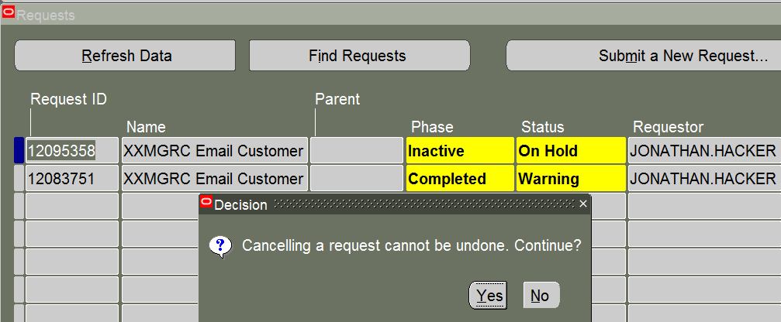

Cancel the scheduled job

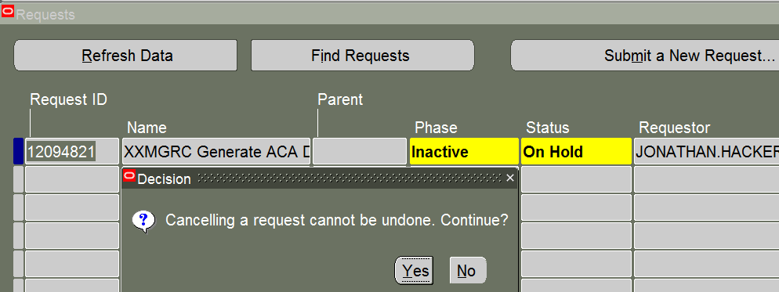

Cancel Below mentioned programs:

1. **XXMGRC Generate ACA LOA File and SFTP**
2. **XXMGRC Generate ACA Demographic and ACA History Files and SFTP%**

# ##Post clone script end

# Drop/Recreate Subscription Events

1. Check if the subscriptions exists:

SELECT TO_CHAR (rule), q.* FROM DBA_QUEUE_SUBSCRIBERS q

WHERE QUEUE_NAME = 'WF_BPEL_Q';



1. Check if the licensed flag is set to ‘y’ for the events:

select * from wf_events where name like 'oracle.apps.xxmgrc.%';



If the above two queries do not return the data shown, contact me to assist with the next steps.

# Remove Holds on Concurrent Requests  —---Need to start from here.

After the refresh, the ITC team should have put all scheduled jobs on hold as part of their process.  After the instance is released to McGrath, we need to remove the hold on all concurrent requests where the requestor is SYSADMIN and CONC_IF.  For CONC_IF jobs if you do not see all of the ones listed in the next section, then they must be scheduled again.

# Scheduled CONC_IF Jobs

First, confirm that all these jobs are on hold.  If any of them are missing, schedule them as follows:

Once you confirm that they are all present, please release these CONC_IF jobs.

Please login with user: CONC_IF for the below.

**Responsibility:** Application Administrator

**Workflow Background Process**

Item Type: OM Order Line

Process Deferred: Yes

Process Timeout: Yes

Schedule: Periodically every 1 minute

**Workflow Background Process**

Item Type: OM Order Header

Process Deferred: Yes

Process Timeout: Yes

Schedule: Periodically every 1 minute

**Workflow Background Process**

Item Type: AR Credit Management Application Process

Process Deferred: Yes

Process Timeout: Yes

Schedule: Periodically every 1 minute

**Workflow Background Process**

Process Deferred: Yes

Process Timeout: Yes

Schedule: Periodically every 15 minute

**Workflow Background Process**

Process Deferred: Yes

Process Timeout: Yes

Process Stuck: Yes

Schedule: Periodically every 1 day, 2:00 PM CST

**Workflow Background Process**

Process Deferred: Yes

Process Timeout: Yes

Process Stuck: Yes

Schedule: Periodically every 1 day, 11:45 PM CST

**~~XXMGRC SOA Summarized Events~~**

~~SOA Event Type: SO~~

~~Schedule: Periodically every 1 minute~~

**Responsibility:** [MGRC Credit Manager](https://ebs-conv2.mgrc.com:443/OA_HTML/OA.jsp?OAFunc=OAHOMEPAGE&akRegionApplicationId=0&navRespId=50760&navRespAppId=222&navSecGrpId=0&transactionid=574153786&oapc=2&oas=4DODe-asQlAcylXFO6p7zA..)

**Initialize Credit Summaries Table**

Parameters: Database Lock: N

Schedule: Periodically every 30 minutes

# Changing Passwords for Users in SMGR2I/SMGR3I/SMGR5I ONLY

SMGR2I/SMGR3I EBS instance does not use single sign on.  However, some users have a profile option set at the user level to use SSO.  In order to change these passwords you need to do the following:

Look up Profile Option: **Applications SSO Login Types**

In SMGR2I/SMGR3I, this profile option should be set to ‘Local’ at the site level and blank at the user level for any user who’s password you cannot change and the password field is greyed out.

SEt the following profile options before running below two scripts

**Set the following Profile Options in EBS (SMGR2I/SMGR3I):**

Applications SSO Type: SSWA w/SSO

Applications SSO Login Types: Both  (set LOCAL to SMGR2I and SMGR3I)

Applications SSO Auto Link User: Enabled

Application SSO LDAP Synchronization: Disabled

**Note:** Do not reset password for Anna, Jonathan or Sandeep.Pawale in S2, S3 or S5 Instance.

First script sets everyone to local (/home/applmgr/clone_scripts) (repeat running the scripts)

Second script updates default password to welcome1.

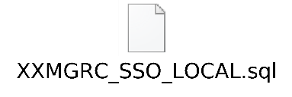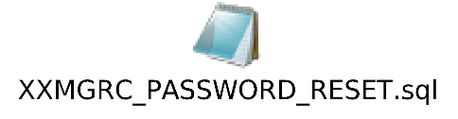

NOTE : run the above two script in order in case of SMGR2I,SMGR3I ONLY

# LDAP Wrapper Issue Fix

Sometimes you may get an error when trying to remove an end-date on a user account after a refresh or update responsibilities on a user account.  To work around this issue you need to log into the UNIX box using Powerbroker access.

Log into the application instance:

Example: pbrun impdba –u aptmgrci

Bash

From the command line type:

sqlplus apps/<apps> @$FND_TOP/patch/115/sql/fndssouu.sql <user name>;

Example:

sqlplus apps/<apps> @$FND_TOP/patch/115/sql/fndssouu.sql SCOTT.GORDON;

Once you run this script, you can add or remove end dates on a user record or on responsibilities for the given user.

sqlplus apps/D2cRG3mh @$FND_TOP/patch/115/sql/fndssouu.sql ERIN.PHILLIPS

sqlplus apps/D2cRG3mh @$FND_TOP/patch/115/sql/fndssouu.sql LORRA.LYTLE

sqlplus apps/D2cRG3mh @$FND_TOP/patch/115/sql/fndssouu.sql ROSALIE.RAMIREZ

sqlplus apps/D2cRG3mh @$FND_TOP/patch/115/sql/fndssouu.sql TILL.RICCI

sqlplus apps/D2cRG3mh @$FND_TOP/patch/115/sql/fndssouu.sql JENNIFER.WOO

sqlplus apps/D2cRG3mh @$FND_TOP/patch/115/sql/fndssouu.sql MARVIN.ALEJANDRINO

sqlplus apps/D2cRG3mh @$FND_TOP/patch/115/sql/fndssouu.sql NORA.DERAS

sqlplus apps/D2cRG3mh @$FND_TOP/patch/115/sql/fndssouu.sql AMY.BRUMBAUGH

sqlplus apps/D2cRG3mh @$FND_TOP/patch/115/sql/fndssouu.sql DAVE.WHITNEY

sqlplus apps/D2cRG3mh @$FND_TOP/patch/115/sql/fndssouu.sql ELIZABETH.CRADER

sqlplus apps/D2cRG3mh @$FND_TOP/patch/115/sql/fndssouu.sql FRAN.SCHETTLER

sqlplus apps/D2cRG3mh @$FND_TOP/patch/115/sql/fndssouu.sql RHONDA.CROUSE

sqlplus apps/D2cRG3mh @$FND_TOP/patch/115/sql/fndssouu.sql SANDI.DEEP

sqlplus apps/D2cRG3mh @$FND_TOP/patch/115/sql/fndssouu.sql SONJA.GONZALEZ

sqlplus apps/D2cRG3mh @$FND_TOP/patch/115/sql/fndssouu.sql TERESA.DEBAY

sqlplus apps/D2cRG3mh @$FND_TOP/patch/115/sql/fndssouu.sql SUSHEEL.PUPPALA

sqlplus apps/D2cRG3mh @$FND_TOP/patch/115/sql/fndssouu.sql TONI.PANIAGUA

# Add/open application Administrator Responsibility to following users.

Sandeep.pawale  (Also add the following addition responsibility for Sandeep.pawale)

* Functional Administrator
* MGRC Payment Setup Administrator
* Inventory Super User
* Funds Capture Setup Administrator
* Application Administrator

**Set the following Profile Options in EBS:**

Applications SSO Type: SSWA w/SSO

Applications SSO Login Types: Both  (set LOCAL to SMGR2I and SMGR3I)

[DEV] Application Authenticate Agent:  <https://ebsassertordev-oci.mgrc.com/ebs>

[TEST] Application Authenticate Agent: [https://ebsassertortst-oci.mgrc.com/](https://ebsassertortst-oci.mgrc.com/ebs)ebs-1

[DEV] Applications SSO Post Logout URL: https://ebs-dev-oci.mgrc.com/OA_HTML/AppsLocalLogin.jsp

[TEST] Applications SSO Post Logout URL: https://ebs-test-oci.mgrc.com/OA_HTML/AppsLocalLogin.jsp

Applications SSO Auto Link User: Enabled

Application SSO LDAP Synchronization: Disabled

**Following steps applicable to TMGRCI and DMGRCI only**

Change password of MCGRATHIDCS user using FNDCPASS to IDCSOracle@1234

Ensure APPL_SERVER_ID at $FND_SECURE at EBS is matching at [vlmgrcidcsap01n-wls-0.oci.mgrc.com](http://vlmgrcidcsap01n-wls-0.oci.mgrc.com/) for the following location

/u01/app/DEV/DMGRCI_VLMGRCIDCSAP01N_SERVER_1.dbc

/u01/app/TEST/TMGRCI_VLMGRCEBSAP02N_SERVER_1.dbc

Test data source on Weblogic

DEV

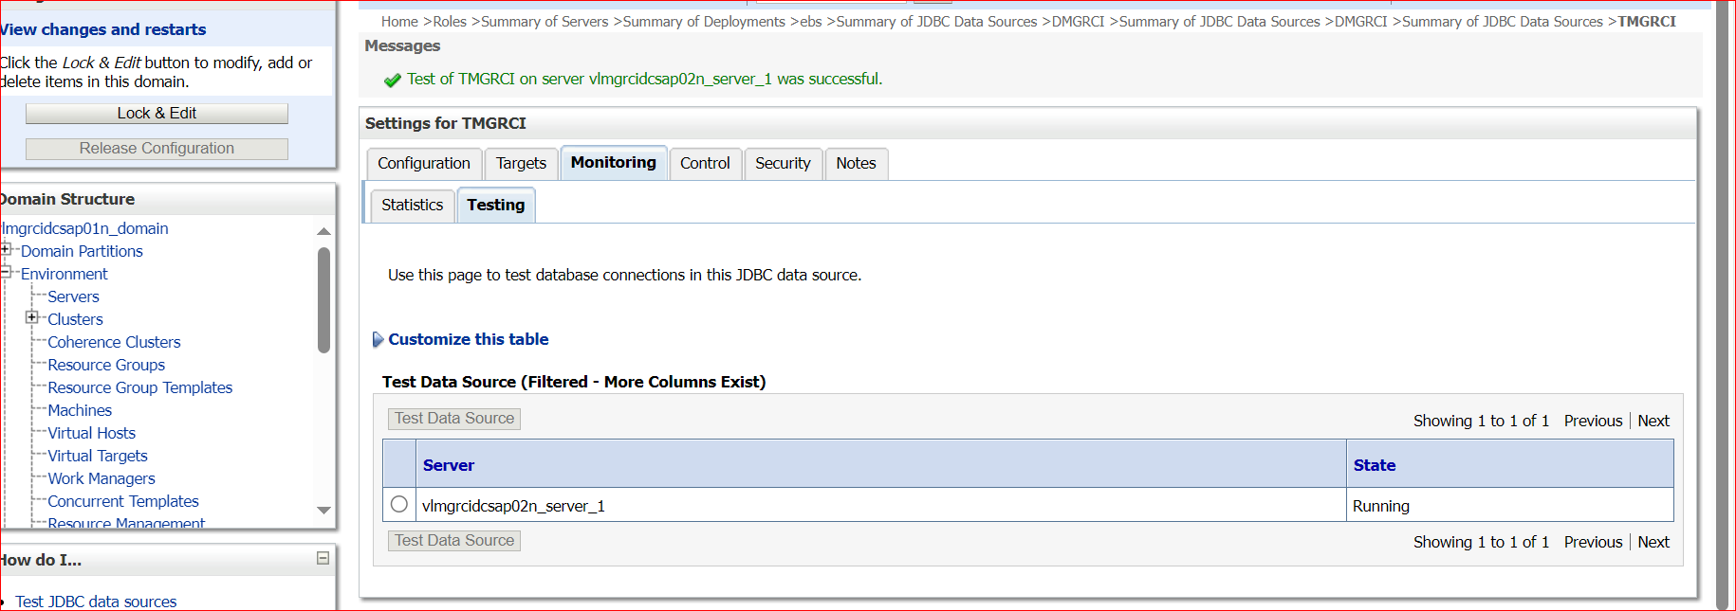

TEST  
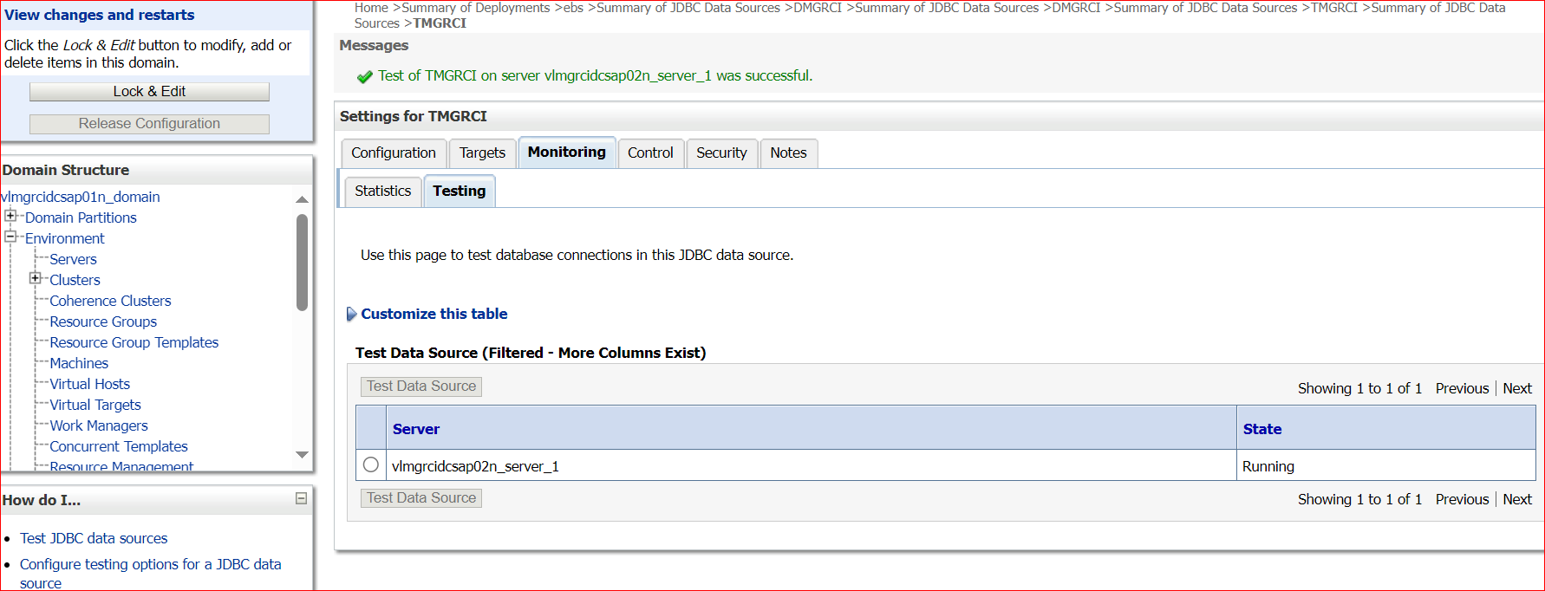

Bounce Managed server of IDSC

weblogic link

<http://10.240.193.231:7001/console>

[vlmgrcidcsap01n_server_1](http://10.240.193.231:7001/console/console.portal?_nfpb=true&DispatcherPortletperspective=configuration-page&_pageLabel=DispatcherPage&DispatcherPortlethandle=com.bea.console.handles.JMXHandle%28%22com.bea%3AName%3Dvlmgrcidcsap01n_server_1%2CType%3DServer%22%29) for managed server for TEST

[vlmgrcidcsap02n_server_1](http://10.240.193.231:7001/console/console.portal?_nfpb=true&DispatcherPortletperspective=configuration-page&_pageLabel=DispatcherPage&DispatcherPortlethandle=com.bea.console.handles.JMXHandle%28%22com.bea%3AName%3Dvlmgrcidcsap02n_server_1%2CType%3DServer%22%29) for managed server for DEV

VEE+A3)X*e/p6ng_

**Bounce the EBS Application Server:**

cd $ADMIN_SCRIPTS_HOME

./adstpall.sh apps/apps_pwd

./adstrtal.sh apps/apps_pwd

**NOTE :** make sure to have these profile options set.

[DEV] Application Authenticate Agent: <https://ebsassertordev-oci.mgrc.com/ebs>

[TEST] Application Authenticate Agent:[https://ebsassertortst-oci.mgrc.co](https://ebsassertortst-oci.mgrc.com/ebs)m/ebs-1

**END**

==================================================

# 20. set xml publisher temporary directory value

Login with sysadmin 🡪 go to Xml Publisher Administrator 🡪 Administration 🡪 +General 🡪 Temporary Directory to “<sid>/applcsf/tmp” For example “/dmgrci/applcsf/tmp”

# 21. Run "apex_post_refresh_cleanup.sql" to avoid sending Apex report subscriptions. Run the script based on the instance name. (/home/oracle/clone_scripts)

[applmgr@vlmgrcebsap01n REFRESH]$ pwd

/stage/REFRESH

[applmgr@vlmgrcebsap01n REFRESH]$ ls -ltr

total 42

drwxrwxr-x 2 applmgr dba 6 Jul 21 07:18 TMGRCI

drwxrwxr-x 2 applmgr dba 2 Jul 21 08:38 SMGR2I

-rwxrwxr-x 1 applmgr dba 5297 Aug 27 08:33 apex_post_refresh_cleanup.sql

drwxrwxr-x 2 applmgr dba 6 Sep 6 19:08 DATA_MASKING_SCRIPTS

-rwxrwxr-x 1 applmgr dba 1194 Sep 7 08:05 apex_post_refresh_cleanup_dmgrci.sql

-rwxrwxr-x 1 applmgr dba 1195 Sep 7 08:05 apex_post_refresh_cleanup_tmgrci.sql

-rwxrwxr-x 1 applmgr dba 1191 Sep 7 08:06 apex_post_refresh_cleanup_smgr2i.sql

-rwxrwxr-x 1 applmgr dba 1191 Sep 7 08:07 apex_post_refresh_cleanup_smgr3i.sql

# 22. drop the dblinks which are not required.

**Using obiee_accnt**

**DMGRCI**

**SQL>@/home/applmgr/clone_scripts/obiee_accnt_db_link_dmgrci.sql**

**TMGRCI/S2/S3**

**SQL>@/home/applmgr/clone_scripts/obiee_accnt_db_link_s2_s3_tmgrci.sql**

**Using bolinf user**

**S2/S3/DMGRCI**

**SQL>@/home/applmgr/clone_scripts/bolinf_db_link_s2_s3_tmgrci.sql**

**TMGRCI**

**SQL>@/home/applmgr/clone_scripts/bolinf_db_link_dmgrci.sql**

**Using apps user**

**S2**

**SQL>@/home/applmgr/clone_scripts/apps_star_dblink_s2.sql**

S3

SQL>@**/home/applmgr/clone_scripts/apps_star_dblink_s3.sql**

TMGRCI

SQL>@**/home/applmgr/clone_scripts/apps_star_dblink_tmgrci.sql**

DMGRCI

SQL>@**/home/applmgr/clone_scripts/apps_star_dblink_dmgrci.sql**

**using XX_FMWSOA user**

**SQL>@/home/applmgr/clone_scripts/XX_FMWSOA_drop_dblink.sql**

Connect to sys as sysdba

Alter session set container=TMGRCI; (SMGR2I,SMGR3I,DMGRCI)

SQL>@drop_publicdb_link.sql

# 23. Make sure the /interface/j_mgrc mounted in the database node.

oracle@vlmgrcebsdb01n:/interface/j_mgrc> pwd

/interface/j_mgrc

oracle@vlmgrcebsdb01n > ls -ltr

total 2

drwxrwxrwx 10 3003 3003 8 Aug 11 13:35 TMGRCI

drwxrwxrwx 10 root root 8 Aug 11 14:01 SMGR2I

drwxrwxrwx 10 root root 8 Aug 11 14:01 DMGRCI

drwxrwxrwx 10 root root 8 Aug 18 14:15 SMGR3I

# 24. Apex post cloning steps. Check the document

**“MGRC_Apex_Post_Clone_Steps_V1_JON.docx” . if you want to see the execution in SMGR2I, then you can refer this document “APEX_execution_SMGR2I_v2.doc”**

<https://drive.google.com/drive/folders/1FrYVF1f62yhBfmDJceDr2-E8DJKFWGRs>

apex related password are available in PASSWORD state for all instances.

**Following steps are from above link.**

===================================================

**START**

oracle@vlmgrcebsdb04n:/home/oracle/clone/APXTEST_BKP> sqlplus '/as sysdba'

 SQL*Plus: Release 12.1.0.2.0 Production on Mon Oct 5 00:46:04 2020

 Copyright (c) 1982, 2014, Oracle.  All rights reserved.

 Connected to:

Oracle Database 12c Enterprise Edition Release 12.1.0.2.0 - 64bit Production

With the Real Application Clusters, Automatic Storage Management and Real Application Testing options

 SQL> show pdbs

    CON_ID CON_NAME                       OPEN MODE  RESTRICTED

---------- ------------------------------ ---------- ----------

         2 PDB$SEED                       READ ONLY  NO

         3 TMGRCI                         READ WRITE NO

SQL> alter session set container= TMGRCI; (DMGRCI,SMGR2I,SMGR3I)

Session altered.

SQL>@/home/oracle/clone_scripts/apxtest_ts_creation.sql

if you face “ORA-28361: master key not yet set” Erorr  
Fix : ADMINISTER KEY MANAGEMENT SET KEY USING TAG 'rotate_key' FORCE KEYSTORE IDENTIFIED BY "8qbWT2NKRtAf_XzxzO#2" WITH BACKUP USING 'backup_key';

 SQL> select username from dba_users where username like 'APX%';

 USERNAME

--------------------------------------------------------------------------------

APXPROD_IAU_VIEWER

APXPROD_IAU_APPEND

APXPROD_WLS

APXPROD_IAU

APXPROD_STB

APXPROD_OPSS

APXPROD_MDS

APXPROD_WLS_RUNTIME

APXPROD_UMS

9 rows selected.

SQL> select username from dba_users where username like 'APEX%';

USERNAME

--------------------------------------------------------------------------------

APEX_REST_PUBLIC_USER

APEX_050100

APEX_INSTANCE_ADMIN_USER

APEX_PUBLIC_USER

APEX_LISTENER

APEX_040200

APEX_HCM

7 rows selected.

 SQL> select TABLESPACE_NAME,STATUS from dba_tablespaces where TABLESPACE_NAME='APXTEST_IAU';

 TABLESPACE_NAME                STATUS

------------------------------ ---------

APXTEST_IAU                  ONLINE

 SQL> select TABLESPACE_NAME,STATUS from dba_tablespaces where TABLESPACE_NAME like 'APXTEST%';

TABLESPACE_NAME                STATUS

------------------------------ ---------

APXTEST_IAS_OPSS             ONLINE

APXTEST_IAS_TEMP             ONLINE

APXTEST_IAS_UMS              ONLINE

APXTEST_IAU                  ONLINE

APXTEST_MDS                  ONLINE

APXTEST_STB                  ONLINE

APXTEST_WLS                  ONLINE

7 rows selected.

SQL> select USERNAME,ACCOUNT_STATUS,DEFAULT_TABLESPACE,TEMPORARY_TABLESPACE from dba_users where username like 'APXTEST%';

 no rows selected

 SQL> create or replace directory APXTEST_DIR as '/home/oracle/clone/APXTEST_BKP';

 oracle@vlmgrcebsdb04n:/home/oracle/clone/APXTEST_BKP> pwd

/home/oracle/clone/APXTEST_BKP

oracle@vlmgrcebsdb04n:/home/oracle/clone/APXTEST_BKP> ls -ltr

total 36132

-rw-r----- 1 oracle oinstall 15351808 Sep  3 06:28 expdp_APXTEST_Schema.dmp_old

-rw-r--r-- 1 oracle asmadmin      644 Sep  3 06:31 impdp_APXTEST_Schema.log_old

-rw-r--r-- 1 oracle oinstall  4054561 Sep  3 06:55 29AUG2020.zip

drwxr-xr-x 2 oracle oinstall     4096 Sep  3 06:56 29AUG2020

-rw-r--r-- 1 oracle oinstall      249 Sep  3 06:59 APXTEST_Schema_imp.par_old

-rw-r--r-- 1 oracle asmadmin    46763 Sep  3 07:02 import_TEST_RCU_SCHEMAS_29AUG2020.log_old

-rw-r----- 1 oracle oinstall   163840 Sep 26 19:31 expdp_TEST_RCU_SCHEMAS_26SEP2020_04.dmp

-rw-r----- 1 oracle oinstall 12005376 Sep 26 19:31 expdp_TEST_RCU_SCHEMAS_26SEP2020_03.dmp

-rw-r----- 1 oracle oinstall  1392640 Sep 26 19:31 expdp_TEST_RCU_SCHEMAS_26SEP2020_02.dmp

-rw-r----- 1 oracle oinstall  1564672 Sep 26 19:31 expdp_TEST_RCU_SCHEMAS_26SEP2020_01.dmp

-rw-r--r-- 1 oracle oinstall    27653 Sep 26 19:31 expdp_TEST_RCU_SCHEMAS_26SEP2020.log

-rw-r--r-- 1 oracle oinstall  1976255 Sep 26 19:32 26SEP2020.zip

-rw-r--r-- 1 oracle oinstall      249 Oct  5 00:29 APXTEST_Schema_imp.par

drwxr-xr-x 2 oracle oinstall     4096 Oct  5 00:33 26SEP2020

-rw-r--r-- 1 oracle asmadmin   357695 Oct  5 00:36 import_TEST_RCU_SCHEMAS_29SEP2020.log_err

-rw-r--r-- 1 oracle asmadmin    25828 Oct  5 01:08 import_TEST_RCU_SCHEMAS_29SEP2020.log

oracle@vlmgrcebsdb02n:/home/oracle/clone/APXTEST_BKP> impdp system/D2cRG3mh123#_1@TMGRCI parfile=APXTEST_Schema_imp.par

 Import: Release 12.1.0.2.0 - Production on Sat May 1 04:38:52 2021

 Copyright (c) 1982, 2014, Oracle and/or its affiliates.  All rights reserved.

 Connected to: Oracle Database 12c Enterprise Edition Release 12.1.0.2.0 - 64bit Production

With the Real Application Clusters, Automatic Storage Management, OLAP and Real Application Testing options

Master table "SYSTEM"."SYS_IMPORT_SCHEMA_01" successfully loaded/unloaded

Starting "SYSTEM"."SYS_IMPORT_SCHEMA_01":  system/********@TMGRCI parfile=APXTEST_Schema_imp.par

Processing object type SCHEMA_EXPORT/USER

Processing object type SCHEMA_EXPORT/SYSTEM_GRANT

Processing object type SCHEMA_EXPORT/ROLE_GRANT

Processing object type SCHEMA_EXPORT/DEFAULT_ROLE

Processing object type SCHEMA_EXPORT/TABLESPACE_QUOTA

Processing object type SCHEMA_EXPORT/PRE_SCHEMA/PROCACT_SCHEMA

Processing object type SCHEMA_EXPORT/SYNONYM/SYNONYM

Processing object type SCHEMA_EXPORT/TYPE/TYPE_SPEC

Processing object type SCHEMA_EXPORT/SEQUENCE/SEQUENCE

Processing object type SCHEMA_EXPORT/TABLE/TABLE

Processing object type SCHEMA_EXPORT/TABLE/TABLE_DATA

. . imported "APXTEST_OPSS"."JPS_ATTRS"                  1.335 MB   20448 rows

.

.

.

.

. . imported "APXTEST_OPSS"."SEQUENCE"                   5.554 KB       3 rows

. . imported "APXTEST_UMS"."UCP_MEDIA_TYPE"              5.570 KB       2 rows

. . imported "APXTEST_WLS"."BEACSS_SCHEMA_VERSION"       5.085 KB       1 rows

Processing object type SCHEMA_EXPORT/TABLE/GRANT/OWNER_GRANT/OBJECT_GRANT

Processing object type SCHEMA_EXPORT/TABLE/COMMENT

Processing object type SCHEMA_EXPORT/PACKAGE/PACKAGE_SPEC

Processing object type SCHEMA_EXPORT/PACKAGE/COMPILE_PACKAGE/PACKAGE_SPEC/ALTER_PACKAGE_SPEC

Processing object type SCHEMA_EXPORT/VIEW/VIEW

Processing object type SCHEMA_EXPORT/PACKAGE/PACKAGE_BODY

Processing object type SCHEMA_EXPORT/TABLE/INDEX/INDEX

Processing object type SCHEMA_EXPORT/TABLE/INDEX/FUNCTIONAL_INDEX/INDEX

Processing object type SCHEMA_EXPORT/TABLE/CONSTRAINT/CONSTRAINT

Processing object type SCHEMA_EXPORT/TABLE/INDEX/STATISTICS/INDEX_STATISTICS

Processing object type SCHEMA_EXPORT/TABLE/INDEX/STATISTICS/FUNCTIONAL_INDEX/INDEX_STATISTICS

Processing object type SCHEMA_EXPORT/TABLE/CONSTRAINT/REF_CONSTRAINT

Processing object type SCHEMA_EXPORT/TABLE/TRIGGER

Processing object type SCHEMA_EXPORT/TABLE/STATISTICS/TABLE_STATISTICS

Processing object type SCHEMA_EXPORT/STATISTICS/MARKER

Processing object type SCHEMA_EXPORT/TABLE/POST_TABLE_ACTION

Processing object type SCHEMA_EXPORT/TABLE/MATERIALIZED_VIEW_LOG

Processing object type SCHEMA_EXPORT/TABLE/POST_INSTANCE/PROCACT_INSTANCE

Processing object type SCHEMA_EXPORT/TABLE/POST_INSTANCE/PROCDEPOBJ

Processing object type SCHEMA_EXPORT/POST_SCHEMA/PROCACT_SCHEMA

Job "SYSTEM"."SYS_IMPORT_SCHEMA_01" successfully completed at Sat May 1 04:40:15 2021 elapsed 0 00:01:21

oracle@vlmgrcebsdb02n:/home/oracle/clone/APXTEST_BKP>

oracle@vlmgrcebsdb04n:/home/oracle/clone/APXTEST_BKP>

SQL> alter session set container=TMGRCI (replace with as per instance SMGR2I, DMGRCI, SMGR3I )

 SQL> col username format a25

SQL> set pages 500

SQL> set lines 500

SQL> select USERNAME,ACCOUNT_STATUS,DEFAULT_TABLESPACE,TEMPORARY_TABLESPACE from dba_users where username like 'APXTEST%';

 USERNAME        ACCOUNT_STATUS                   DEFAULT_TABLESPACE             TEMPORARY_TABLESPACE

--------------- -------------------------------- ------------------------------ ------------------------------

APXTEST_WLS   OPEN                             APXTEST_WLS                  APXTEST_IAS_TEMP

APXTEST_MDS   OPEN                             APXTEST_MDS                  APXTEST_IAS_TEMP

APXTEST_WLS_RUNTIME OPEN                             APXTEST_WLS                  APXTEST_IAS_TEMP

 APXTEST_OPSS  OPEN                             APXTEST_IAS_OPSS             APXTEST_IAS_TEMP

APXTEST_STB   OPEN                             APXTEST_STB                  APXTEST_IAS_TEMP

APXTEST_UMS   OPEN                             APXTEST_IAS_UMS              APXTEST_IAS_TEMP

APXTEST_IAU   OPEN                             APXTEST_IAU                  APXTEST_IAS_TEMP

7 rows selected.

SQL> select username from dba_users where username like 'APXTEST%';

 USERNAME

--------------------------------------------------------------------------------

APXTEST_WLS

APXTEST_STB

APXTEST_OPSS

APXTEST_MDS

APXTEST_WLS_RUNTIME

 APXTEST_IAU

APXTEST_UMS

 7 rows selected.

**Change password of apex users**

 SQL> alter session set container=TMGRCI ; (SMGR2I,SMGR3I,DMGRCI)

 SQL> @/home/oracle/clone_scripts/apx_password_change.sql

 -----------------------------------------------------------------------------

 oracle@vlmgrcebsdb04n:/stage/installers/apex/apex> ls -ltr apxchpwd.sql

-rw-r--r-- 1 oracle oinstall 3736 Nov 12  2015 .sql

 oracle@vlmgrcebsdb04n:/stage/installers/apex/apex> pwd

/stage/installers/apex/apex

 SQL> show pdbs

    CON_ID CON_NAME                       OPEN MODE  RESTRICTED

---------- ------------------------------ ---------- ----------

         2 PDB$SEED                       READ ONLY  NO

         3 TEST                         READ WRITE NO

SQL> alter session set container==TMGRCI ; (SMGR2I,SMGR3I,DMGRCI)

 Session altered.

SQL>

SQL> show con_name;

 CON_NAME

------------------------------

TMGRCI

SQL> @apxchpwd.sql

================================================================================

This script can be used to change the password of an Application Express

instance administrator. If the user does not yet exist, a user record will be

created.

================================================================================

Enter the administrator's username [ADMIN]

User "ADMIN" exists.

Enter ADMIN's email [ jonathan.hacker@mgrc.com]

Enter ADMIN's password []

Changed password of instance administrator ADMIN.

 SQL>

Now start the services

Type bounce_help to know the Apex bounce order and commands

oracle@vlmgrcebsdb04n:/home/oracle> bounce_help

  ALIAS COMMAND           START ORDER

---------------           --------------

startnm :            To start Nodemanager

tailnmlog:           To tail the Nodemanager startup log

startwl :            To start Admin Server

tailwllog:           To tail the Adminserver startup log

startms :            To start Managed Server

tailmslog:           To tail the Managed Server startup log

  ALIAS COMMAND           STOP ORDER

---------------           --------------

stopms :             To stop Managed Server

tailmslog:           To tail the Managed Server shutdown log

stopwl :             To stop Admin Server

tailwllog:           To tail the Adminserver shutdown log

stopnm :             To stop Nodemanager

tailnmlog:           To tail the Nodemanager shutdown log

###########################################################

oracle@vlmgrcebsdb04n:/home/oracle> startnm

[1] 24387

oracle@vlmgrcebsdb04n:/home/oracle> tailnmlog

oracle@vlmgrcebsdb04n:/home/oracle> startwl

[2] 24941

oracle@vlmgrcebsdb04n:/home/oracle> tailwllog

oracle@vlmgrcebsdb04n:/home/oracle> startms

oracle@vlmgrcebsdb04n:/home/oracle> tailmslog

ONCE ALL SERVICES STARTED GO THE BROWSER.

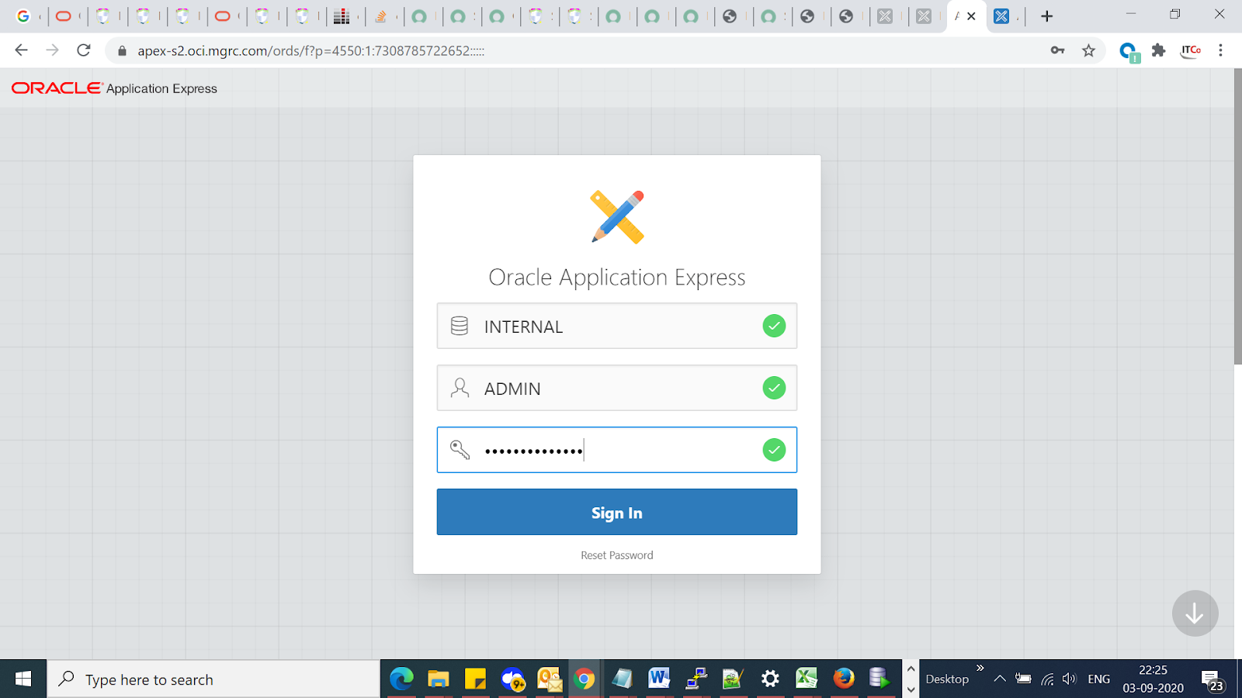

< Internal Workspace Admin: ************> you need to use this passwd in above screen to login for TEST

Now go to MANAGE WORKSPACES  🡪 Manage Developers and users

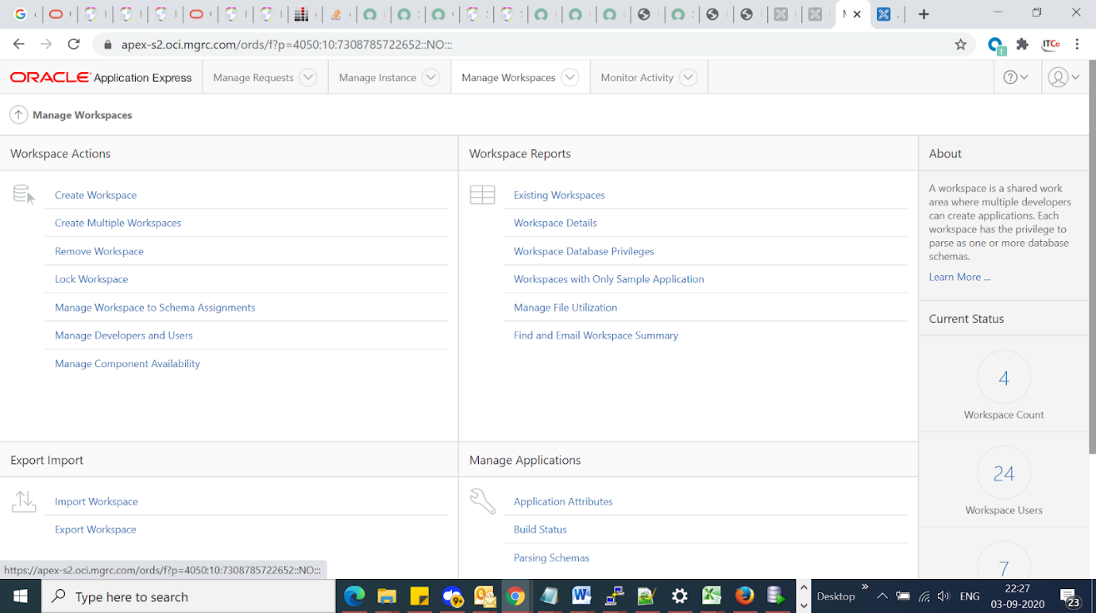

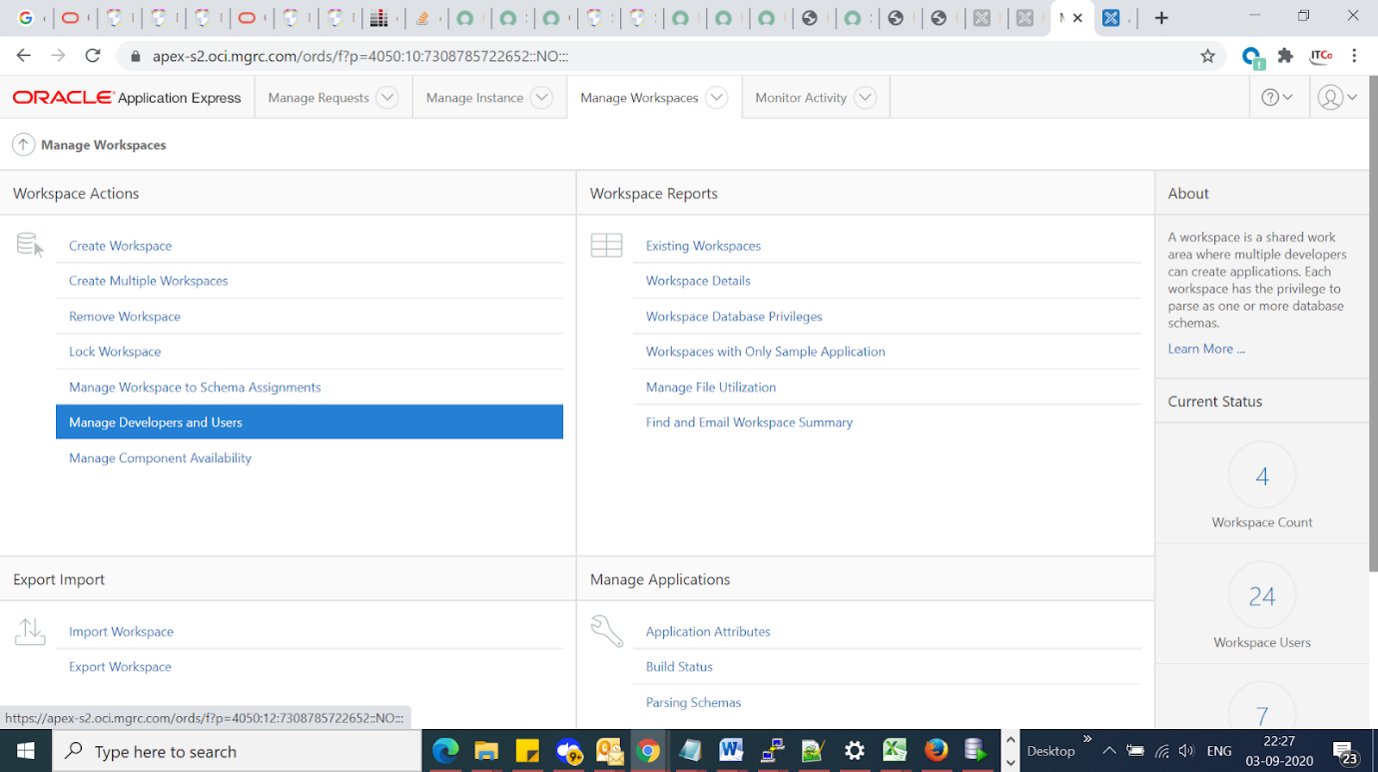

Click on ADMIN with Workspace XX_APEX

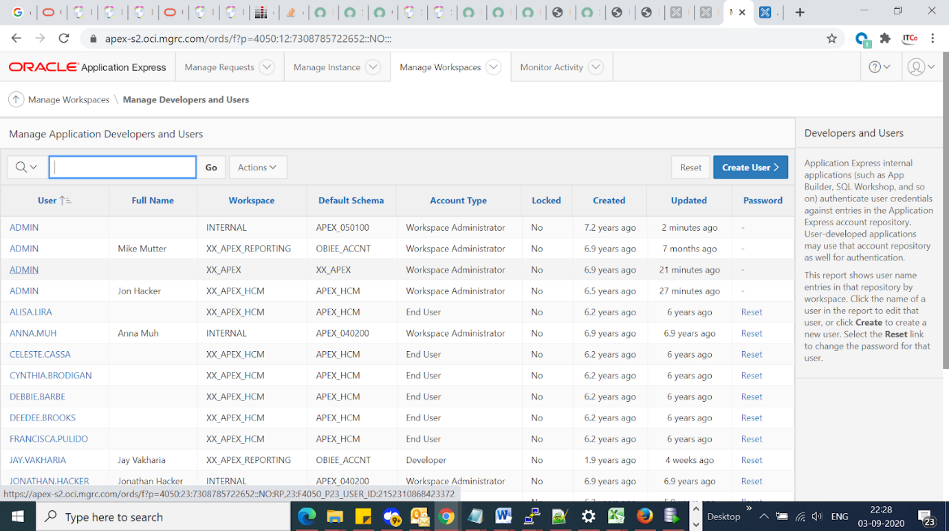

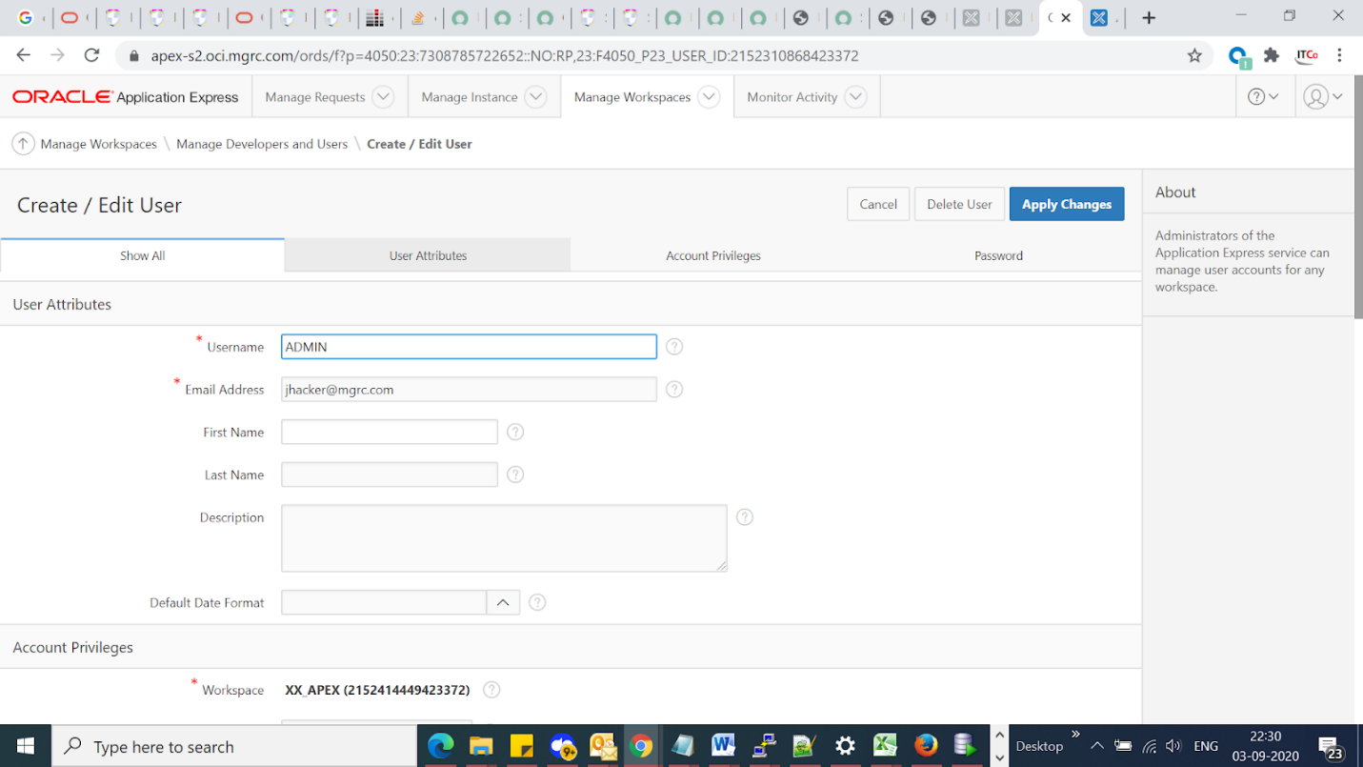

Update the password in password field (XX_APEX: ADMIN : S2teprD#$dp667)

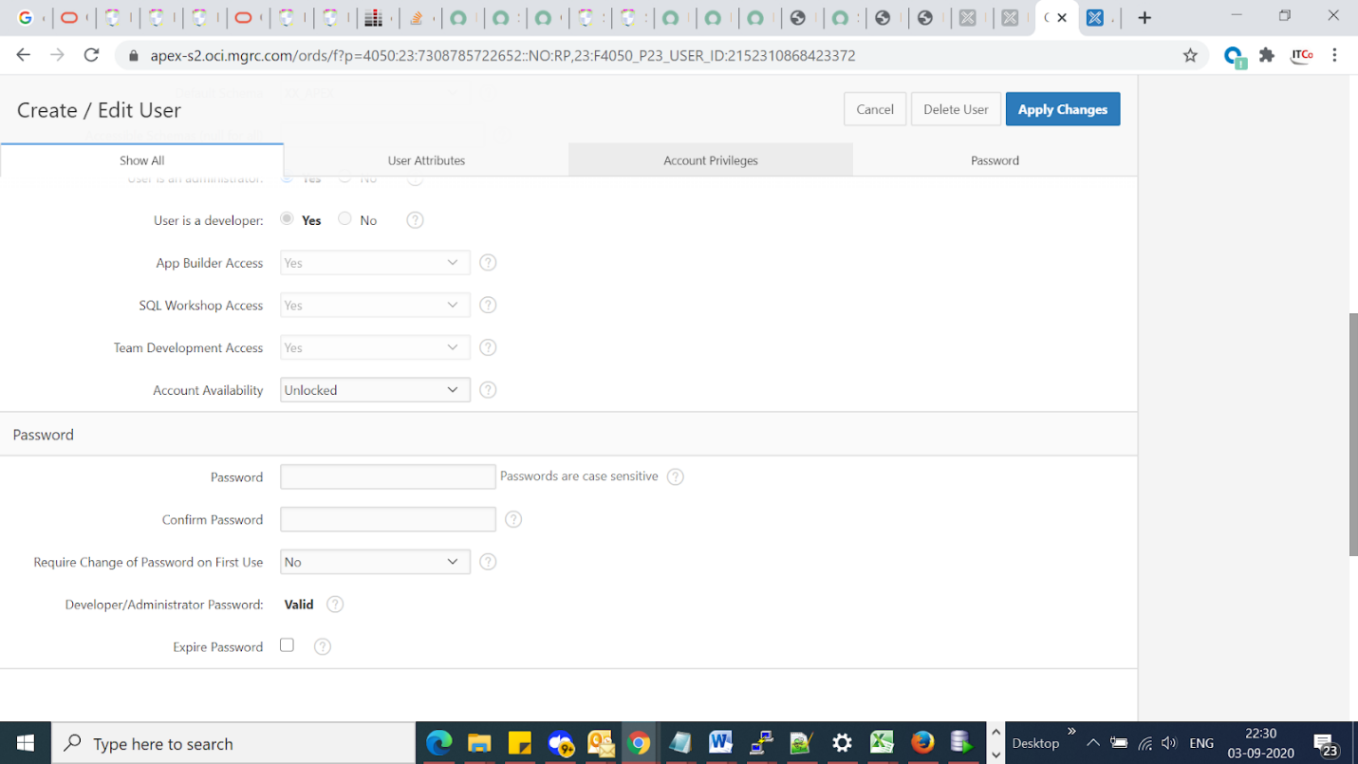

Same perform with XX_APEX_HCM workspace with ADMIN

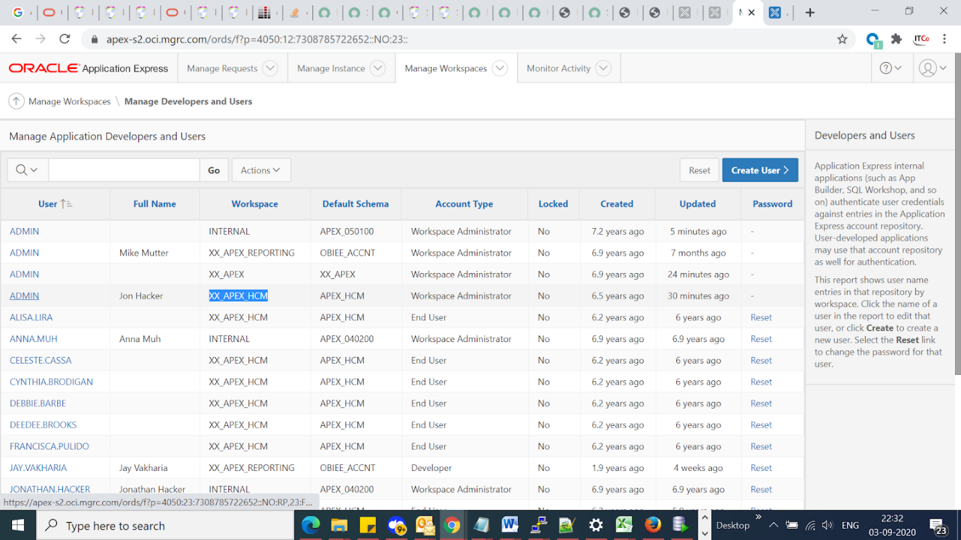

Now go to the ROCC url

<http://vlmgrcebsdb04n.oci.mgrc.com:7000/ords/f?p=105>

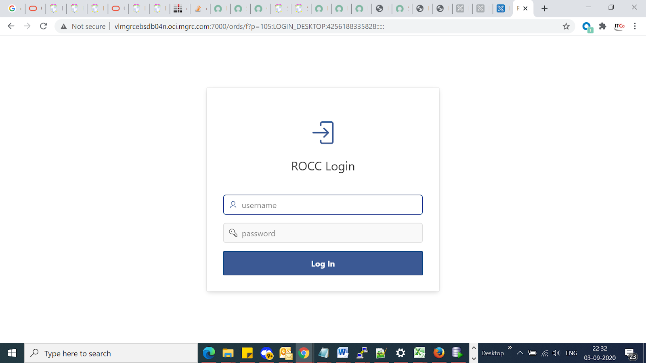

Make sure that above page landed along with BLUE color Login bar.

If you see not with BLUE color , you need to bounce the managed server from weblogic console and check.

IF YOU GET BELOW ERROR WHILE RESETTING WORKSPACE passwords for XX_APEX and XX_APEX_HCM.

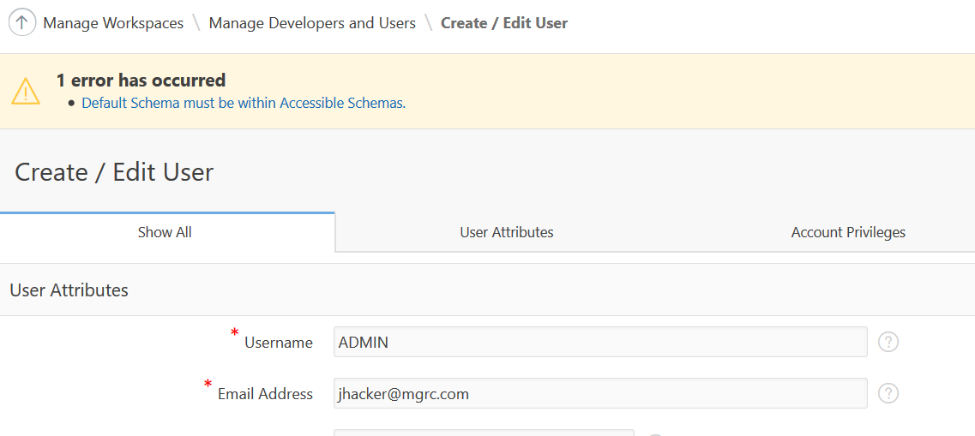

Reset the passwords as shown in the below screen.

Login as INTERNAL workspace and with ADMIN user and change the password for workspaces XX_APEX_HCM and XX_APEX

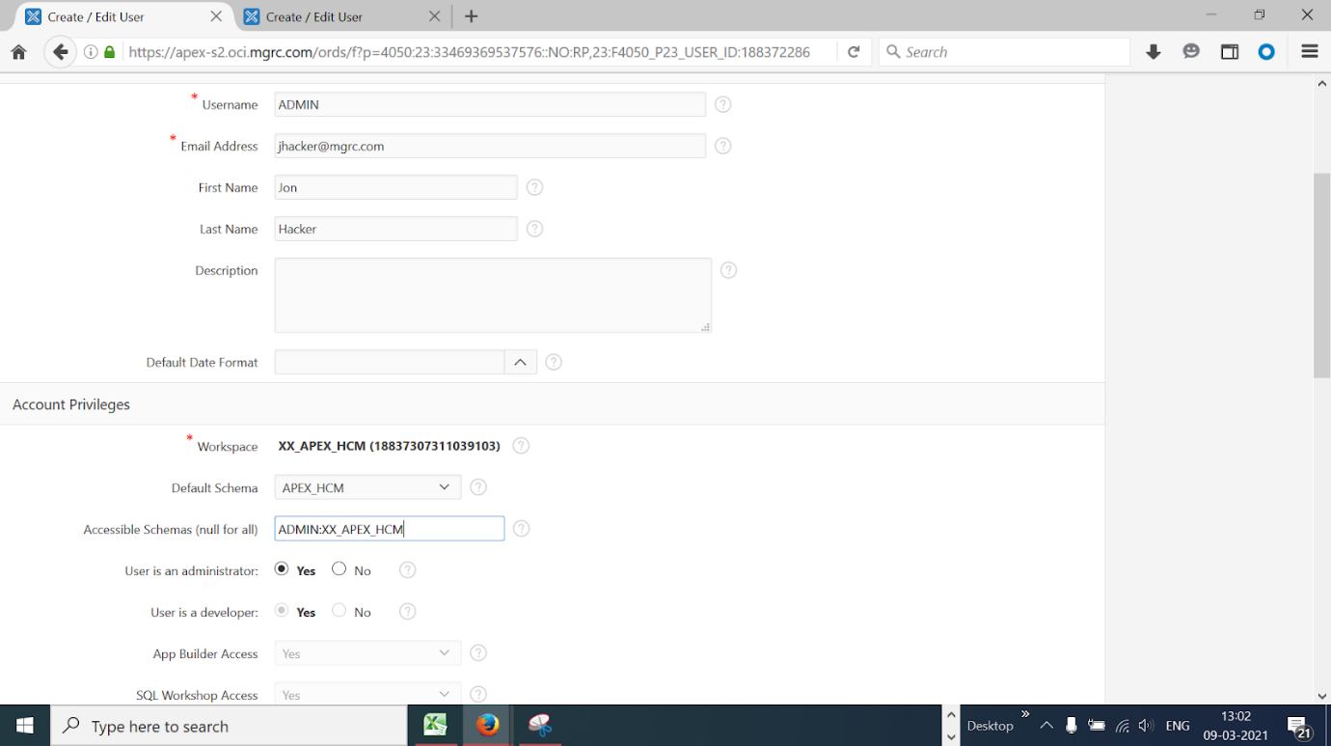

**END**

================================================

# ISSUE and fixes for Apex

**==============================**

Issue :

apex url issue in chrome browser after cloning.

NOTE :this is happening only in CHROME browser. other browsers work perfectly.

After some troubleshooting, we have used the below oracle doc and added and now we are able to access it on google chrome.

Could you also check from your side and let me know.

Solution

============

Added the below line on defaults.xml file under /u01/app/oracle/Middleware/apex/ords and bounce managed server.

<entry key="security.forceHTTPS">true</entry>

Oracle Doc

===============

403 Forbidden Error Accessing Apex Application with ORDS 3.0.4 or above Using Chrome: Resource Does Not Support Cross Origin Sharing Requests (Doc ID 2139195.1)

**Issue 2:**

While creating tablespace if we face ORA-28361: master key not yet set

Issue fix for APEX tablespace creation

=====================================

Connect to SYS user

SQL> alter session set container=dmgrci

SQL>ADMINISTER KEY MANAGEMENT SET KEY USING TAG '*****' FORCE KEYSTORE IDENTIFIED BY "**********" WITH BACKUP USING '******';





# 25. Markview post clone steps. Applicable to TMGRCI,DMGRCI ONLY.

***MarkView Setup Procedure after Clone (high level steps)***

1. Prior to refresh, shut down markview_server in Weblogic
2. Also shut down Capture and KTM VMs
3. Tar /documents directory from production
4. cd /pmgr2t/local/markview
5. nohup tar –cvzf /stage/vlmgrcmkvap01p_mkview/documents_<date>.tar.gz documents &
6. Now on the nonprod Markiew server vlmgrcmkvap02n.oci.mgrc.com
7. Remove the existing documents folder and untar the production documents.tar.gz

**Make sure u are on nonprod server and correct location**

1. cd /tmgr2t/local/markview ; nohup rm -r documents &

[oracle@vlmgrcmkvap02n markview]$ pwd

/tmgr2t/local/markview

nohup tar -xvzf /stage/vlmgrcmkvap01p_mkview/documents.tar.gz &

mv pmgr2t/local/markview/documents /tmgr2t/local/markview/

1. Generate SQL script and run in Markview schema to change pointers to refreshed instance
2. Drop and Recreate ACL for SSA Login and commit in the database (connect as SYSDBA user)
3. Update DB passwords for Markview and Advisor schemas

Log into DB non-prod server

sqlplus / as sysdba

ALTER USER MARKVIEW IDENTIFIED BY markview;

1. Startup markview_server in WebLogic console
2. Check deployments to make sure they are all active
3. Check datasources to make sure they are running
4. Bring up MarkView Home
5. For our Development environment, we have not been using SSA, so change the system value on the 'WEBCLNT_SEC_AUTH_TYPE' preference from 'CUSTOM' to 'ERP'
6. Update volume path from prod to non-prod (ex, tmgr2t)
7. Open all volumes - Dev, Test and Prod
8. Change URL for Message Name 'MVC_CUSTOM_BODY' to current instance
9. Change Preference XSS_FILTER_ENABLED_FOR_EXCEPTION_URL to FALSE at System Level
10. Change preference MVT_MAIL_FROM_NAME system value from 'MarkView' to 'MarkView - Dev' or 'MarkView - Test'
11. Change Preference MVAP_CONTROL_EMAIL_ADDRESS from 'Markview.Approver@mgrc.com' to 'Markview.Approver-DEV@mgrc.com'or 'Markview.Approver-TEST@mgrc.com'
12. Update Module Admin > Organizations > Global AP Settings

E-mail Address to receive system alerts - Change from 'APAdmin@mgrc.com' to 'APAdmin-DEV@mgrc.com' or 'APAdmin-TEST@mgrc.com'

E-mail Address to send system alerts from - Change from 'APKofax.NO-REPLY@mgrc.com' to 'APKofax.NO-REPLY-DEV@mgrc.com' or 'APKofax.NO-REPLY-TEST@mgrc.com'

1. Change password for ADMIN user in MarkView home to markview
2. Change the password for the MARKVIEW.USER in MarkView Home to markview - the password for the MARKVIEW.USER account has to match in EBS,

# *STEPS TO FOLLOW*

**TMGRCI : MarkView Console**

<http://vlmgrcmkvap02n.oci.mgrc.com:42501/console>

**TMGRCI : MarkView**

<http://vlmgrcmkvap02n.oci.mgrc.com:8001/markview/MVT_MV_Home.Home>

**DMGRCI : MarkView Console**

<http://vlmgrcmkvap01n.oci.mgrc.com:43701/console>

**DMGRCI : MarkView**

<http://vlmgrcmkvap01n.oci.mgrc.com:8001/markview/MVT_MV_Home.Home>

The Markiew Managed server should be down before proceeding, Usually Jonathan would stop it.

Login to Markview weblogic console and check the managed server is shutdown

Login to the DB node of TMGRCI or DMGRCI

oracle@vlmgrcebsdb02n:/home/oracle> sqlplus

SQL*Plus: Release 12.1.0.2.0 Production on Tue May 18 07:29:30 2021

Copyright (c) 1982, 2014, Oracle. All rights reserved.

Enter user-name: /as sysdba

Connected to:

Oracle Database 12c Enterprise Edition Release 12.1.0.2.0 - 64bit Production

With the Real Application Clusters, Automatic Storage Management, OLAP and Real Application Testing options

SQL> sho pdbs ;

CON_ID CON_NAME OPEN MODE RESTRICTED

---------- ------------------------------ ---------- ----------

2 PDB$SEED READ ONLY NO

3 TMGRCI READ WRITE NO

SQL> alter session set container=TMGRCI ;

Session altered.

SQL> alter user markview identified by markview ;

SQL> conn markview/markview@tmgrci

Connected.

SQL>

SQL> sho user

USER is "MARKVIEW"

@/home/oracle/markview_tmgrci_1.sql

NOTE : above scripts are available in location “/stage/REFRESH_DO_NOT_DELETE” for both DMGRCI and TMGRCI

oracle@vlmgrcebsdb02n:/home/oracle> sqlplus / as sysdba

SQL> alter session set container=TMGRCI;

SQL>@/home/oracle/markview_tmgrci_2.sql

Review for any errors and proceed further

Now restart the [markview_server](http://vlmgrcmkvap02n.oci.mgrc.com:42501/console/console.portal?_nfpb=true&DispatcherPortletperspective=configuration-page&_pageLabel=DispatcherPage&DispatcherPortlethandle=com.bea.console.handles.JMXHandle%28%22com.bea%3AName%3Dmarkview_server%2CType%3DServer%22%29) managed server from the Markview weblogic console:

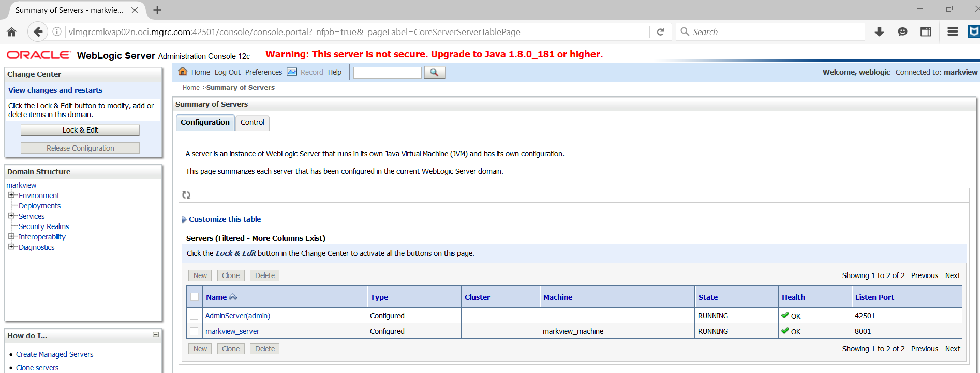

Go to Deployments and make sure the viewer is in Active state, else stop and start it

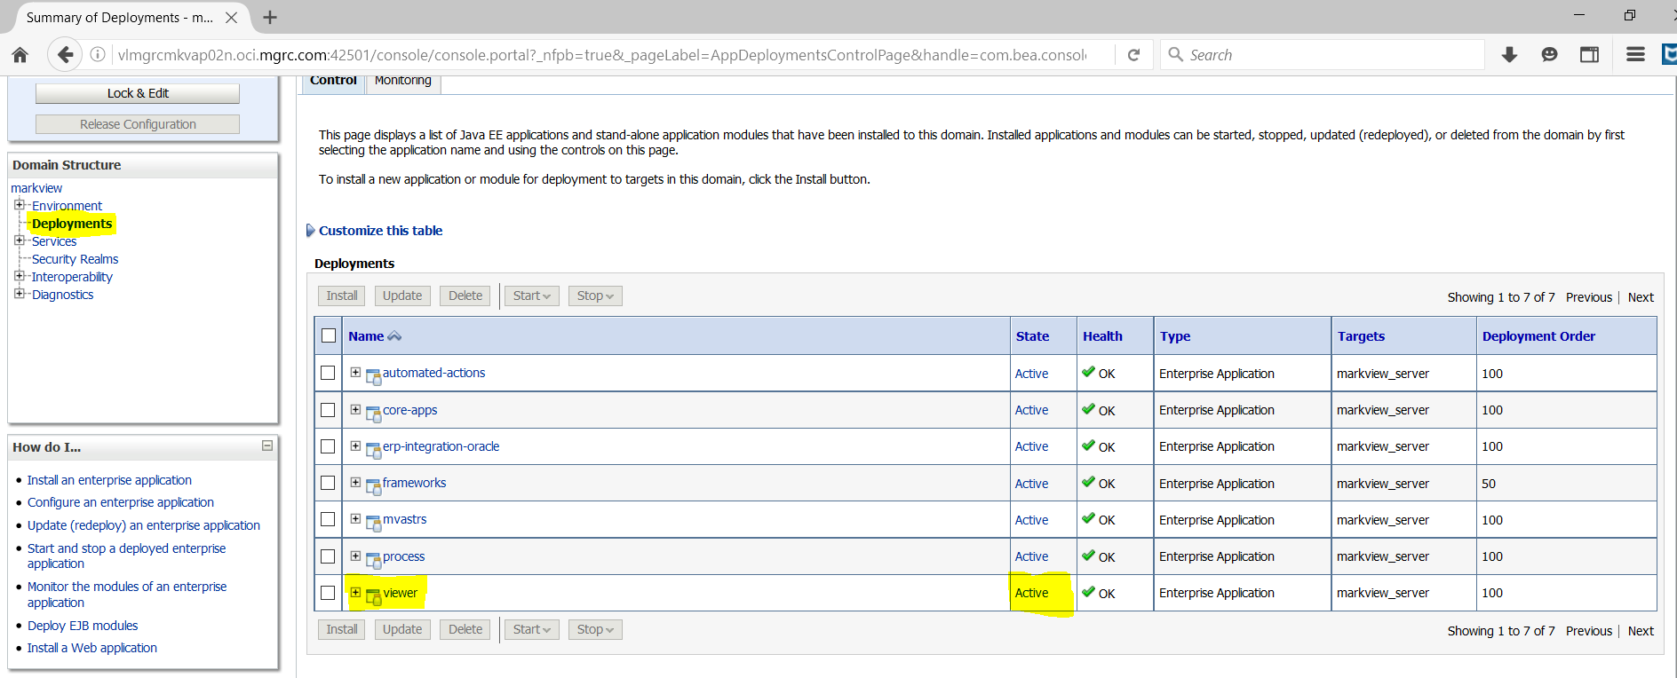

Go to Data sources and make sure the below data source is in running state

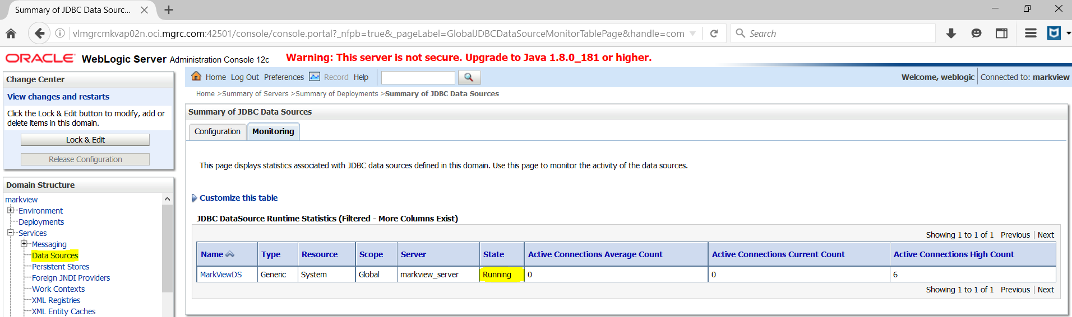

***Login to MARKVIEW Application (admin/markview17)***

<http://vlmgrcmkvap02n.oci.mgrc.com:8001/markview/MVT_MV_Home.Home>

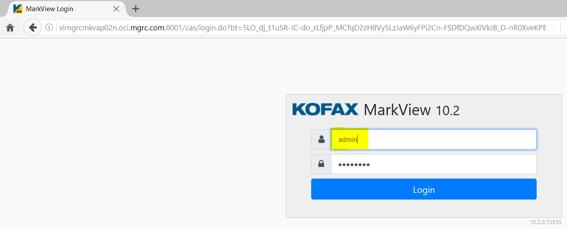

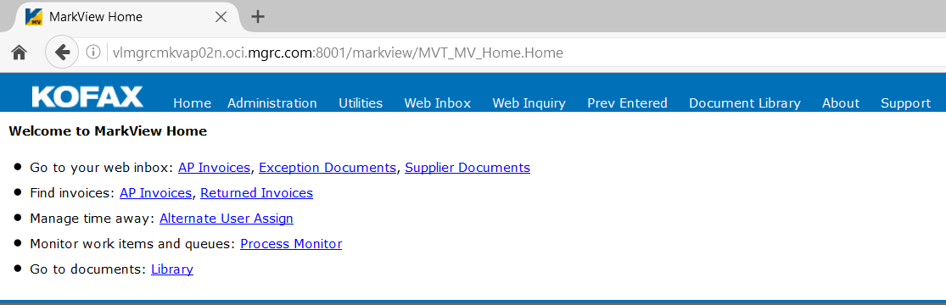

Click on Administration -> Markview Admin -> Preferences ( 3rd row 3rd tab)

Change the system value on the 'WEBCLNT_SEC_AUTH_TYPE' preference from 'CUSTOM' to 'ERP'

Search for WEBCLNT_SEC_AUTH_TYPE and click on Filter

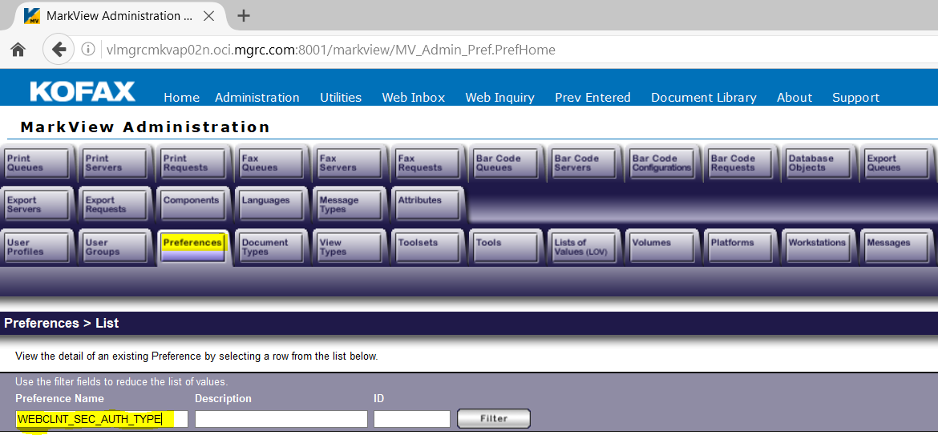

Click on Details ------ System Preferences Tab ------ Details ---

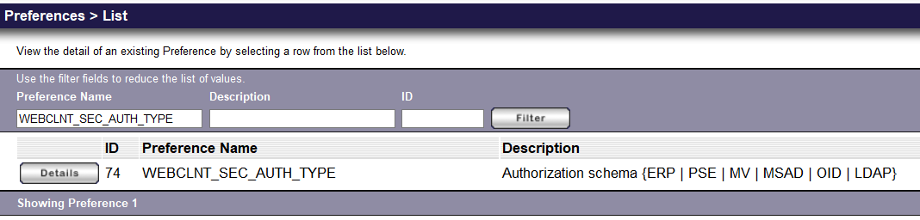

Change the Preference value from custom to ERP and save

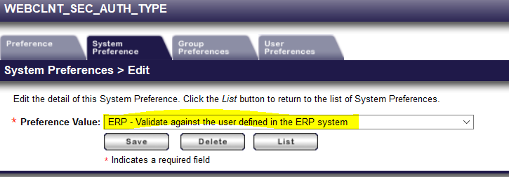

Now click on first tab preference tab and you should as below

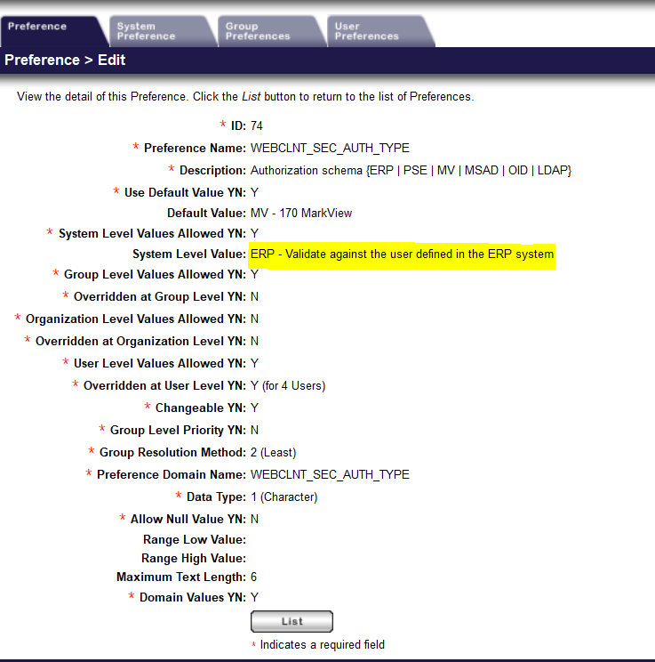

***Update volume path from prod to non-prod (ex, tmgr2t)***

Click on Administration -> Markview Admin -> Volumes (3rd row 9th tab)

***Click on Details for DEVELOPMENT Volume Name***

***Note: Either for DMGRCI or TMGRCI or for PROD PMGRCI, we set only for DEVELOPMENT Volume***

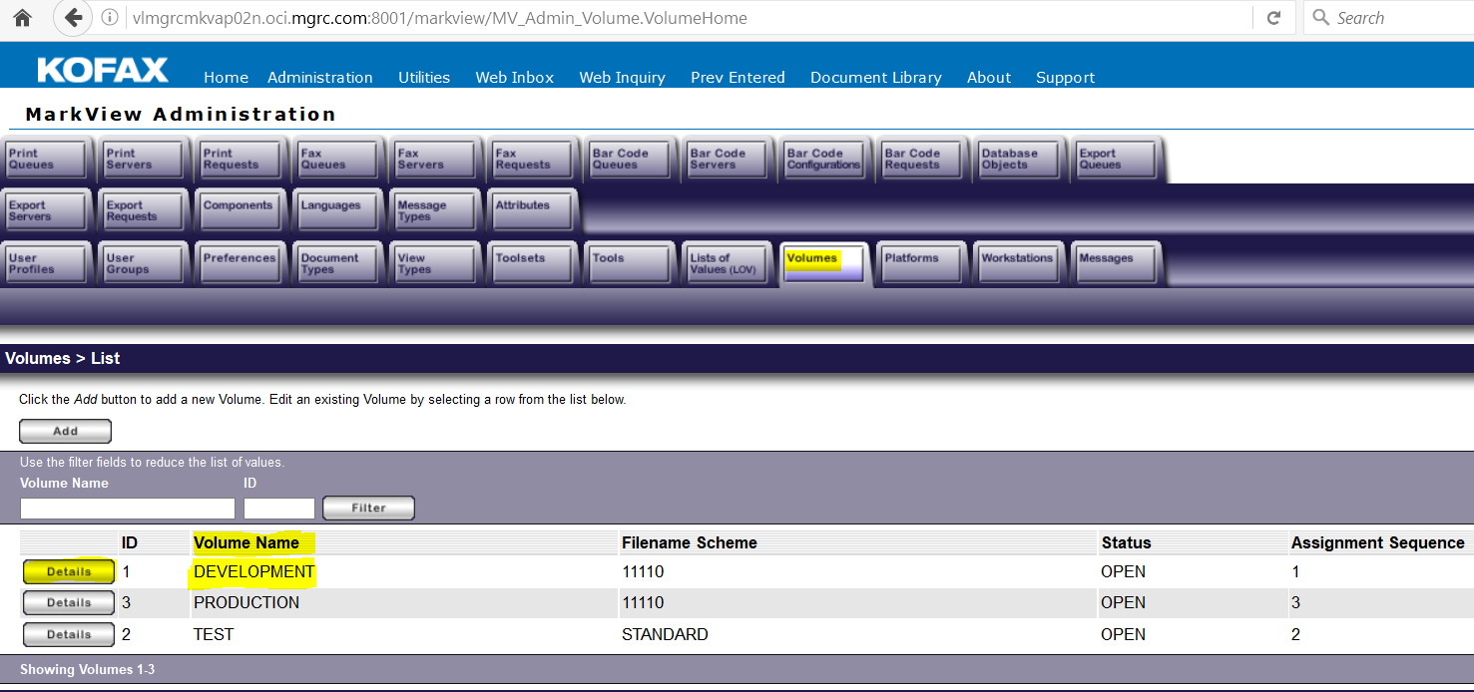

***Click on Volume Paths***

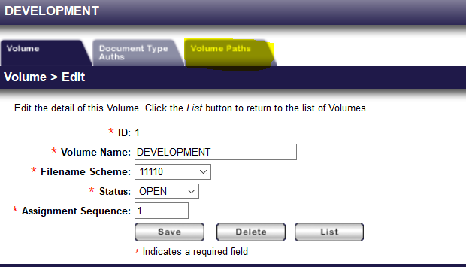

Click on Details for each row to update the url and path as per the target instance and save

Here we have updated for TMGRCI instance for Dev, the url and Path would be different

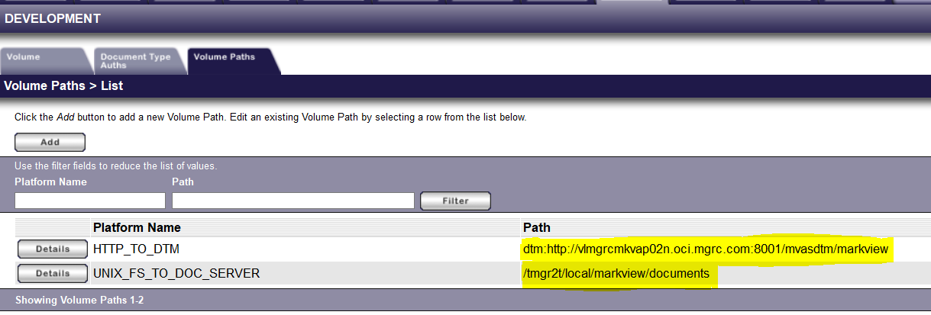

Click on Volumes – List

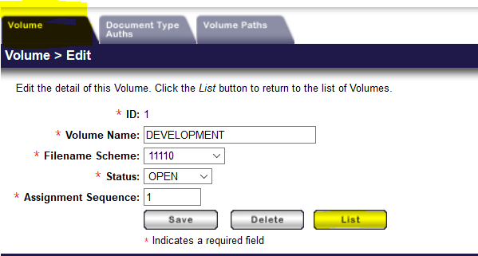

Make sure the STATUS is OPEN for ALL ,

Cick on details for each DEV, PROD and TEST and set the status to OPEN and SAVE

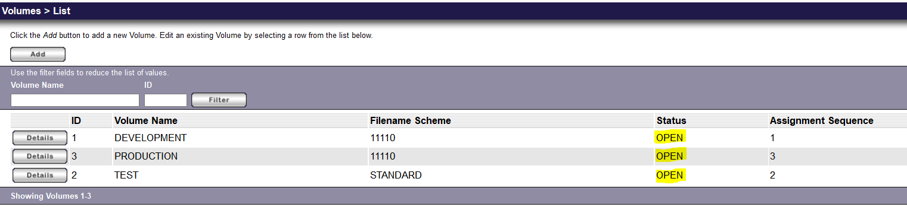

***Change URL for Message Name 'MVC_CUSTOM_BODY' to current instance***

Click on Administration -> Markview Admin -> Messages

Search for MVC_CUSTOM_BODY in the message name and click Filter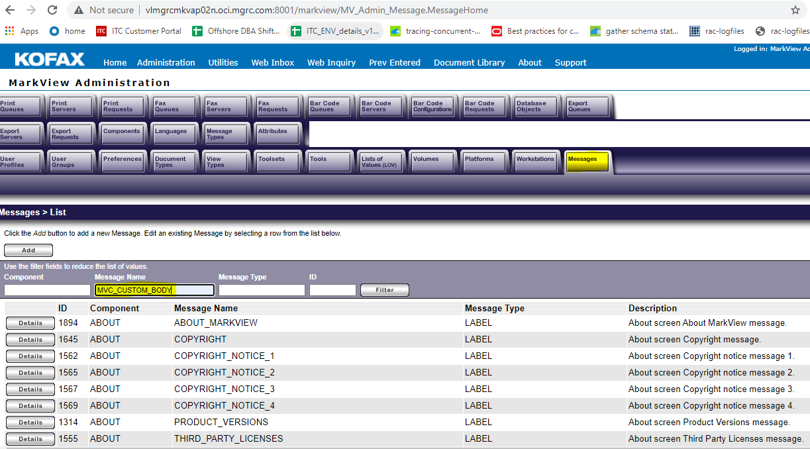

Click on Details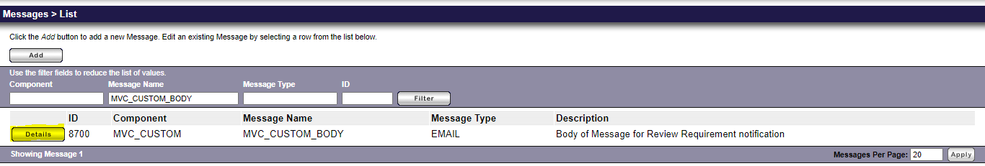

***Click on Message Text Translations and u see an url with production hostname***

***Click on details and update the hostname to target instance and save.***

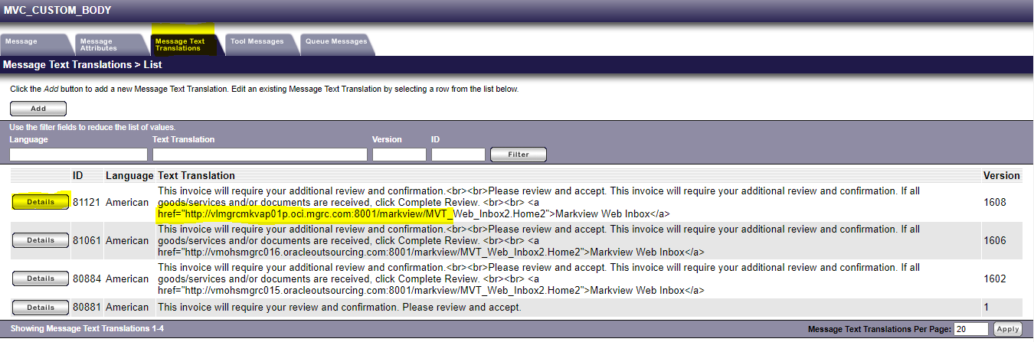

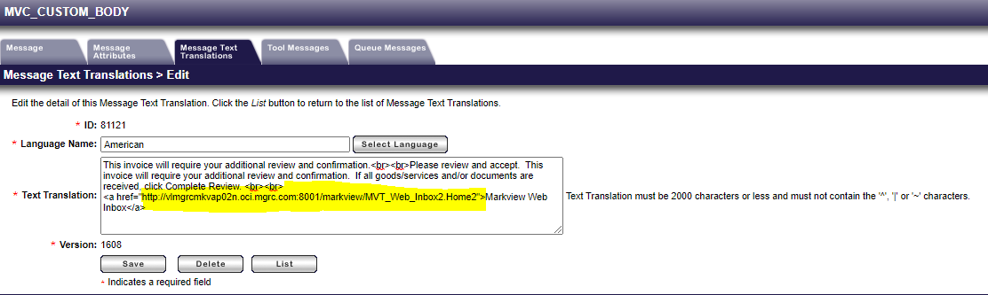

You would see the updated entry in the first row

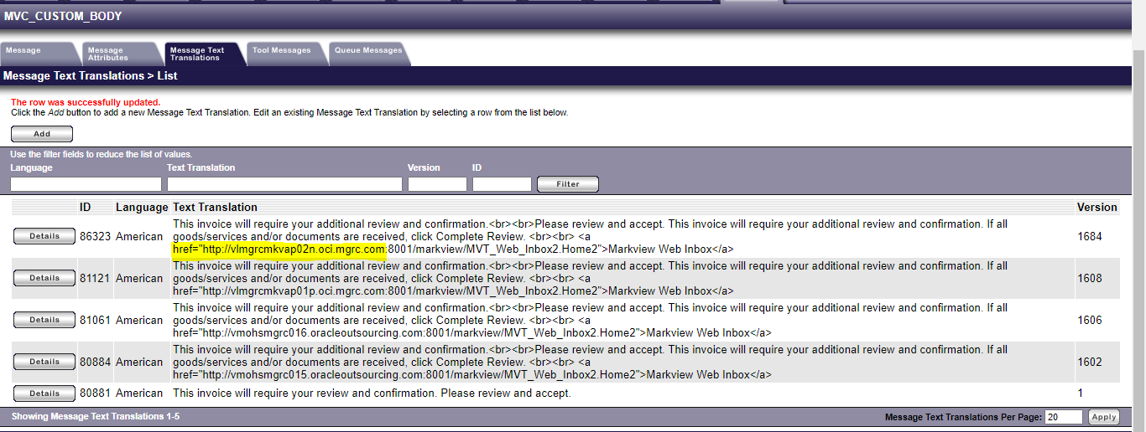

***Change Preference XSS_FILTER_ENABLED_FOR_EXCEPTION_URL to FALSE at System Level***

***This would be set False already as on production it is FALSE, we just need to verify.***

Click on Administration -> Markview Admin -> Preferences

Search for XSS_FILTER_ENABLED_FOR_EXCEPTION_URL and click filter

***You should see as false at the system level Value***

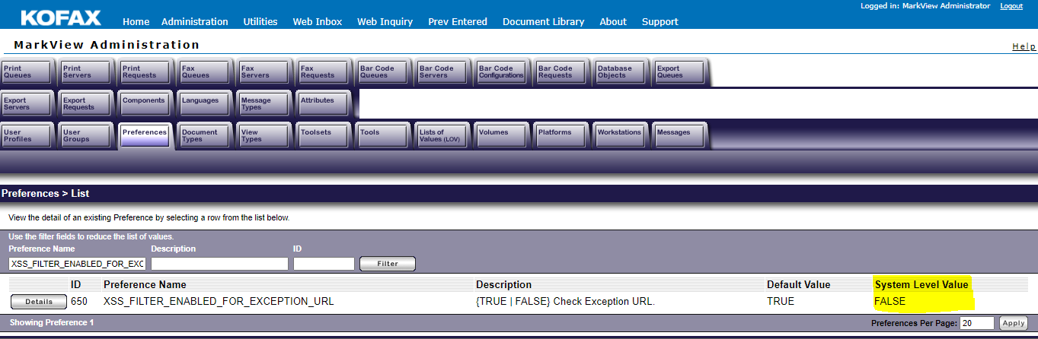

***Change preference MVT_MAIL_FROM_NAME system value from 'MarkView' to 'MarkView - Dev' or 'MarkView - Test'***

Click on Administration -> Markview Admin -> Preferences

***Search for MVT_MAIL_FROM_NAME***

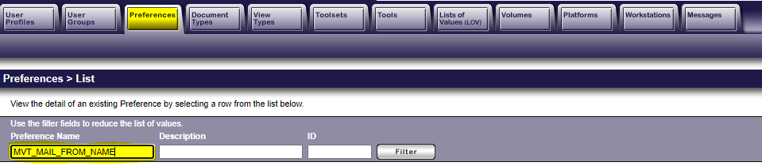

Click on Details -> System preferences->Details

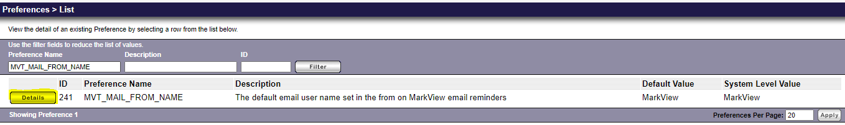

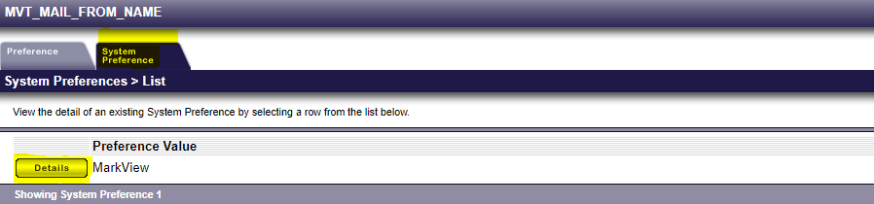

Update it to Markview – Test as below and click save

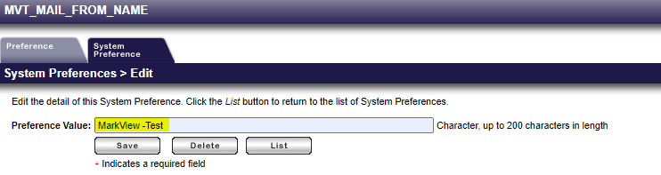

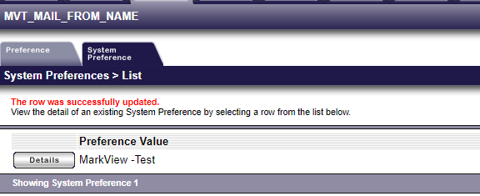

***Change Preference MVAP_CONTROL_EMAIL_ADDRESS from 'Markview.Approver@mgrc.com' to 'Markview.Approver-DEV@mgrc.com'or 'Markview.Approver-TEST@mgrc.com'***

Search for MVAP_CONTROL_EMAIL_ADDRESS -> Filter->Details -> System Preferences -> Details

Change it to [Markview.Approver-TEST@mgrc.com](mailto:Markview.Approver-TEST@mgrc.com) ***and save.***

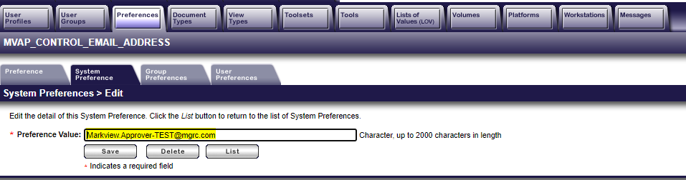

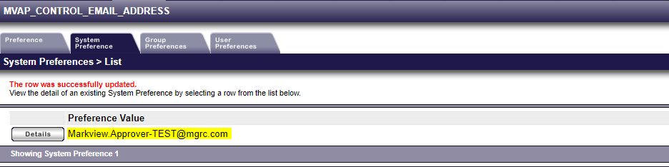

***Update Module Admin***

***Administration-> Module Admin > Organizations > Global Configurations -> AP Settings - > Update***

***E-mail Address to receive system alerts –***

***Change from 'APAdmin@mgrc.com' to 'APAdmin-DEV@mgrc.com' or 'APAdmin-TEST@mgrc.com'***

***E-mail Address to send system alerts from –***

***Change from 'APKofax.NO-REPLY@mgrc.com' to 'APKofax.NO-REPLY-DEV@mgrc.com' or 'APKofax.NO-REPLY-TEST@mgrc.com'***

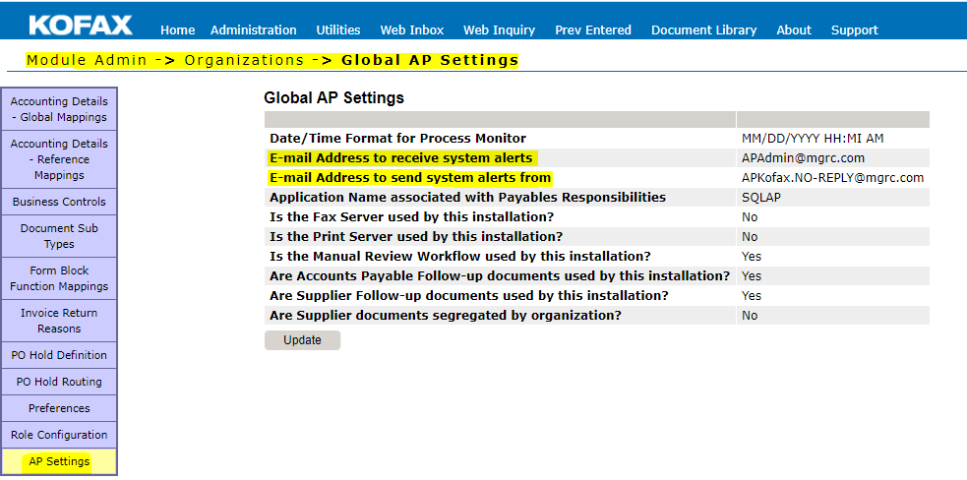

Updated values should as below as per the Target Instance

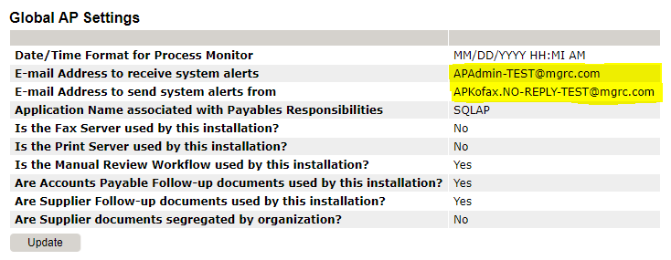

***Change password for ADMIN user and MARKVIEW.USER user to markview***

***Administration > MarkView Admin > User Profiles***

***Search for ADMIN -> Details -> Change Password Tab – update the password to markview and save***

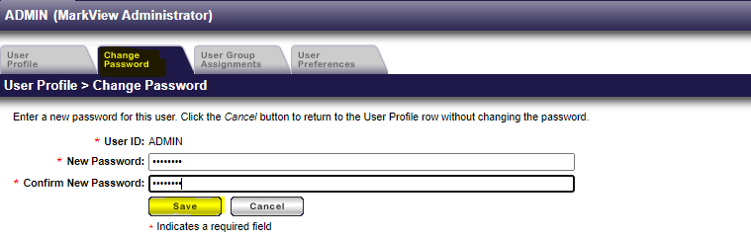

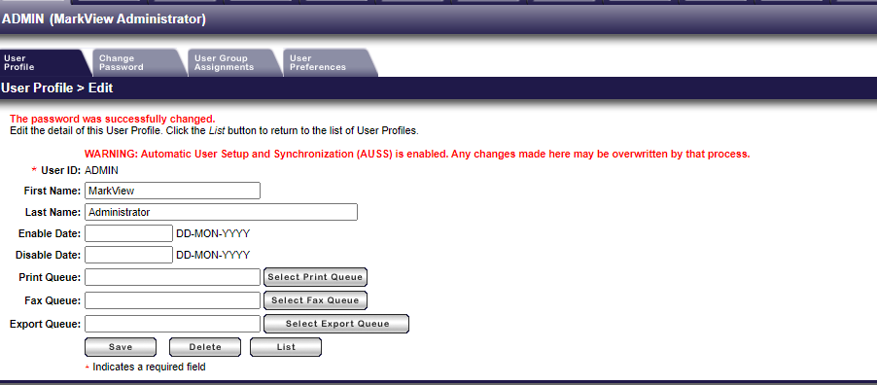

***Similarly change the password for MARKVIEW.USER to markview***

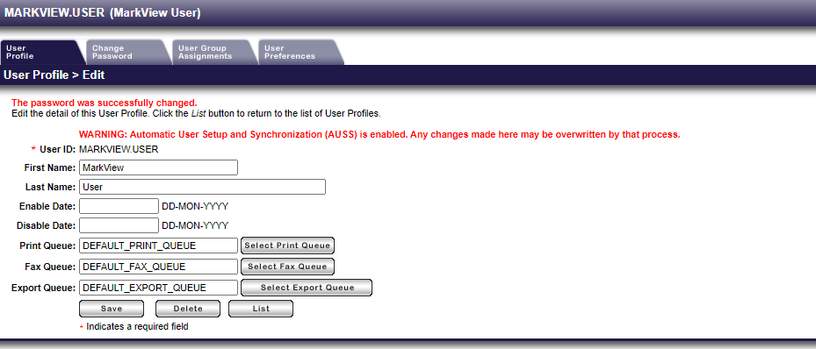

***Change the Password for MARKVIEW.USER to markview from EBS application.***

Login with sysadmin user , System Administrator – Security – User –Define query for MARKVIEW.USER

Set the password to some temporary password such as welcome1 or some other.

Now logout and try logging into EBS with MARKVIEW.USER with the above password.

It would force to change the password, now set it to markview

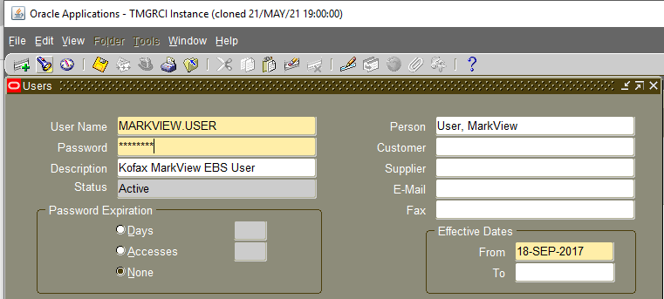

***Enter the new password and press tab , and re-enter the password and save.***

***Now login with the MARKVIEW.USER to EBS***

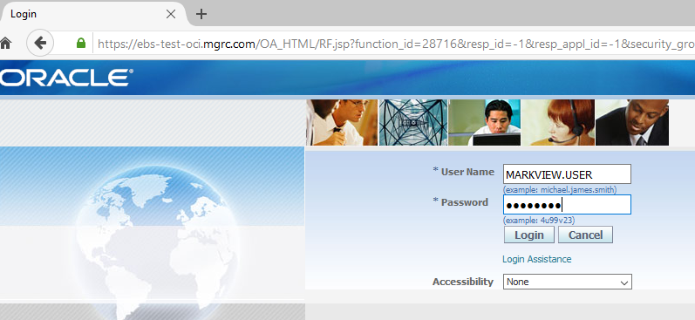

After u login , reset the password to markview and save

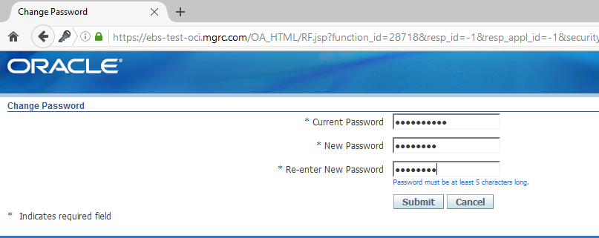

***After you save , try logging into EBS with MARKVIEW.USER with the new password set i.e markview***

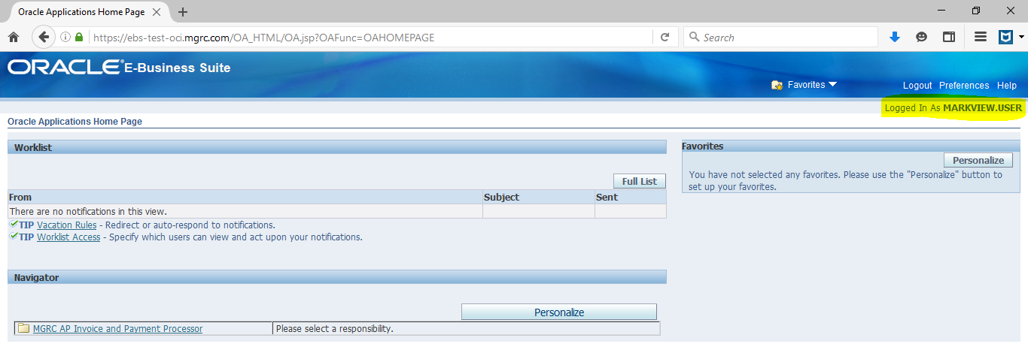

***This completes the Markview Setup***

# 26. Enable cronjobs which were disabled during database restore.

oracle@vlmgrcebsdb04n:/home/oracle> crontab -l

## Backup

47 17 * * 3 /stage/ProcedureLibrary/rman/rmancloud_backupol cmgebss 0 > /dev/null 2>&1

00 18 * * 0,1,2,4,5,6 /stage/ProcedureLibrary/rman/rmancloud_backupol cmgebss 1 c > /dev/null 2>&1

30 02,06,10,14,18,22 * * * /stage/ProcedureLibrary/rman/rmancloud_backuparch cmgebss > /dev/null 2>&1

####################RCU Schemas Backup###################

30 18 * * 6 /stage/RCU_SCHEMA_BACKUP/rcu_schema_backup.sh cmgebss > /stage/RCU_SCHEMA_BACKUP/logs/rcu_schema_backup_cmgebss.out 2>&1

oracle@vlmgrcebsdb04n:/home/oracle>

# 27. make sure to have the following entries in sqlnet.ora file to avoid Workflow Builder connectivity issues to the database.

oracle@vlmgrcebsdb01n:/u01/app/oracle/product/12.1.0.2/dbhome_1/network/admin> cat sqlnet.ora

ENCRYPTION_WALLET_LOCATION=(SOURCE=(METHOD=FILE)(METHOD_DATA=(DIRECTORY=/opt/oracle/dcs/commonstore/wallets/tde/$ORACLE_UNQNAME)))

SQLNET.ENCRYPTION_SERVER=ACCEPTED

SQLNET.CRYPTO_CHECKSUM_SERVER=REQUESTED

SQLNET.ENCRYPTION_TYPES_SERVER=(AES256, AES192, 3DES168, RC4_128, RC4_256, 3DES112)

SQLNET.CRYPTO_CHECKSUM_TYPES_SERVER=(SHA1,MD5)

SQLNET.ENCRYPTION_CLIENT=REQUESTED

SQLNET.CRYPTO_CHECKSUM_CLIENT=REQUESTED

SQLNET.ENCRYPTION_TYPES_CLIENT=(AES256, AES192, 3DES168, RC4_128, RC4_256, 3DES112)

SQLNET.CRYPTO_CHECKSUM_TYPES_CLIENT=(SHA1,MD5)

SQLNET.ALLOWED_LOGON_VERSION_SERVER = 8

SQLNET.ALLOWED_LOGON_VERSION_CLIENT = 8

#-- ldap

NAMES.DIRECTORY_PATH= (LDAP, TNSNAMES)

And bounce the grid/local listener once the above changes completed.

$>lsnrctl reload

# 28. Cancel OnDemand Gather Schema Statistics concurrent program which is running and reschedule it

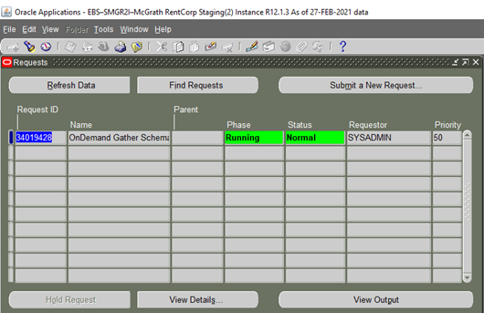

Concurrent request name : OnDemand Gather Schema Statistics

Parameters :

Analyze type : TABLES

Schemas : ALL

Estimate Percent : 40

Jobs:0

Parallelism Degree : 1

# 29. restore MWA configuration files backup taken in step 1.1 above.

default_key.ini

gui_key.ini

symbol.ini

mwa.cfg

After application clone is completed restore the above files in $INST_TOP/admin/install

# 30. send test notification email to jonathan.hacker and make sure that email shows SENT status in wf_notification table using below query.

SELECT name,display_name,notification_preference,email_address,orig_system FROM WF_LOCAL_ROLES WHERE name LIKE '&user_name';

select max(notification_id) from wf_notifications where message_type='WFTESTS' and message_name like 'OA%'

union

select max(notification_id) from wf_notifications where message_type='WFTESTS' and message_name like 'PL%';

to know the status of worklflow notifications

----------------------------------------------

select * from wf_notifications where notification_id in ('9169379','9169380');

select notification_id,message_type,recipient_role,mail_status,sent_date from wf_notifications where notification_id in ('&ID1','&ID2');

# 31. Please release the Cloned instance to the following people only from Mcgrath side

[jonathan.hacker@mgrc.com](mailto:jonathan.hacker@mgrc.com) ,[sandeep.pawale@jadeglobal.com](mailto:sandeep.pawale@jadeglobal.com)

Service name issue and bounce CM (make sure the the service name is like below) (this updated as part step 10. But we need to validate)

Validate the below value

SQL> SELECT UPPER(SYS_CONTEXT('userenv','service_name')) FROM DUAL;

UPPER(SYS_CONTEXT('USERENV','SERVICE_NAME'))

--------------------------------------------------------------------------------

SMGR2I

if the value above is EBS_SMGR2I (change it in tnsnames.ora **ifile** in application node then bounce the cm.)

The value should be SMGR2I.

***Example tns entry :***

DMGRCI=

(DESCRIPTION=

(ADDRESS=(PROTOCOL=tcp)(HOST=vlmgrcebsdb01n.oci.mgrc.com)(PORT=1521))

(CONNECT_DATA=

(SERVICE_NAME=DMGRCI)

(INSTANCE_NAME=cmgebsd)

)

)

# 32. make sure logo preview works after the clone.

Below are the steps to fix Logos missing issue in MGRC after a cert renewal/clone. This is applicable to both PROD and non-prod environments.

Follow below steps to update cacerts with renewed server cert values:

Get the filename/wallet which is being used as keystore from weblogic console.

Go to Environment 🡪 servers 🡪 oacore_server(n) 🡪 click on Keystores.

Values against Custom Identity Keystore and Custom Trust Keystore will give the actual keystore values.

Display the contents of keystore using command below.

                                      keytool  -list -keystore /pmgrci/applmgr/fs1/FMW_Home/webtier/jdk/jre/lib/security/cacerts   -v

If it’s a jks file, you need the password which was used to create the jks else for cacerts ‘changeit’ is the default password.

Check for expired certs and delete the expired cert alias from Keystore file after taking a backup of cacerts file.

**Example :** keytool -delete -alias mykey -v -keystore /pmgrci/applmgr/fs1/FMW_Home/webtier/jdk/jre/lib/security/cacerts  (mykey is expired cert alias found in keystore)

Import with same alias name from new certs file.

keytool -import -alias mykey -v -file /stage/bb/ebs-prod-oci.mgrc.crt -keystore /pmgrci/applmgr/fs1/FMW_Home/webtier/jdk/jre/lib/security/cacerts

Verify the new validity of alias name (mykey)

keytool -list  -v -keystore /pmgrci/applmgr/fs1/FMW_Home/webtier/jdk/jre/lib/security/cacerts

Update the password(changeit) against Keystore Passphrase and click on Save

Check for similar values in SSL tab and update values accordingly(if any)

Perform rolling oacore bounce(Make sure there are no errors in managed server logs)

Add the below on oacore Arguments for logo issue

 -DUseSunHttpHandler=true -Dhttps.protocols=TLSv1.2

Please note that any time after the certificate renewal in keystore, please copy them to other file system and invoke adop phase=fs_clone force=yes option while applying patches.

# 33. CHECKS after AUTOCONFIG run in EBS application side.

**Check 1 :**

Profile option at site level

IBY: HTTP Proxy to set to NULL <Blank>

**Check 2:**

Profile option

**ICX:Session Timeout set to 120**

**Check 3:**

-updating the  [ibywebprf.sh](https://linkprotect.cudasvc.com/url?a=https%3a%2f%2fibywebprf.sh&c=E,1,D7fjVoXo2RMVkF80F8dY8H48cQGSqrqaMa7s8sYPcRHbZdbZnFrwnZyafP8gAojH4zc1FzQ2WVxzy7FnT3P_p9_O0b55r68f_IB9gadJDsw,&typo=1&ancr_add=1) with below entry ($IBY_TOP/admin/template/[ibywebprf.sh](https://linkprotect.cudasvc.com/url?a=https%3a%2f%2fibywebprf.sh&c=E,1,N4Xx3M97WxmUZ7a1buO2vekd-pmAR2IQcZcNKAmkQi0Xzd6qd9rWOnISfOLDn4d_fkMyw3EZZGBFCUFBU8bkwugtM7tsK5-B8CRgkiJN2IjaajtW3qf3&typo=1&ancr_add=1)) and ($INST_TOP/admin/install/ibywebprf.sh)

HTTP_PROXY="https://vlmgrcproxy.oci.mgrc.com:80"

NO_PROXY="oci.mgrc.com"

echo $HTTP_PROXY;

echo $NO_PROXY;

if [ "${HTTP_PROXY}" = "http://vlmgrcproxy.oci.mgrc.com:80" ]; then

HTTP_PROXY=""

else

if [ "${HTTP_PROXY}" = "https://vlmgrcproxy.oci.mgrc.com:80" ]; then

HTTP_PROXY=""

fi

fi

# 34. REST API Steps to perform after each clone.

Error : oracle.apps.fnd.framework.oaexception: password for user:asadmin is not configured

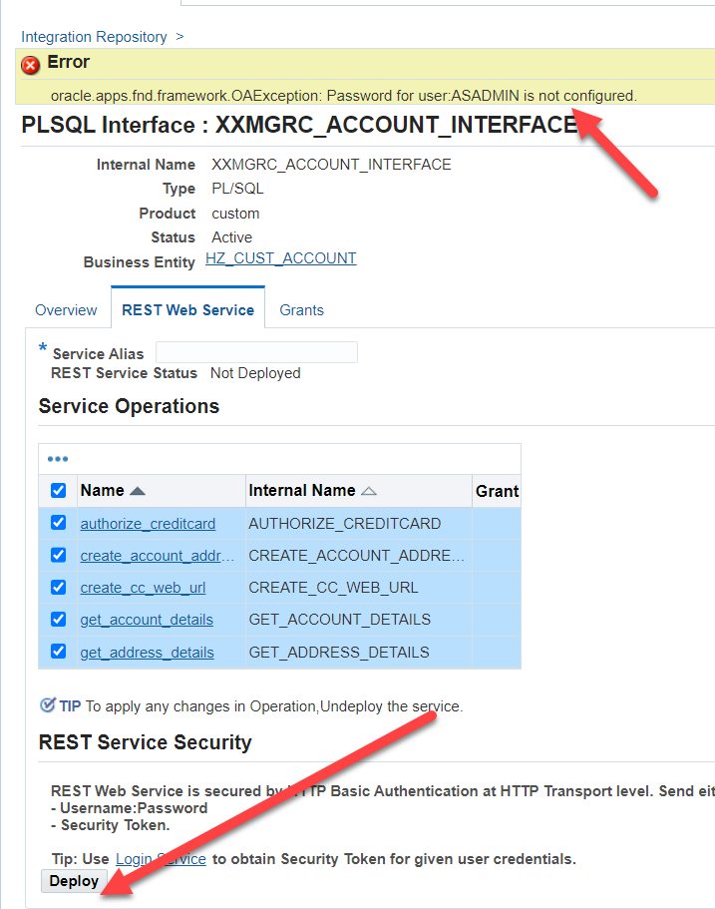

**Please try below steps to resolve this issue :**

**NOTE : perform these steps irrespective of any instance wihtout fail.**

**Validate REST values:**

* Integrated SOA Gateway →Integration Repository
* Search XXPIN_CREATE_IC_REQ in the internal name.
* Click GO
* Then click Hyperlink from the above result .
* Click REST Web services
* Click on View WADL.
* We should not get any PROD values when we click the above WADL url.

If we see any PROD entries ,Please run the below again and validate.

ant -f $JAVA_TOP/oracle/apps/fnd/isg/ant/isgDesigner.xml -Dactions=postclone -Dverbose=ON

**NOTE : PERFORM ALL STEPS IN ALL NON PROD INSTANCES**

Step 1: Confirm if the below queries retrieve the same password for ASADMIN user.

SQL> select fnd_vault.get ( 'ISG', 'ASADMIN' ) from dual;

FND_VAULT.GET('ISG','ASADMIN')

--------------------------------------------------------------------------------

*********

SQL> select fnd_vault.get ( 'FND', 'ASADMIN' ) from dual;

FND_VAULT.GET('FND','ASADMIN')

--------------------------------------------------------------------------------

*********

Step 2: If above queries retrieve different results or null value or same value, update ASADMIN password in FND_VAULT using the below script. Replace ASADMIN password accordingly.

SQL> @$FND_TOP/sql/afvltput.sql FND ASADMIN <Asadmin Password>

Step 3: if above step 2 is executed, update ASADMIN password under ISG using below script. Make sure it completed successfully

ant -f $JAVA_TOP/oracle/apps/fnd/txk/util/txkSoaConfigUtility.xml addASADMINToFNDVault

ant -f $JAVA_TOP/oracle/apps/fnd/isg/ant/isgDesigner.xml -Dactions=postclone -Dverbose=ON

Step 4: Confirm that the ASADMIN user's password changed correctly, below query must retrieve ‘Y’.

select fnd_web_sec.validate_login('ASADMIN','<Asadmin Password>') From dual;

Step 5: Make sure step 1’s queries retrieve same result.

Step 6: While Admin server is running, source run file system environment file and run the following script: (the script may take 10+ mins)

perl $FND_TOP/patch/115/bin/ISGRestSetup.pl

Optional step when and required, if password for ASADMIN DOES NOT MATCH

—-------------------------------------------------------------------------------------------------------

change the ASADMIN pwd using FNDCPASS

FNDCPASS apps/<pwd> 0 Y system/<pwd> USER ASADMIN <asadmin pwd from step 1>

NOTE : above script “ISGRestSetup.pl” will shutdown and start the EBS application services during the run.

ISSUES and Fixes

==================

Customer McGrath , EBS 12210, DB 12102

apex url issue in chrome browser after cloning.

NOTE :this is happening only in CHROME browser. other browsers work perfectly.

**Solution**

============

Added the below line on defaults.xml file under /u01/app/oracle/Middleware/apex/ords and bounce managed server.

<entry key="security.forceHTTPS">true</entry>

Oracle Doc

===============

403 Forbidden Error Accessing Apex Application with ORDS 3.0.4 or above Using Chrome: Resource Does Not Support Cross Origin Sharing Requests (Doc ID 2139195.1)